Image formation by compound optical system using thick lenses

Experiment and manual prepared by Alex Terseck (Fall 2015)

Revised by Brian Ferrari, Cameron Nickle and Seth Calhoun (Fall 2016)

Revised by Rikki Leyva (Summer 2017)

Supervised by Prof. R. E. Peale

Purpose
To experimentally test the predictions of image formation using a compound optical system comprising two thick converging lenses.

Materials Checklist:
(This list is to stay with the materials box at all times. All materials are the property of Prof. R. E. Peale and are on temporary loan to the UCF Physics upper division labs.)

1. Optical Bench with lens holders
2. 2 Thick Lenses
3. Light Source
4. Object to be imaged (preferably something with sharp edges such as an aperture or an image with high contrast and small details)
5. Screen
6. Mirror

Please inform the instructor if any of these materials are missing.

Introduction and Background
Geometric optics predicts the distance of image formation as a function of the separation between the source and the optical system. Carefully review Appendix A and the solution to problem 1 from section 56 for a better understanding of the theoretical predictions. Before you begin, you should know the definitions of principal foci, principal points, and principal focal length.

Experimental Setup

The optical bench is equipped with a fixed ruler. The thick lenses themselves have no obvious reference point to mark their location. Instead, define some point such as the edge of their mounting stand to define their position with respect to the scale. Also note that the lens are not generally symmetrical, so record their orientation. A cell phone light makes a convenient and bright point source. Some are not that point like, but you can make them more point like with an opaque aperture.

Experimental Procedure

1) Principal Foci
Mount a first lens to the right of the origin x = 0 of the scale. Record its position and orientation. Determine to positions of both principal foci of this lens x = g₁ and –h₁ on the scale by the autocollimation method. Here you will mount a plane mirror at any position on one side of the lens and a point source on the other side. Surround the point source with a white screen. The position of the point source that gives the sharpest image of the point source on the screen defines the principle focus position on that side of the lens. That is the position where rays approaching the mirror are parallel to the optical axis.

Mount a second lens to the right of the first lens. Record its position and orientation. Temporarily remove the first lens from the bench. Find the principal foci x = g₂ and –h₂. You want l = g₂-(-h₁)>0. If it isn’t, then move the second lens farther “down stream” until it is. Record the final values of g₂ and –h₁.

2) Principal Focal Lengths
The values of the principal foci depend on the origin of the x coordinate system. In contrast, the principal focal length of a lens is a fundamental property of the lens itself and is independent of the coordinate system.

For the first lens place the illuminated aperture or a point source at a position x < g1. Find the position of its image x’ to the right of the lens using a white screen. The principal focal length of the lens f₁ is determined by the equation XX’ = -f₁², where X = x-g1 and X’=x’-(-h1) are the object and image positions relative to the principal foci. Repeat for lens 2. Note, when the object is at x = g, then the image is at x’=∞. For this case, X = x - g = 0, or x = g, which is the origin of the X coordinate system. Therefore when an object is located at the origin of the X coordinate system, X’=$\frac{-f^{2}}{X-δ}=\frac{-f^{2}}{0-δ}=+∞ as δ→0.$

3) Principal Points
Locate the principal points for each lens. These are located at X = f and X’ = -f. For a thin lens, these points coincide with the center of the lens. Do they coincide for the thick lenses? Where are they located with respect to the lens surfaces? Are they symmetrically positioned about the center of the lens as best as you can tell? After completing the compound lens experiment, find a really thick lens, locate its principal points, and answer those questions again.

4) Principal Foci and Focal Length of a Compound Lens System
Determine the principal foci and principal focal length for the compound system by the same procedures used for each individual lens. Plot X_{c}’ vs X_{c} for as wide a range of X_{c} values that you can. Compare the formula X_{c}X_{c}’=-f_{c}² using the calculated principal focal length f_{c.}

Write-up requirements
The lab report should be in the form of a research paper comprising, title, author, affiliation, abstract, introduction, theoretical considerations, experimental details, results, discussion, conclusion, and references. Length limit is 6 pages. Results section should include a scale (e.g. 1 mm = 1 cm) of the optical axis, indicating lens positions, principal foci (e.g. g1,g2,gc etc), and principal points, and plots of image position vs object position for both individual and compound lenses (e.g. X1’ vs X1) together with theoretical curves. Discuss the positions of the principal points with respect to the lens surfaces (inside or outside?) and lens centers (do principal points coincide? Are they symmetric with respect to lens center?)

Appendix A
(from L. D. Landau & E. M. Lifshitz, Classical Theory of Fields, 4th revised edition)
(Pay special attention to section 56 and the problem. The rest is background that may need to fully understand section 56. Most elementary descriptions of a two lens system describe the telescope, for which holds for the special situation l = 0. This lab evaluates a more general situation.)

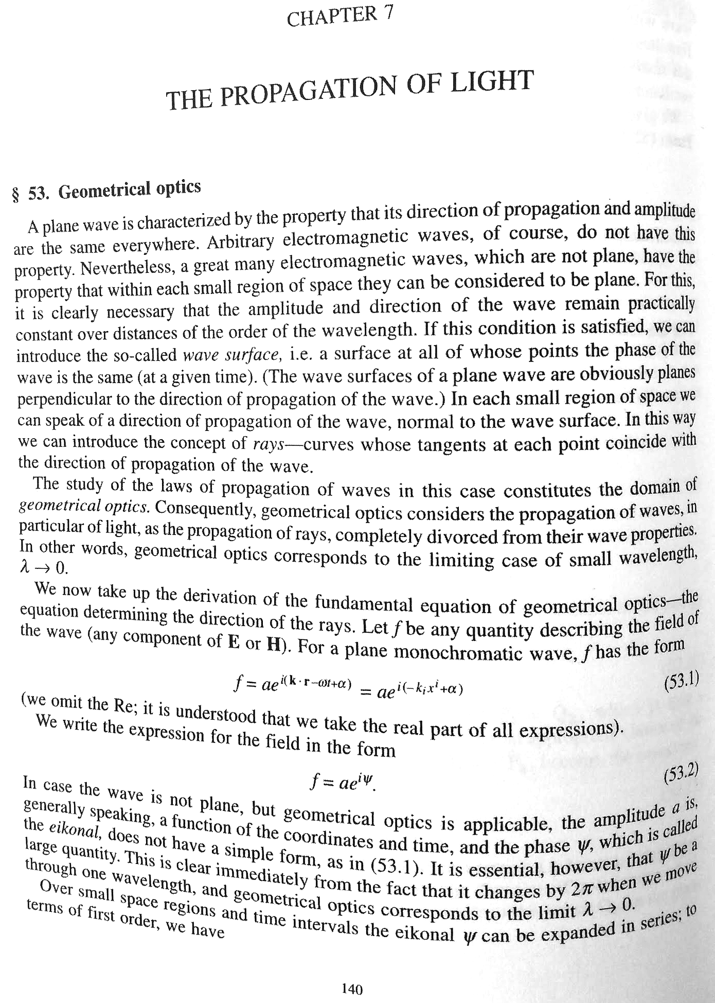
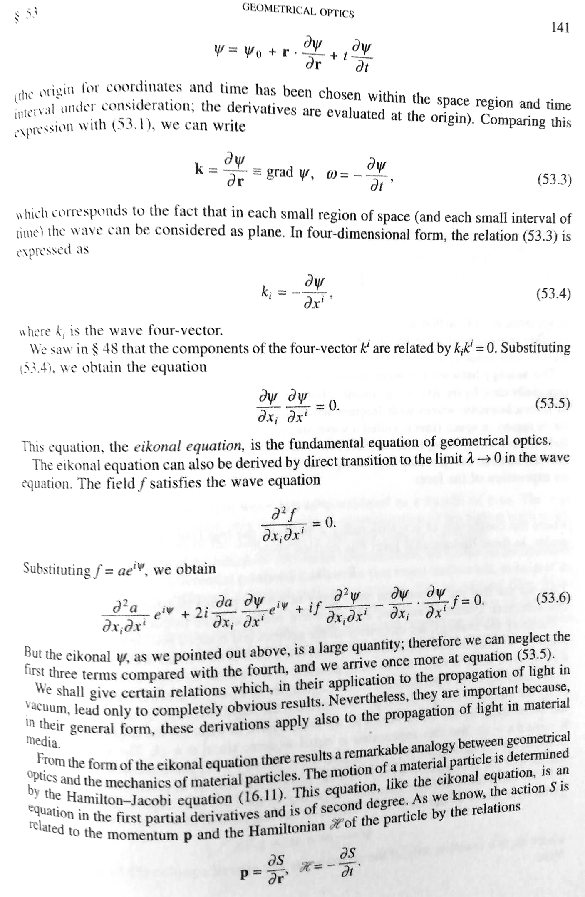
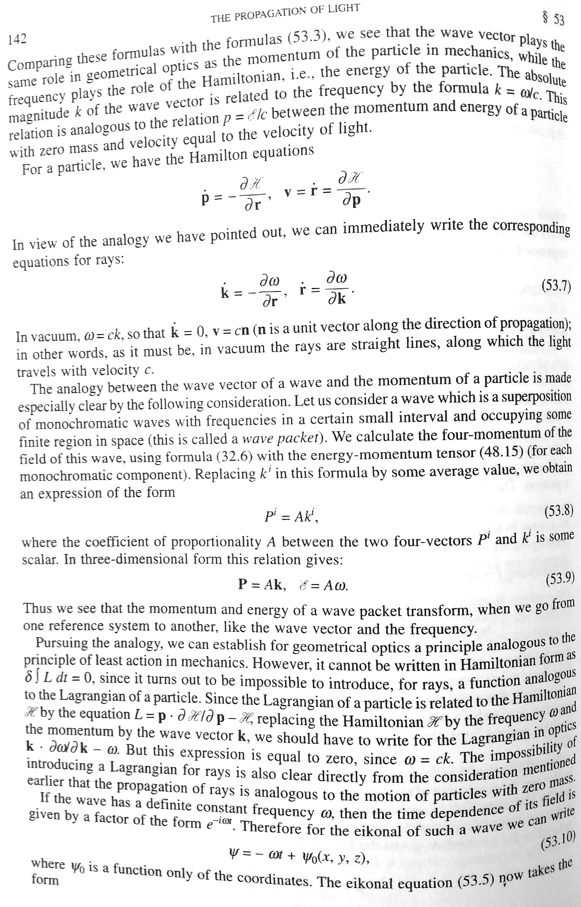
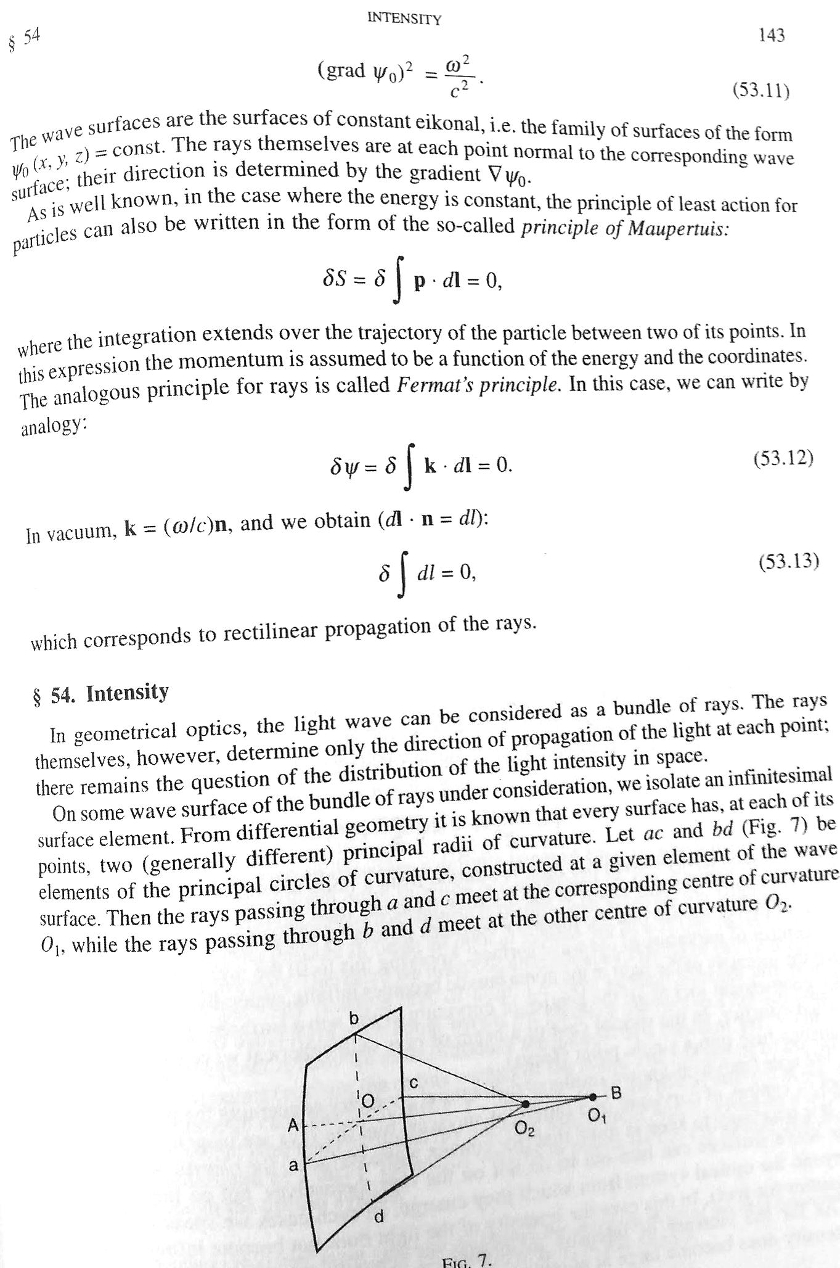
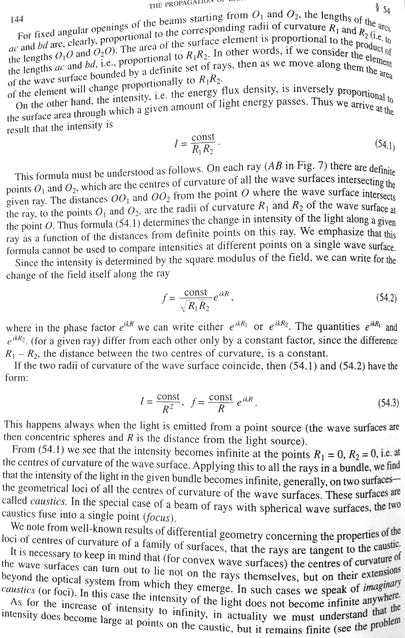
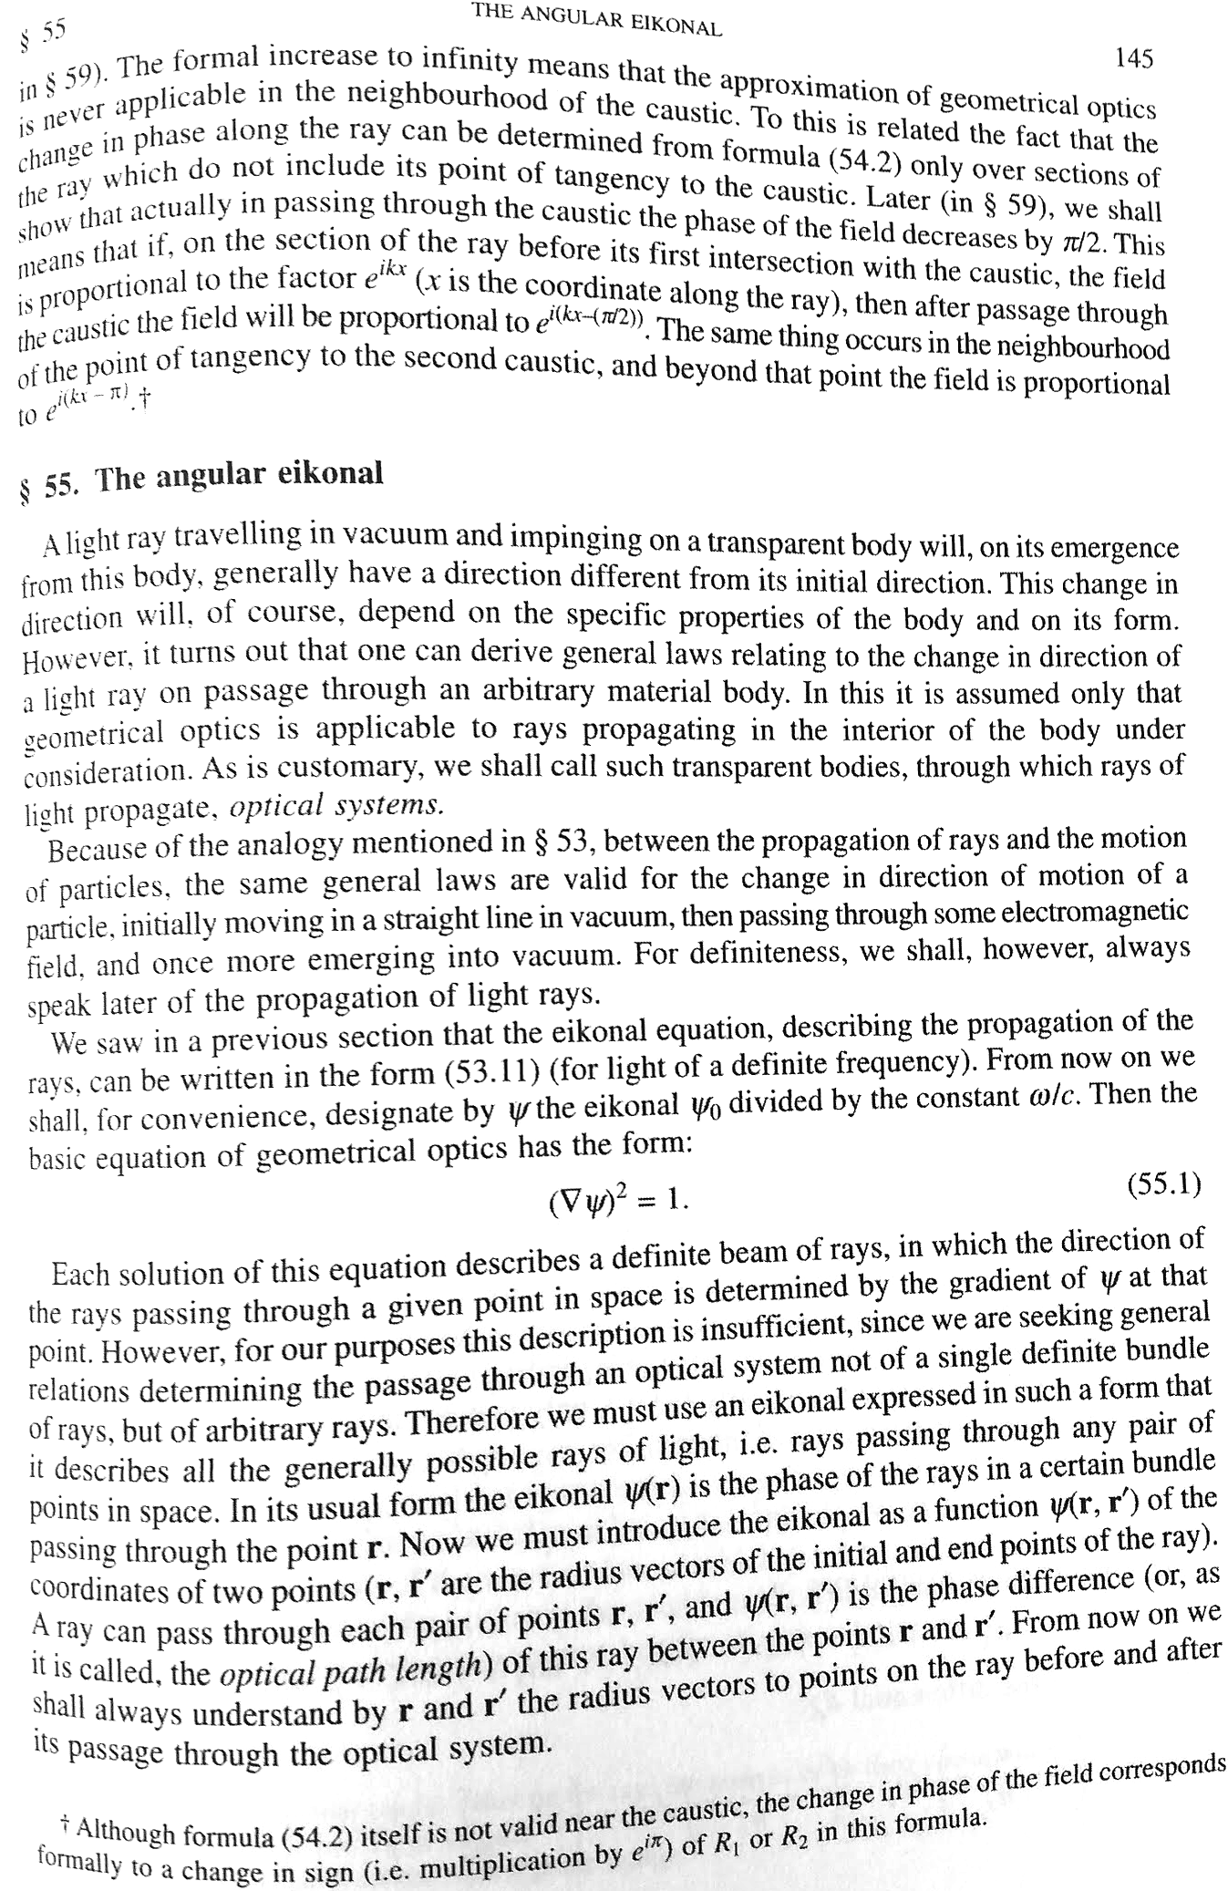
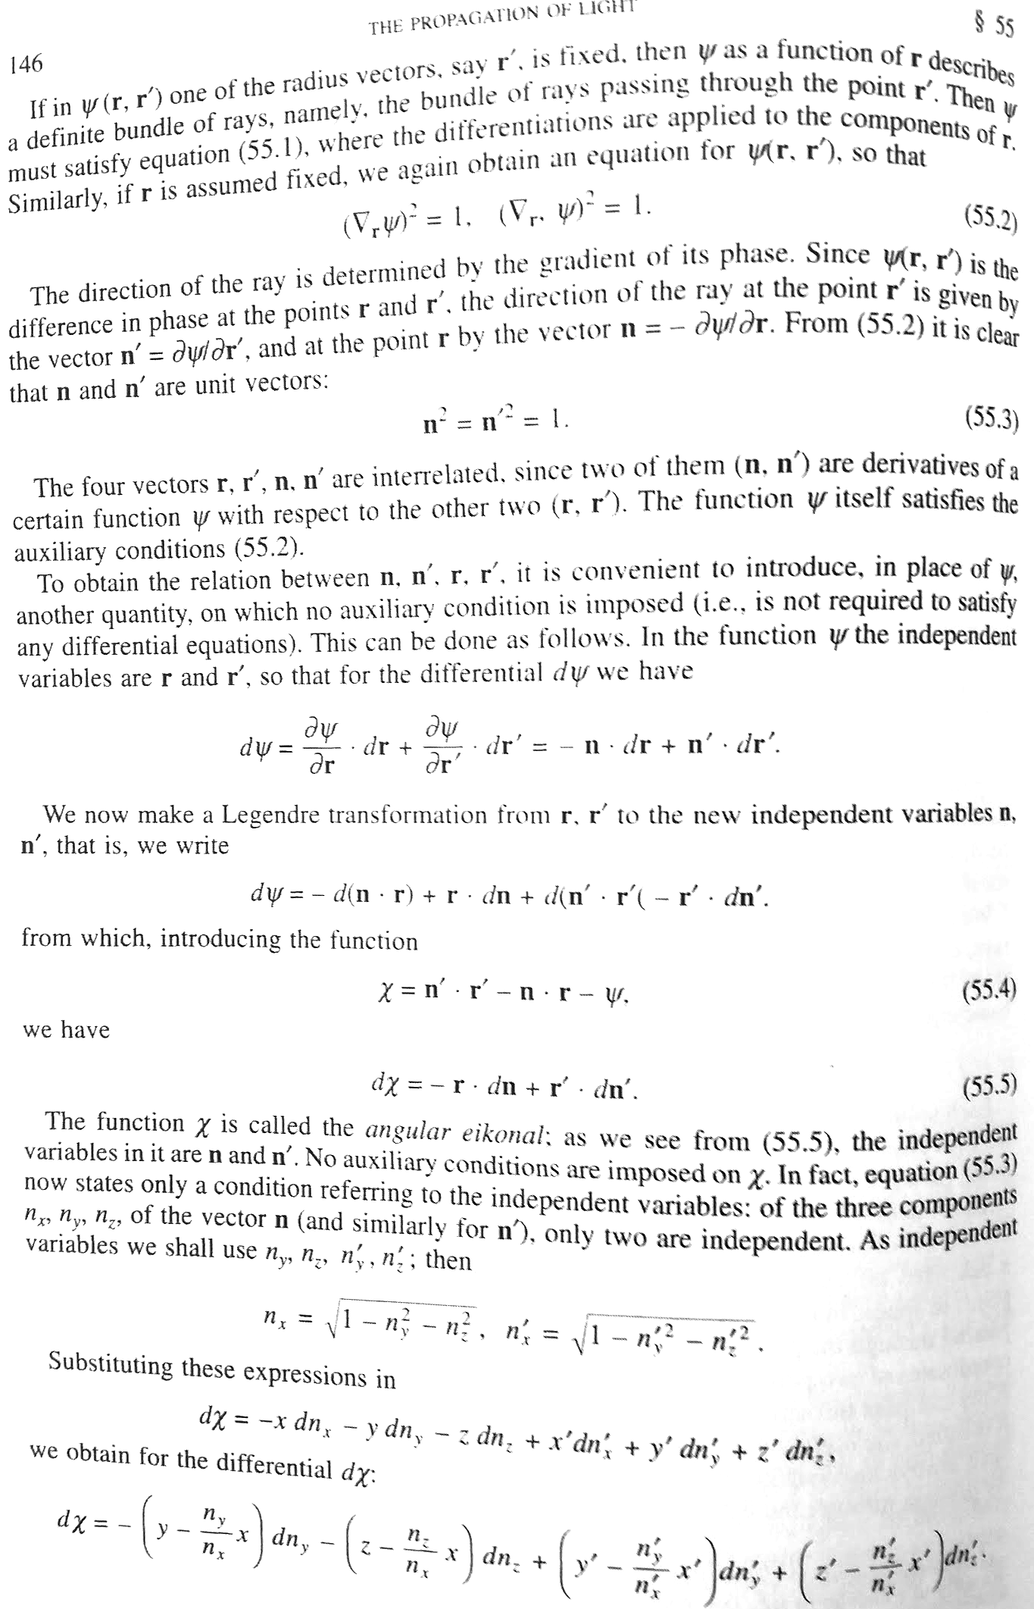
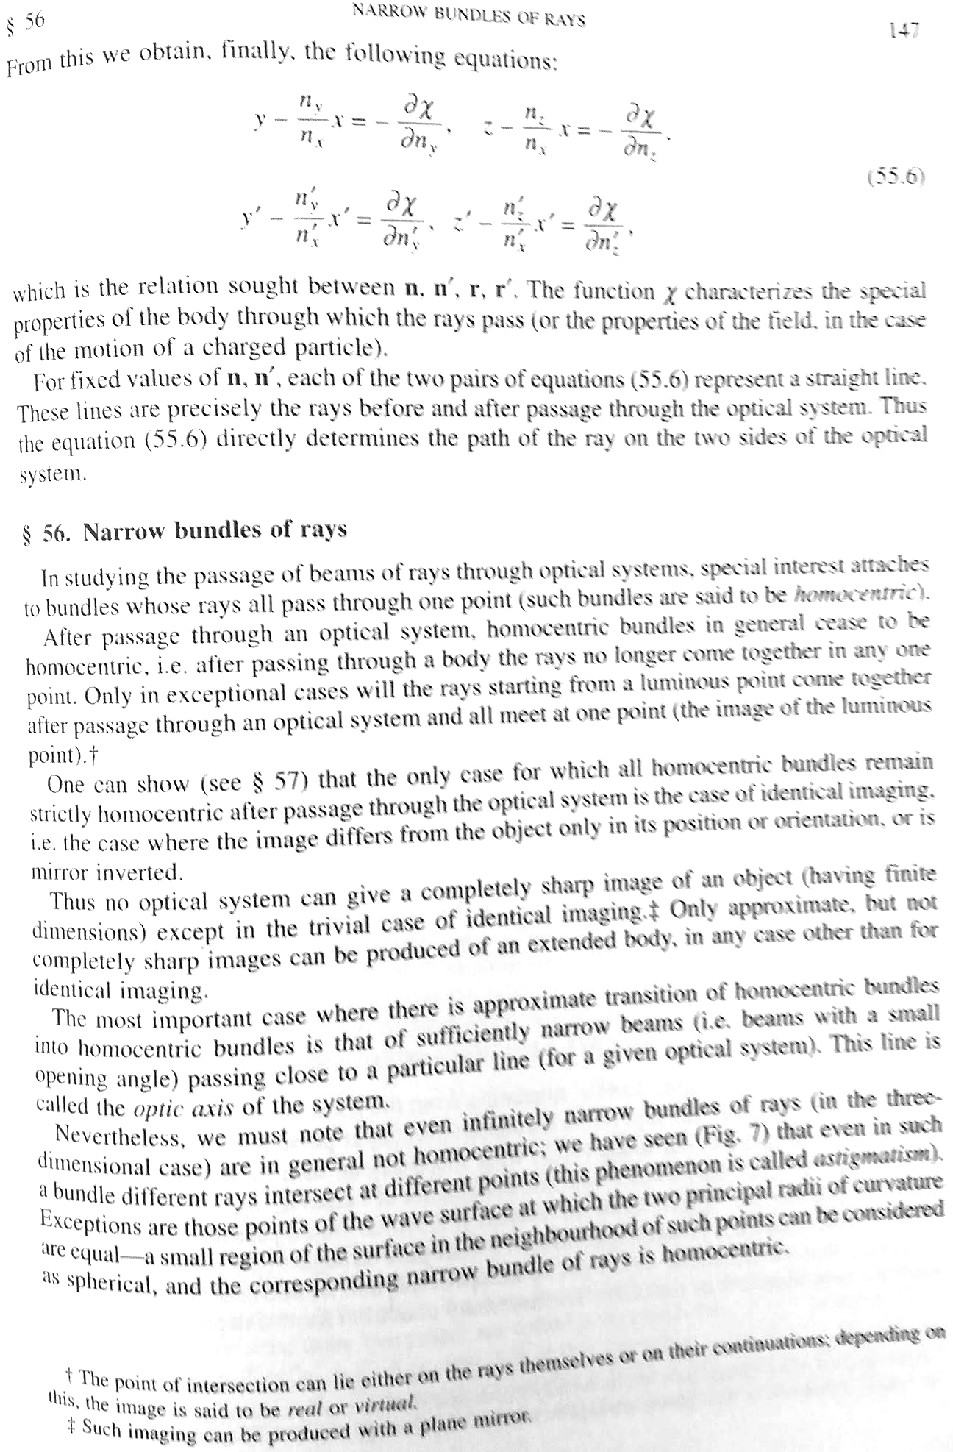
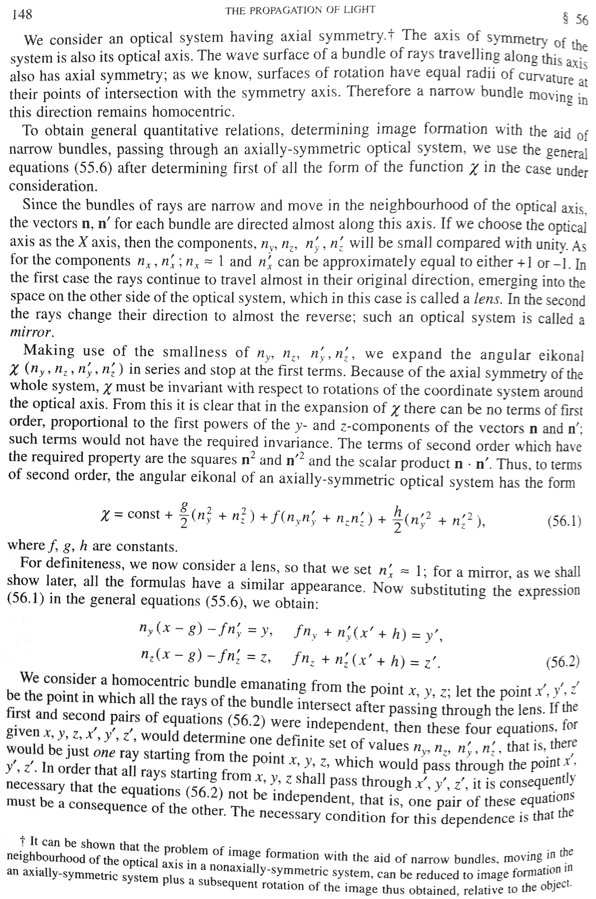
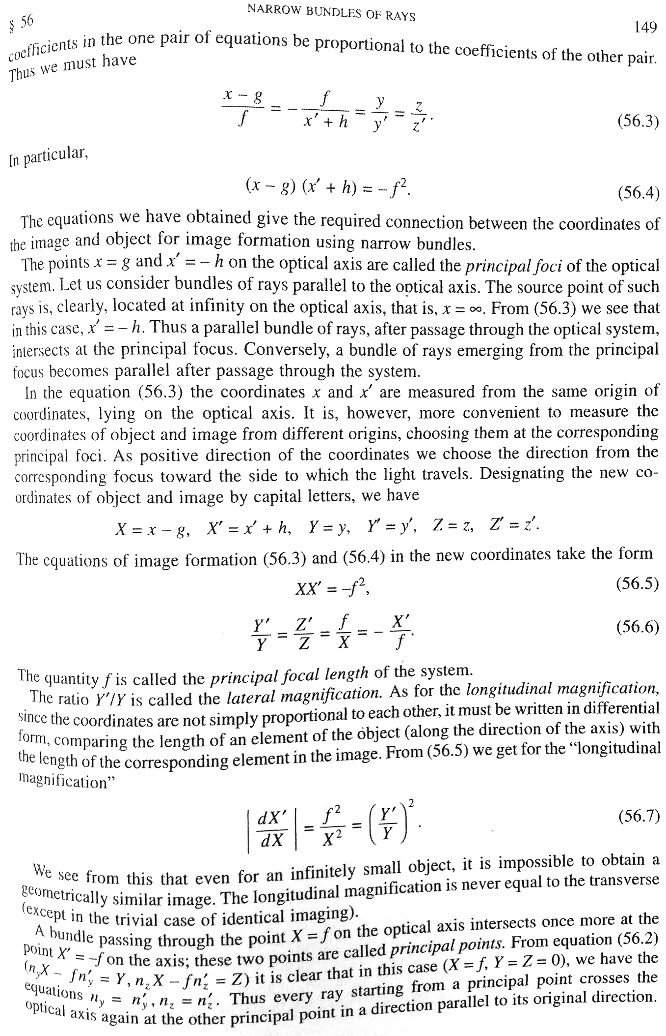
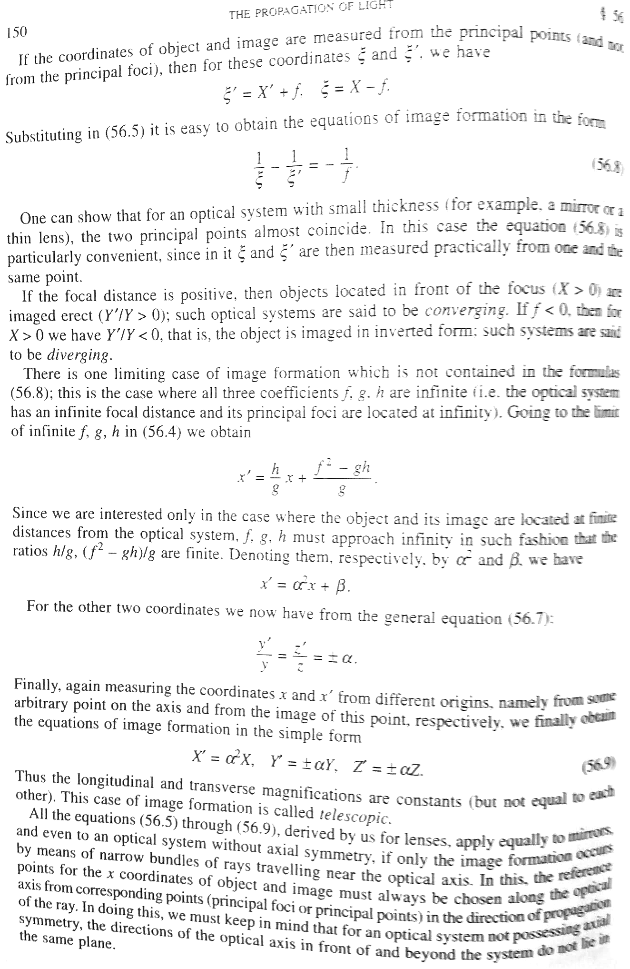
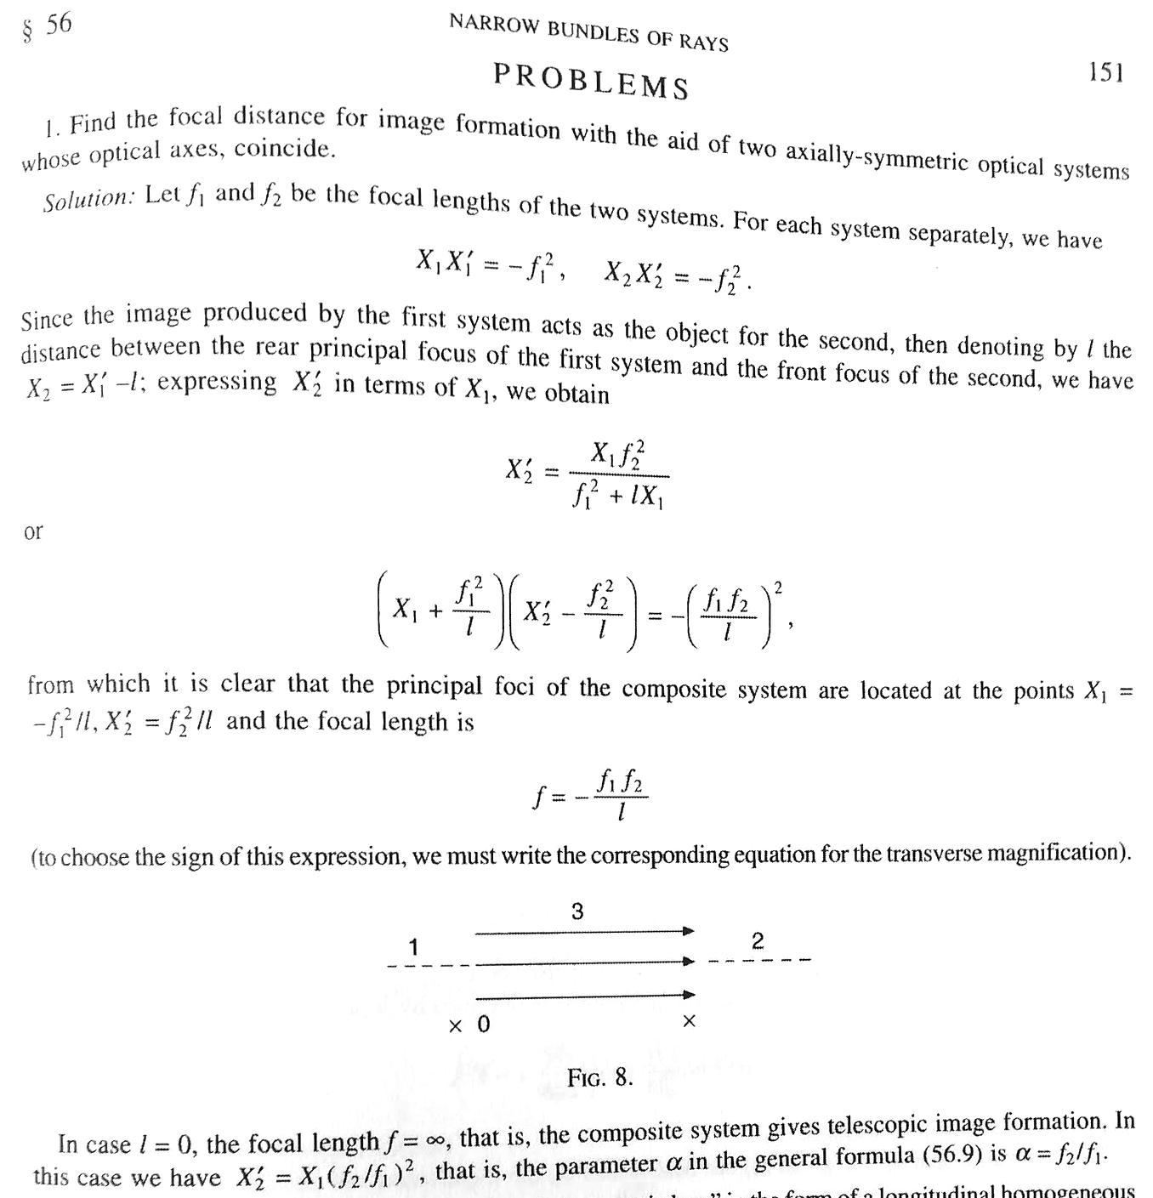

Details of solution to Problem 1
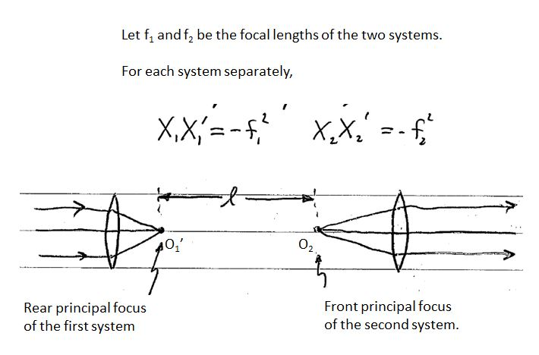

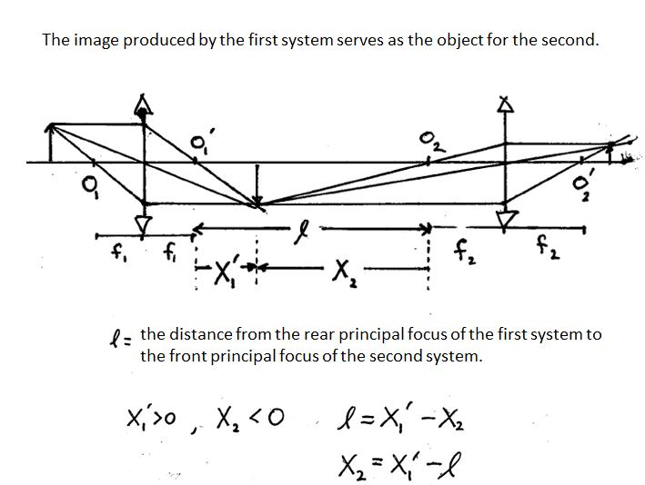

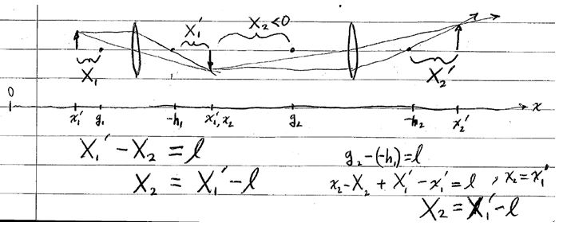

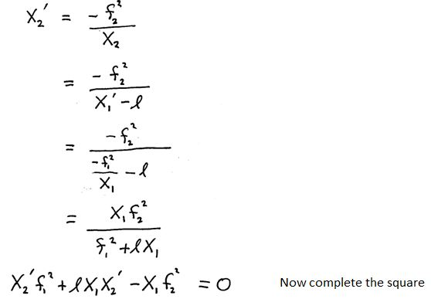
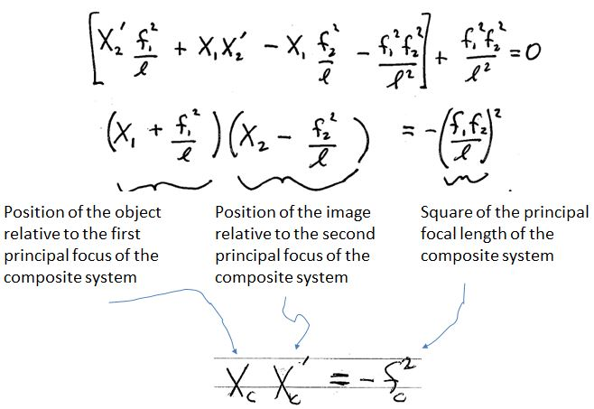
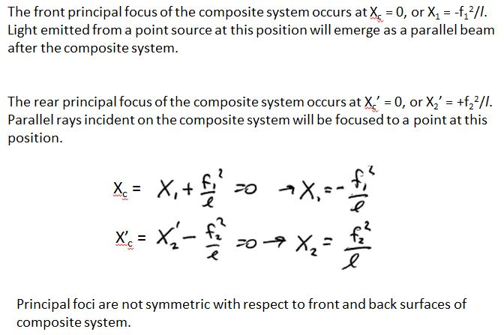
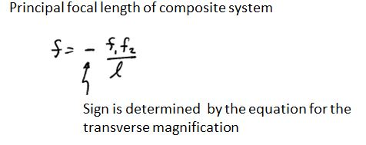

Appendix B

Example Results collected by Alex Terseck using thin lenses (2015).

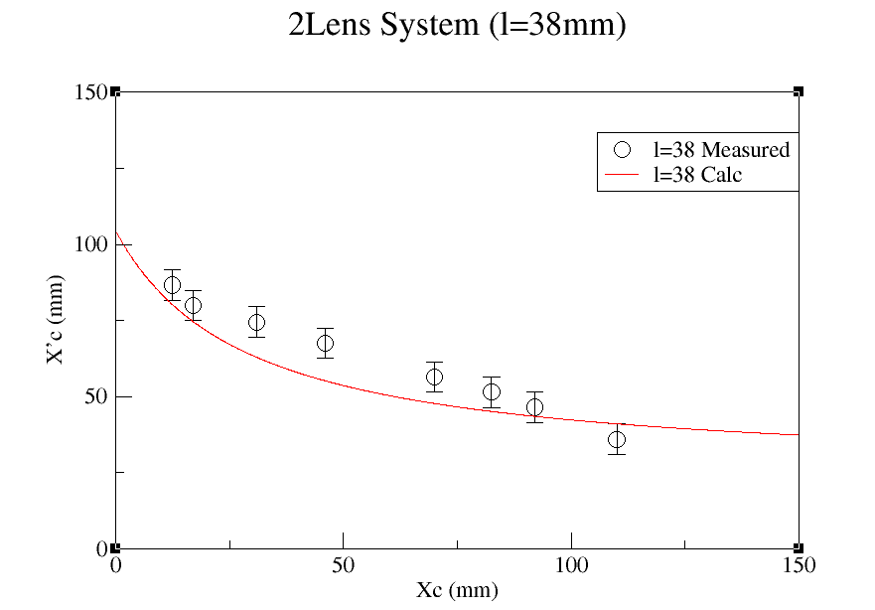
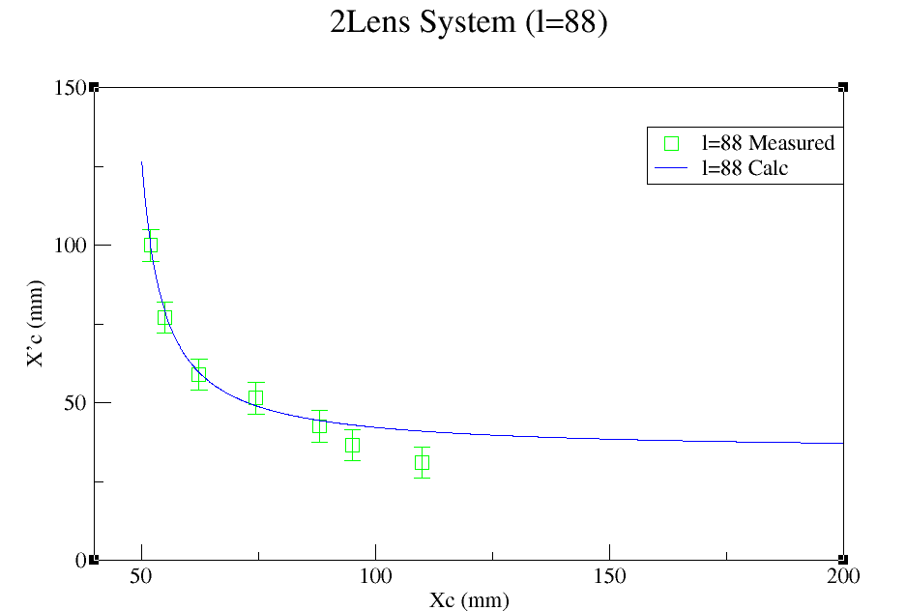

Individual lenses had focal lengths of 33 and 55 mm. The data collected is compared with calculations executed in Fortran. The data are agree better for larger l and for smaller X_{C}, which makes X_{C}’ larger and easier to measure accurately.

Fortran Code:
c program in Fortran 77
c Optics

implicit real(a-h,o-z)
parameter (n=1500)
double precision x2,xi,xf,f1,f2,l,fc,s1,s2

f1 = 33.0d0
f2 = 55.0d0
xi = 0.0d0
l = 38.0d0
fc = (f1*f2)/l
s1 = (f1*f1)/l
s2 = (f2*f2)/l

write(6,*)fc,s1,s2

do i = 1,n

xf = (fc*fc)/(xi-f1-s1)
x2 = xf + s2
xi = xi + 0.1
write(7,*)xi,x2
end do

stop
end

Example Results Collected by Rikki Leyva using thick lenses (2017).

Lens A at 43.6 cm
 | g | - h |  | Principal Planes
 | 35.15 | 52.4 |  | 44.97
 |  |  |  | 42.57
x | x' | X | X' | -f² | -f
25.35 | 61.3 | -9.8 | 8.9 | -87.22 | 9.34
15.35 | 57.3 | -19.8 | 4.9 | -97.02 | 9.85
21.85 | 59.3 | -13.3 | 6.9 | -91.77 | 9.58
7.45 | 56.4 | -27.7 | 4 | -110.8 | 10.53
16.65 | 57.8 | -18.5 | 5.4 | -99.9 | 9.99
19.65 | 58.7 | -15.5 | 6.3 | -97.65 | 9.88
23.55 | 60.3 | -11.6 | 7.9 | -91.64 | 9.57
 |  |  |  | AVG | 9.82
 |  |  |  | Uncertainty | ±0.38

Lens B at 74 cm
 | g | -h |  | Principal Planes
 | 64.2 | 83.1 |  | 73.86
 |  |  |  | 72.44
x | x' | X | X' | -f² | -f
54 | 95 | -10.2 | 11.9 | -121.38 | 11.02
61.6 | 105.1 | -2.6 | 22 | -57.2 | 7.56
55.6 | 98.1 | -8.6 | 15 | -129 | 11.36
53.6 | 93.2 | -10.6 | 10.1 | -107.06 | 10.35
56.6 | 95.5 | -7.6 | 12.4 | -94.24 | 9.71
60.6 | 103.6 | -3.6 | 20.5 | -73.8 | 8.59
58.6 | 97.6 | -5.6 | 14.5 | -81.2 | 9.01
 |  |  |  | AVG | 9.66
 |  |  |  | Uncertainty | ±1.36

Compound at 43.6cm and 74cm
 | g | -h
 | 26.5 | 93.5
x | x' | X | X' | -f² | -f
22.65 | 105.6 | -3.85 | 12.1 | -46.585 | 6.83
19.65 | 101.7 | -6.85 | 8.2 | -56.17 | 7.49
21.05 | 104.9 | -5.45 | 11.4 | -62.13 | 7.88
15.65 | 100.2 | -10.85 | 6.7 | -72.695 | 8.53
11.15 | 99.2 | -15.35 | 5.7 | -87.495 | 9.35
18.35 | 103.1 | -8.15 | 9.6 | -78.24 | 8.85
13.3 | 99.5 | -13.2 | 6 | -79.2 | 8.90
 |  |  |  | AVG | 8.26
 |  |  |  | Uncertainty | ±0.89

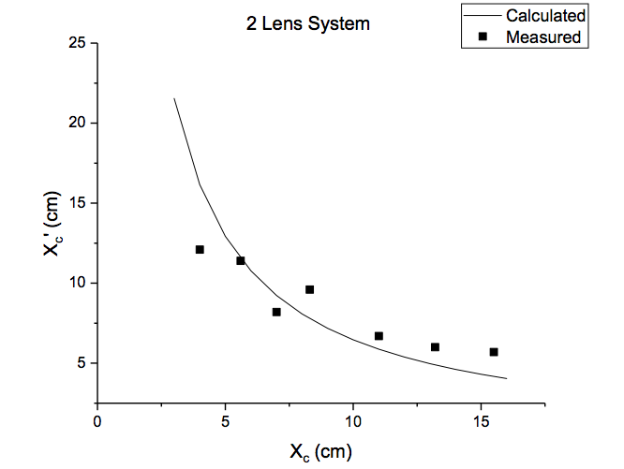
l=11.8cm

