Image formation by compound optical system

Experiment and manual prepared by Alex Terseck.
Supervised by Prof. R. E. Peale
(Fall 2015)

Purpose
To experimentally test the predictions of image formation using a compound optical system comprising two converging lenses.

Materials Checklist:
(This list is to stay with the materials box at all times. All materials are the property of Prof. R. E. Peale and are on temporary loan to the UCF Physics upper division labs.)

- 1 Optical Bench
- 2 lens holders and adjustable stands
- 2 screws
- 1 allen wrench (to fasten the lens stands to the bench)
- 1 double convex lens (DIA 19mm; FL 33mm)
- 1 double convex lens (DIA 33mm; FL 55mm)
- 1 ruler/measuring tape
- 1 light receptacle with bulb
- 1 aluminum slide
- A piece of paper or cardboard to collect the image

Please inform the instructor if any of these materials are missing.

Introduction and Background
Geometric optics predicts the distance of image formation as a function of the separation between the source and the optical system. Carefully review Appendix A and the solution to problem 1 from section 56 for a better understanding of the theoretical predictions.

Materials and Procedure
This experiment will require the following materials: a ruler, 1 optical bench, 2 adjustable lens holders (with screws to fasten them to the optical bench), 2 double convex lenses (preferably with a large diameter ~30mm), 1 incandescent light bulb (or some other visible light source), a receptacle to provide power for the light source, a slide or aperture that will form an image (with sharp edges) when placed in front of the source, and a piece of paper to collect the final image.

Don’t trust the focal length specifications for the individual lenses. Measure them based on the image distance for a distant object. Record the measurements.

Place each lens in an adjustable holder and fasten them to the optical bench. Ensure that the two lenses are coaxial and perpendicular to the optical axis. Separate the lenses by more than the sum of their focal lengths, i.e. choose l > 0 and record the value. Place the aluminum letter A shadow mask inside the receptacle, then place on the left hand side (l.h.s.) of the optical system on the optical axis. The “A” is the object that will be imaged by your optical system. The source must be free to slide along the axis of symmetry in order to vary the value of X_{C}. Stand a white screen (e.g. paper or cardboard) perpendicular to the optical axis on the right hand side (r.h.s.) of the system. You will form your image on the screen.

For the given value of l, choose 6-10 different values of the independent variable X_{C} > 0. For each, measure the dependent variable X_{C}’ at which there is a sharp image on the screen. Note the orientation of the image. Choose a different value of l > 0, and repeat the experiment. Plot your measured data (which error bars indicating your estimated uncertainty) together with calculated curves X_{c}’ vs X_{c}.

Measure the magnification (with sign) of the compound system and compare with theory.

Your lab report should be organized like a journal paper: Title, Names, Affiliation, Date, Abstract (three sentences, “what”, “how”, and “why”.) The briefest introduction possible stating why you are doing the experiment and citing the source of the theory that you will be comparing to. Next, Theoretical Considerations (give only the equations that you actually will use, and cite the reference you got them from), then Experimental Details (basically the operating procedure above), then results (plots of your data and theory with a factual discussion of what the plots contain). Then Discussion (here you discuss agreement between theory and experiment), then a short Summary, then Acknowledgments (anyone who helped you but is not a coauthor), then a reference section.

Appendix A
(from L. D. Landau & E. M. Lifshitz, Classical Theory of Fields, 4th revised edition)
(Pay special attention to section 56 and the problem. The rest is background that may need to fully understand section 56. Most elementary descriptions of a two lens system describe the telescope, for which holds for the special situation l = 0. This lab evaluates a more general situation.)
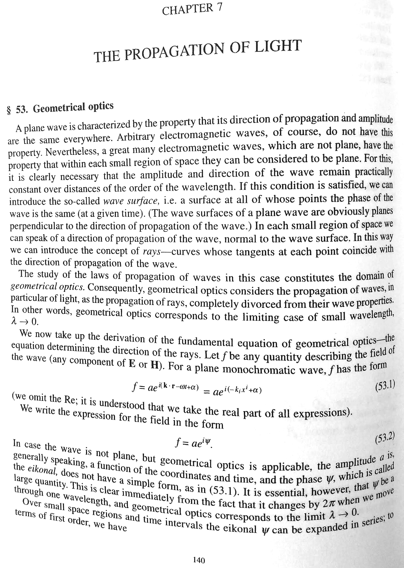
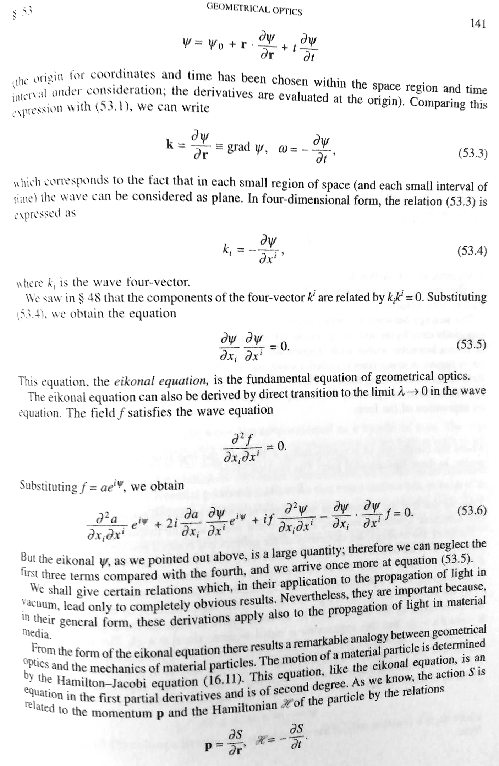
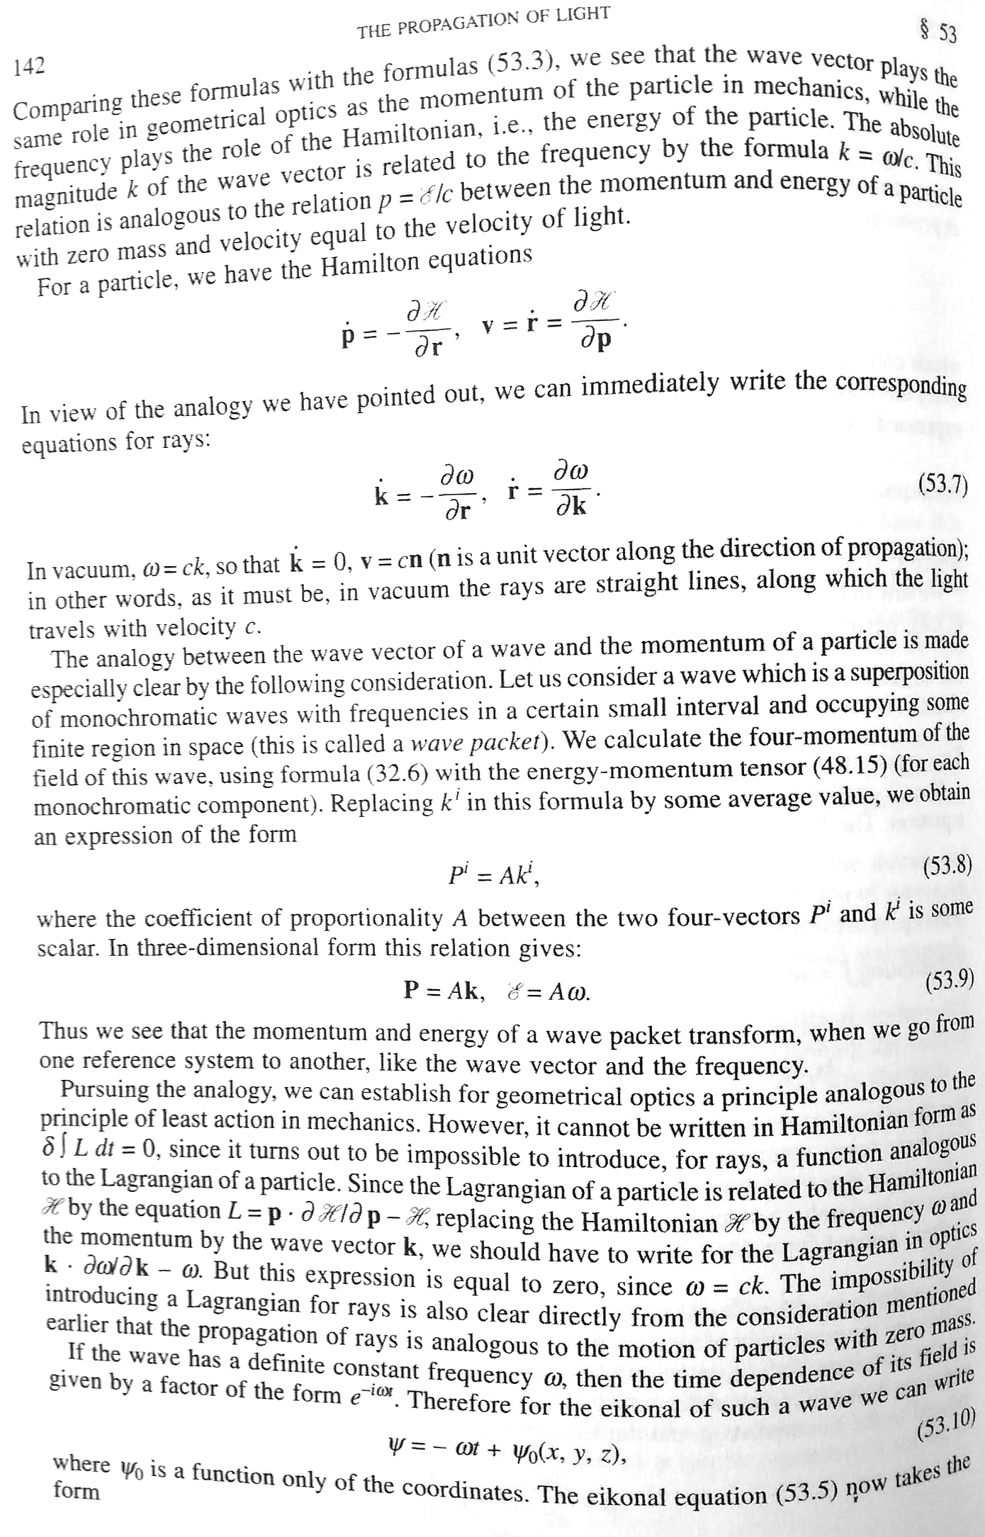
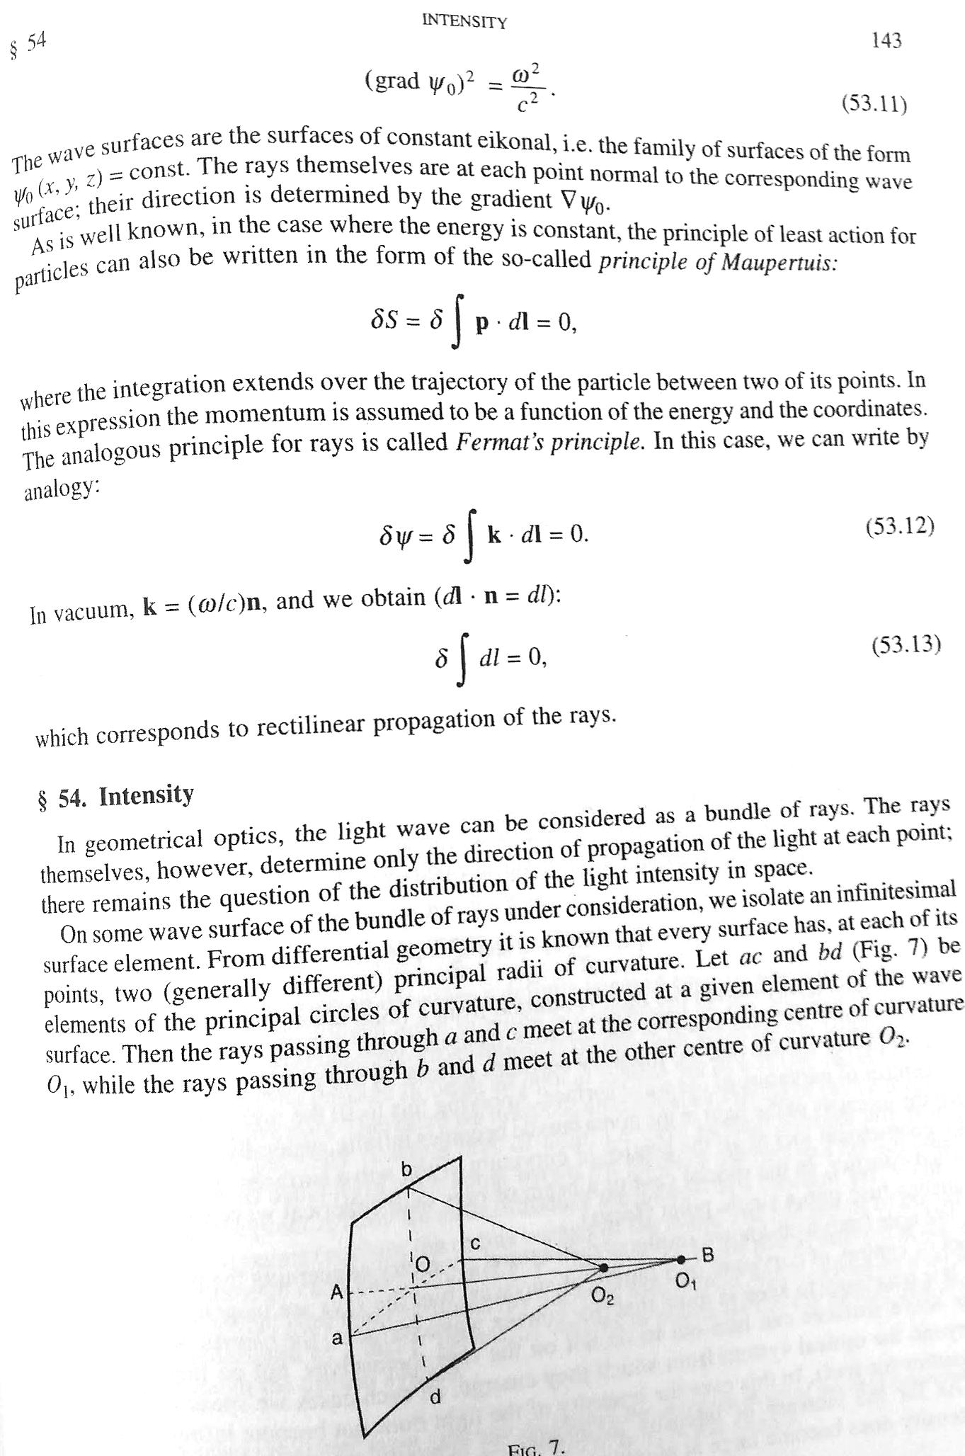
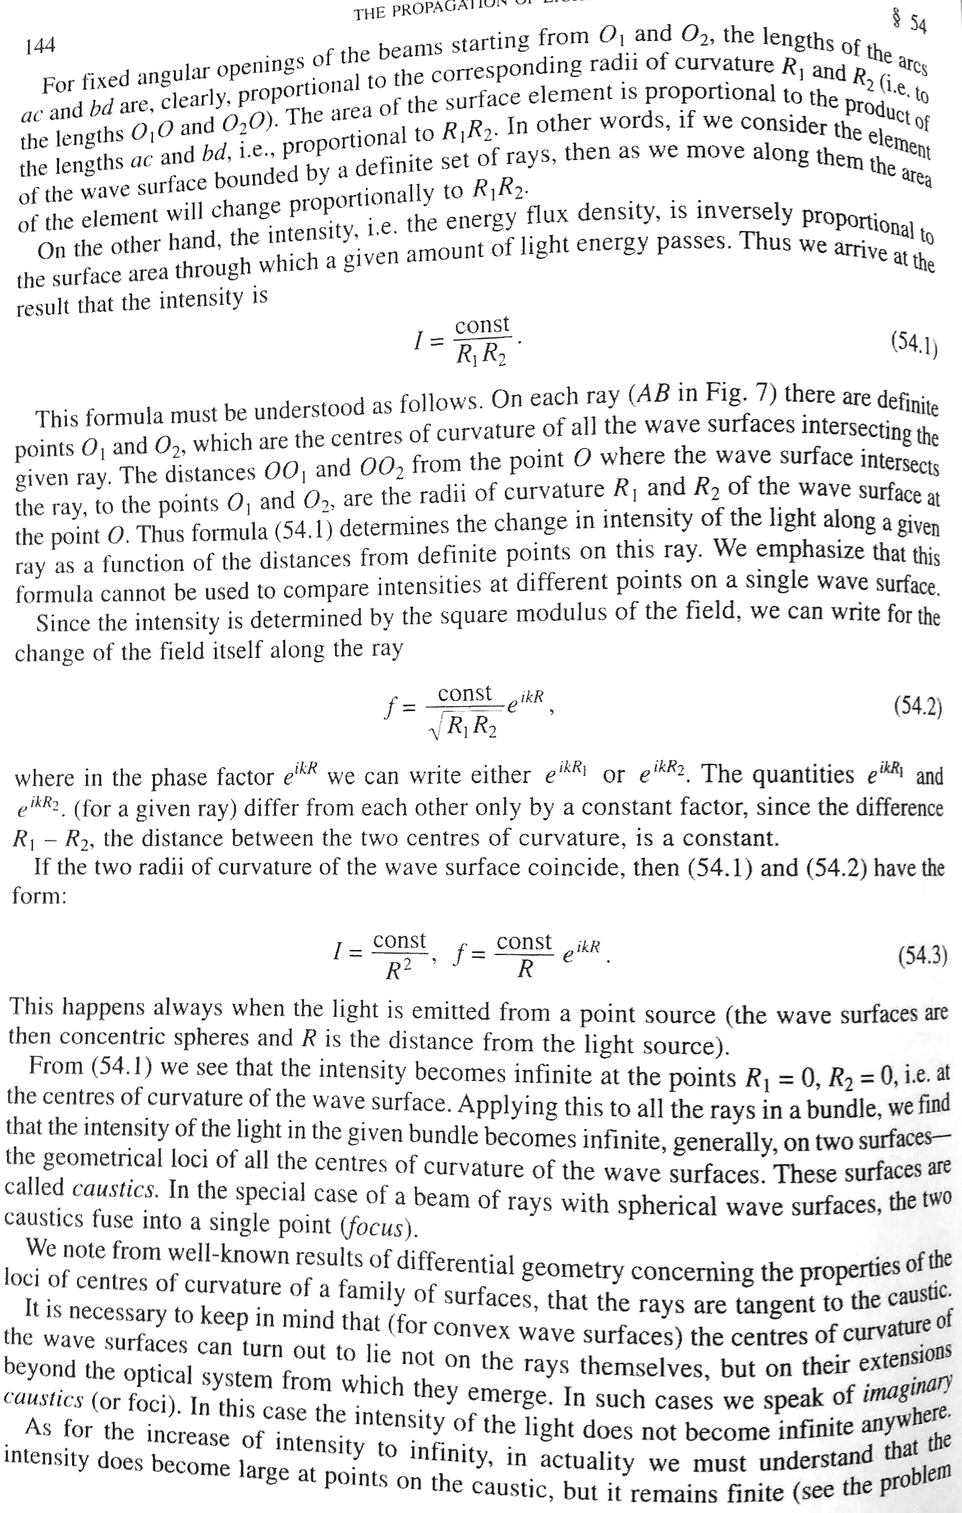
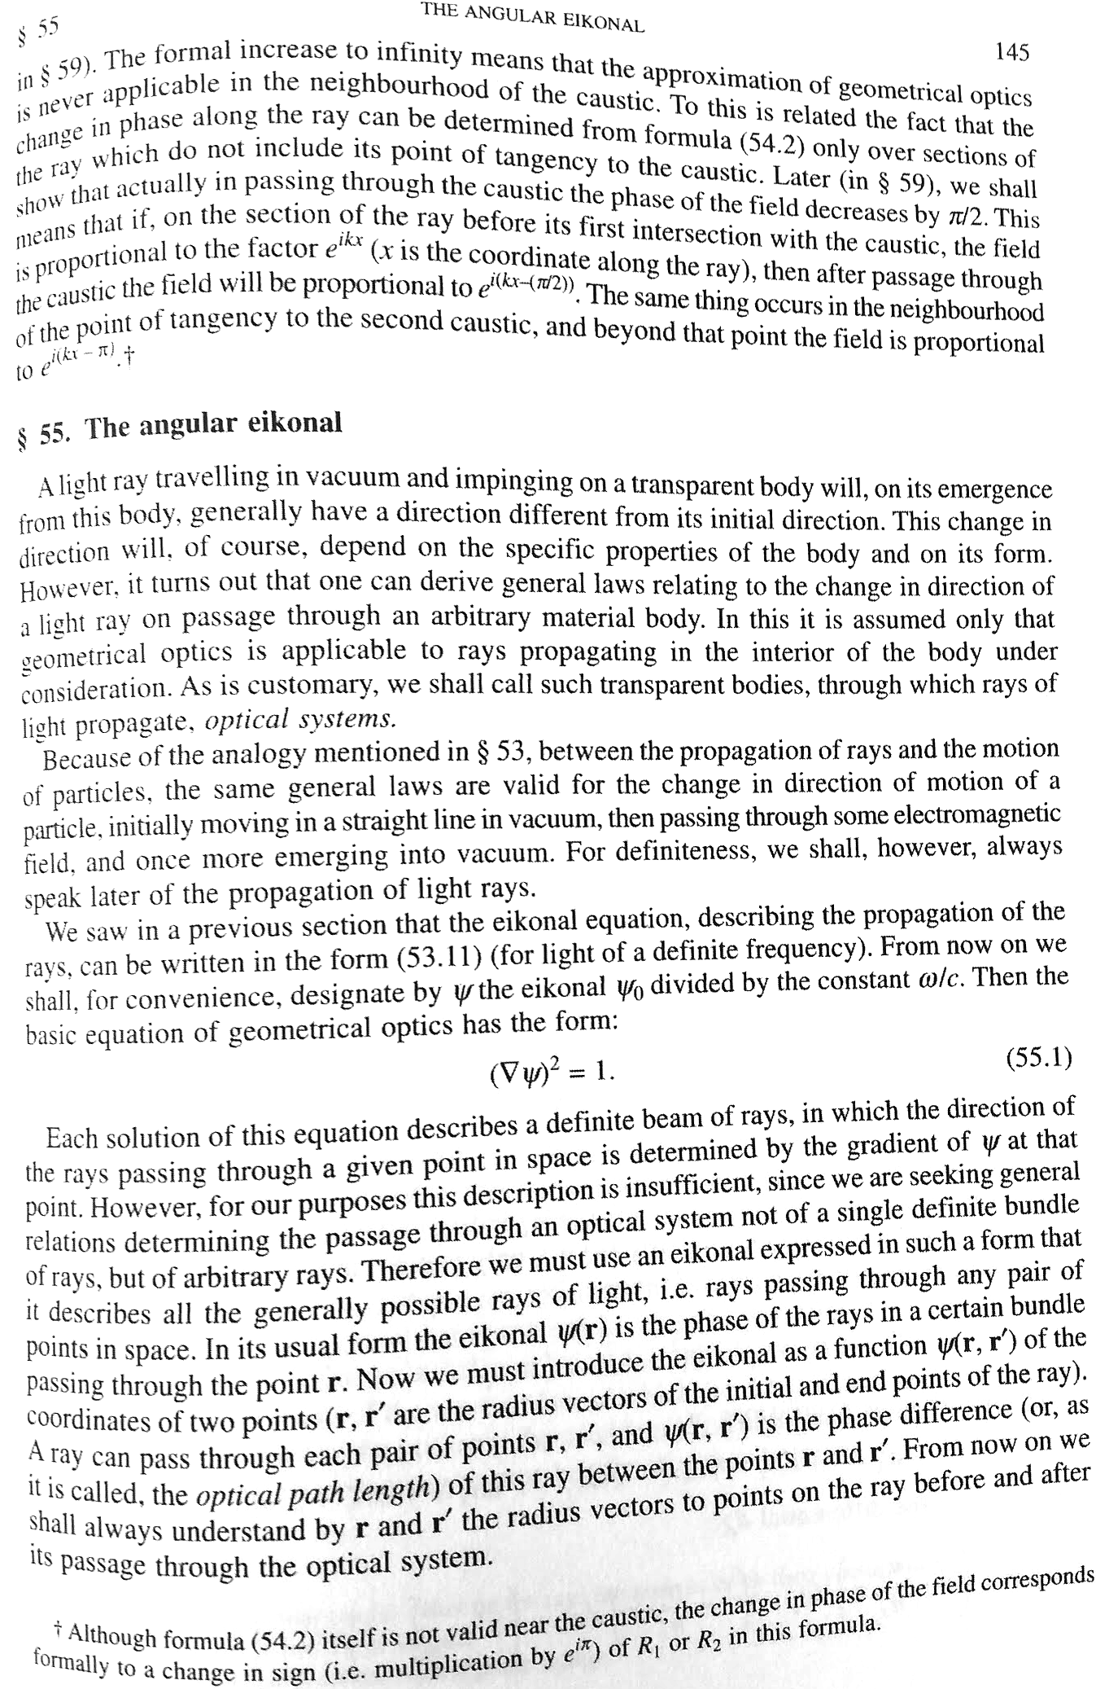
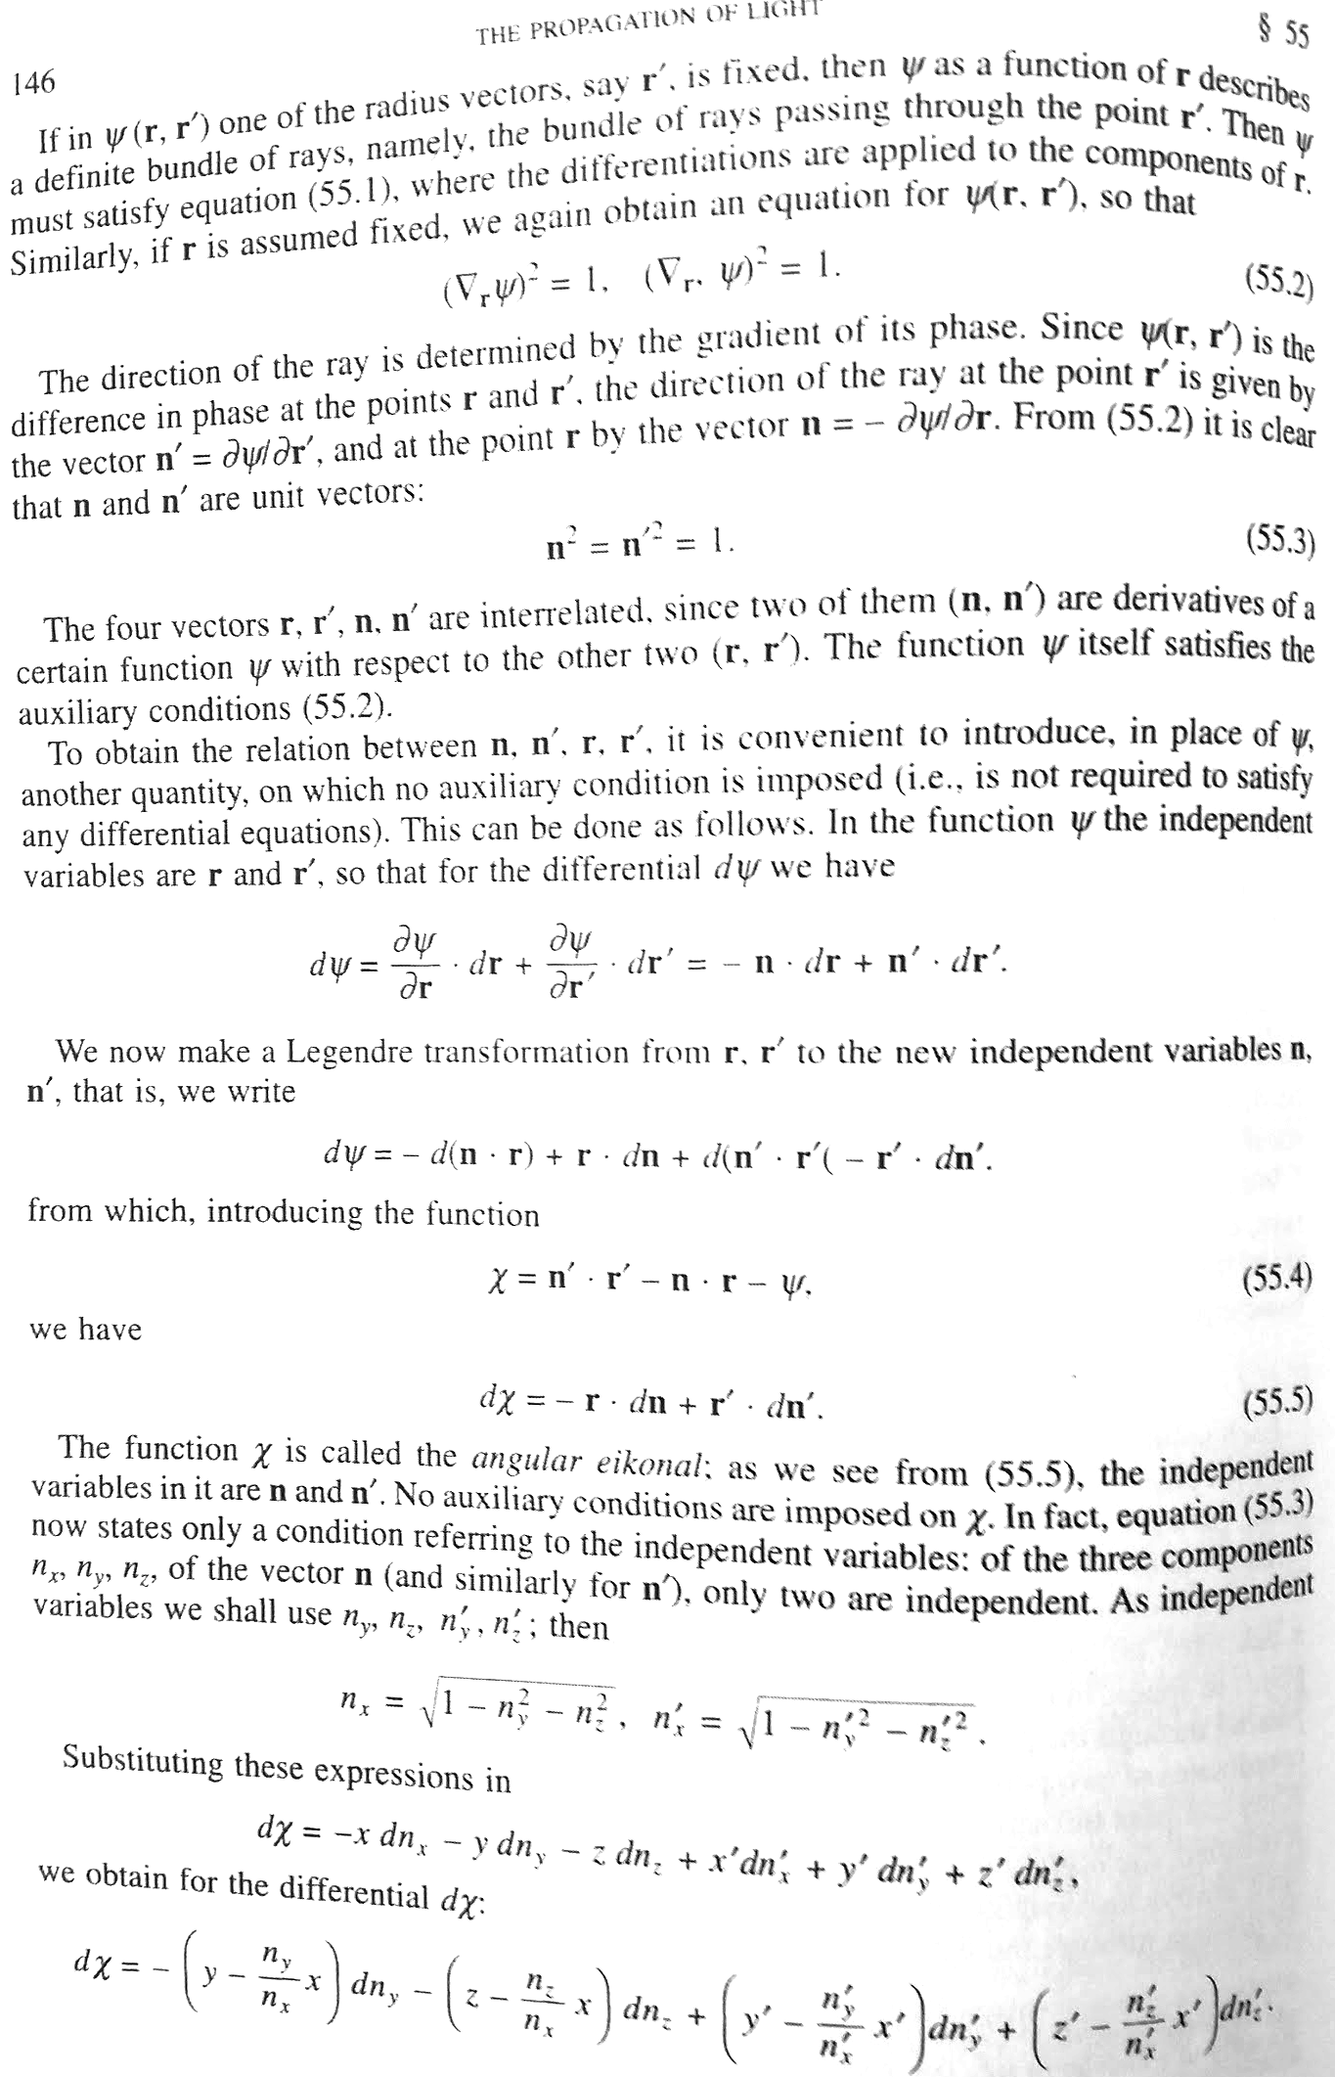
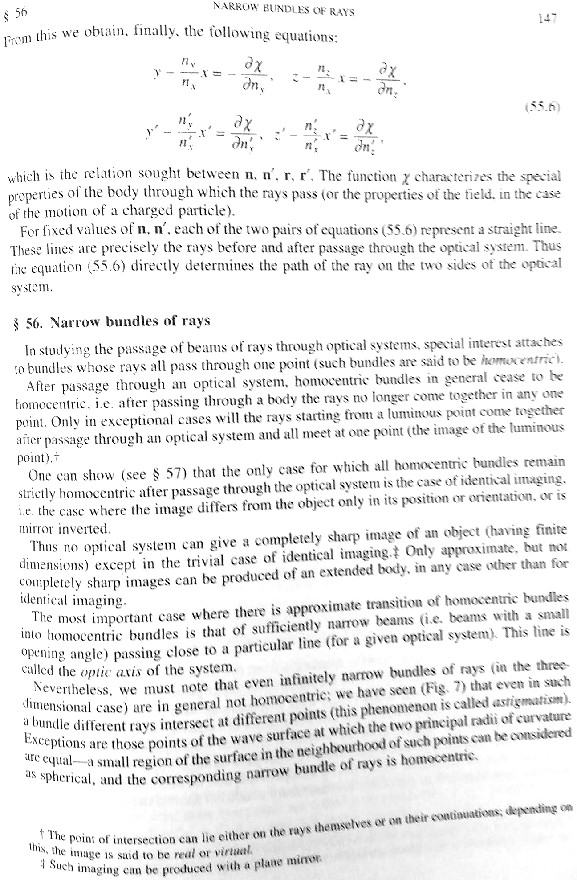
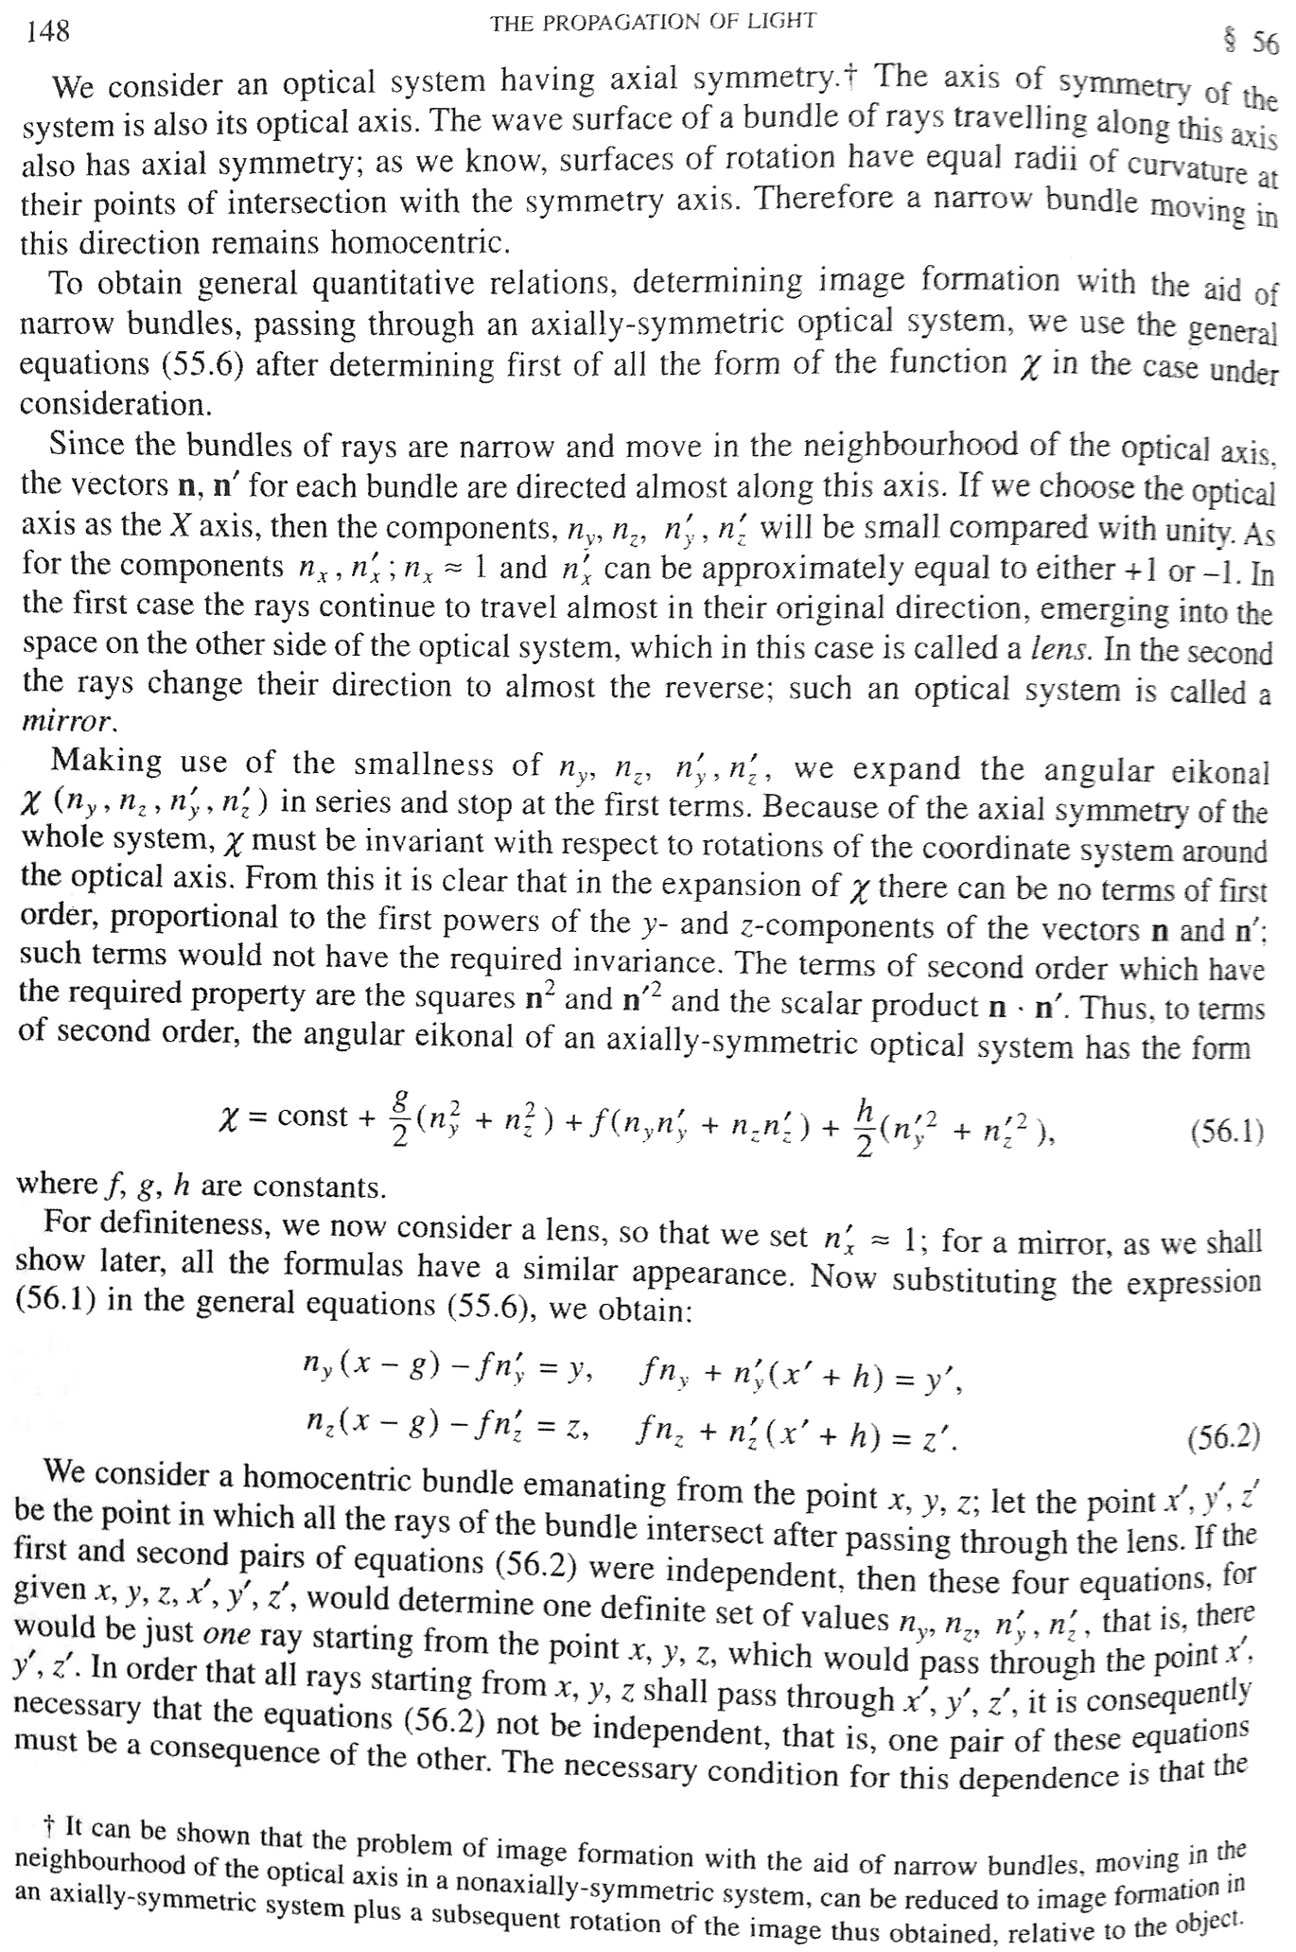
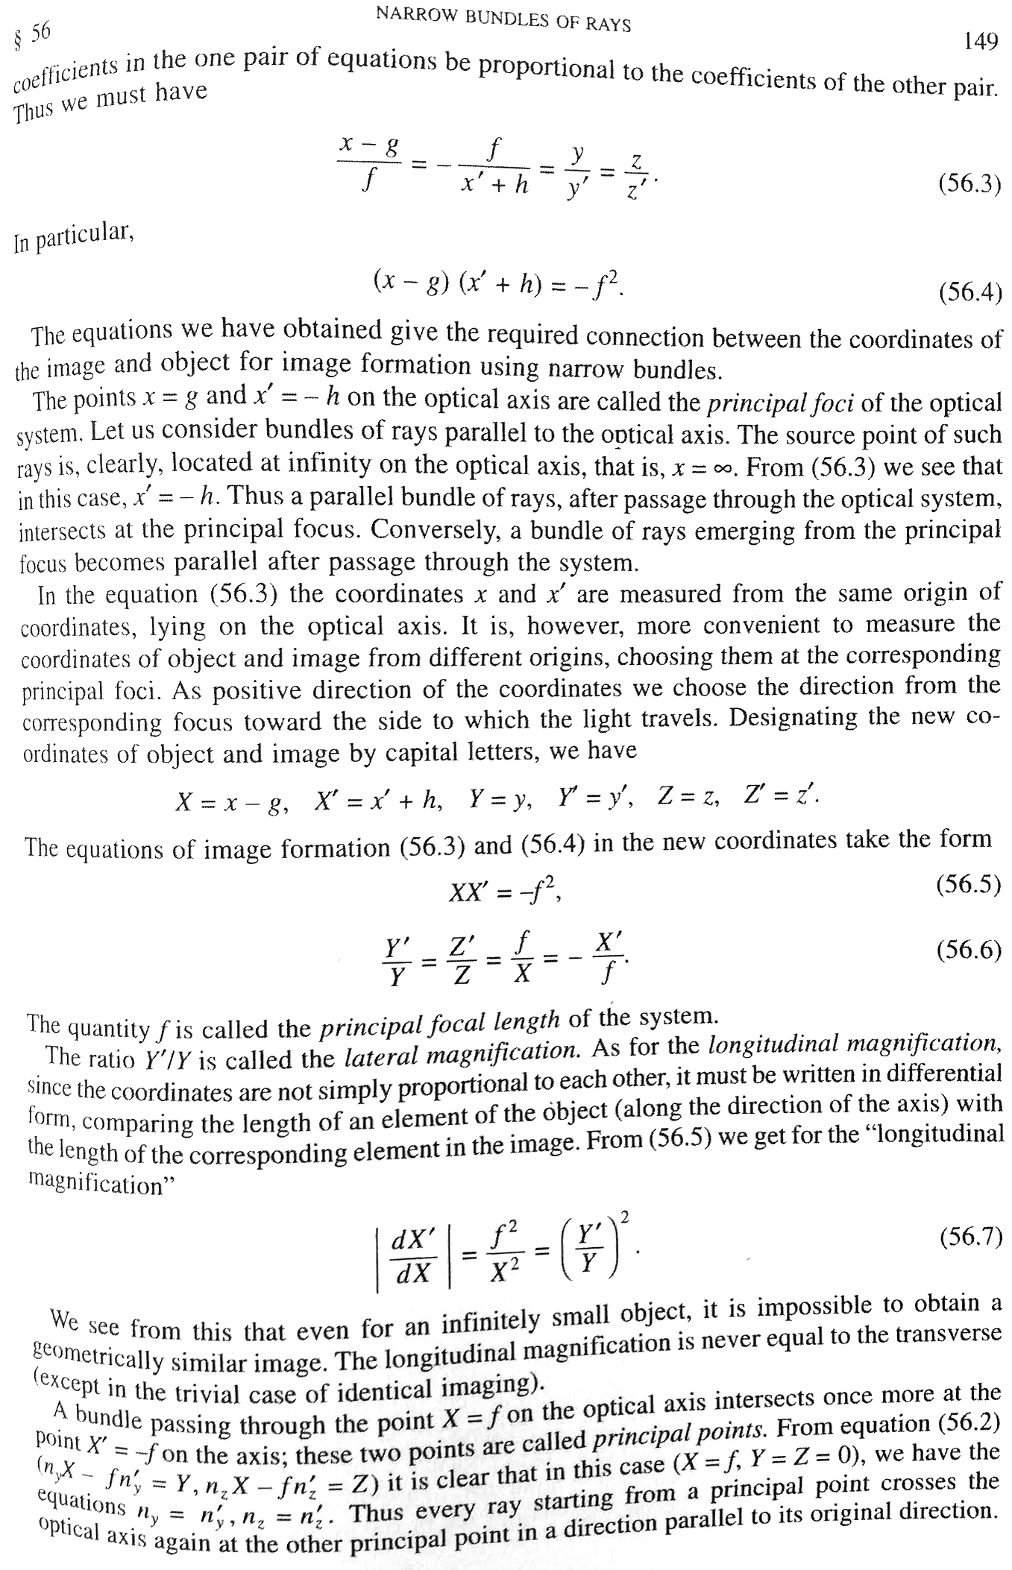
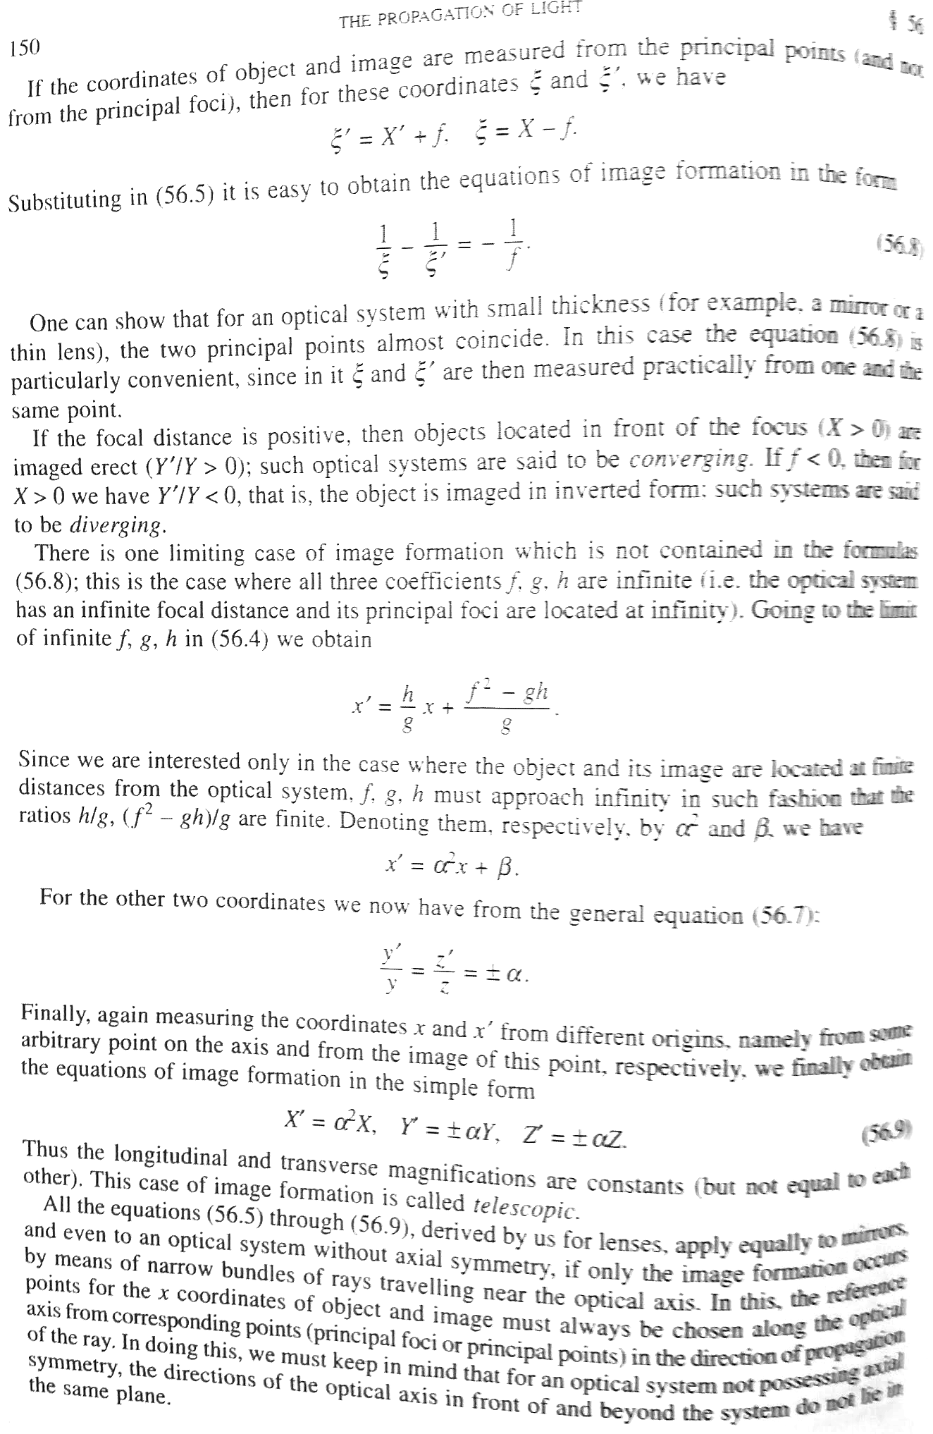
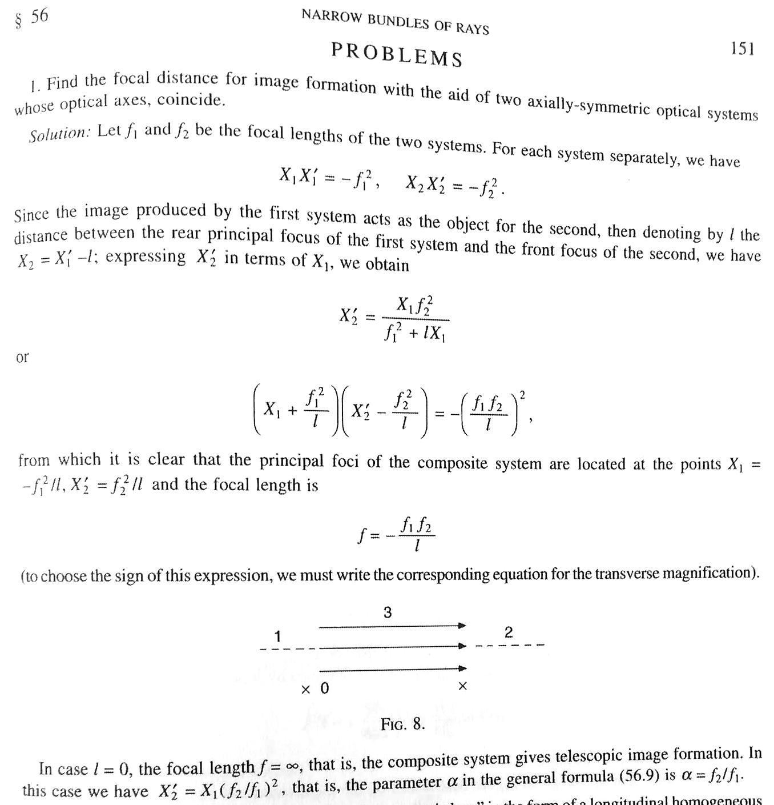

Details of solution to Problem 1
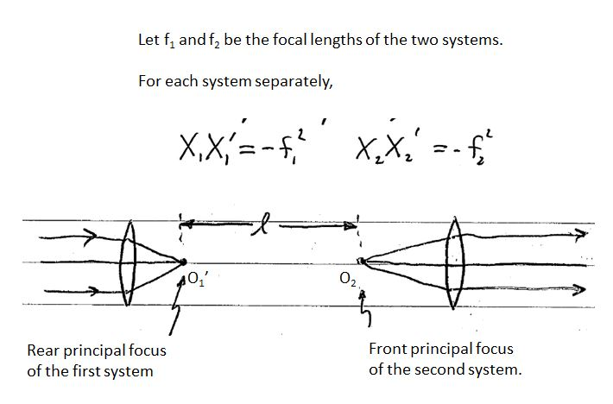

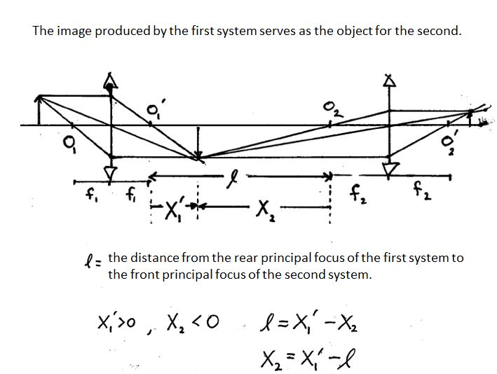

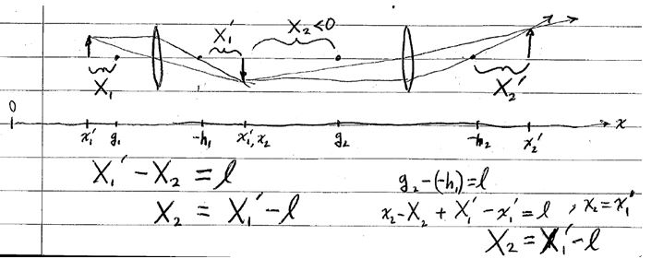

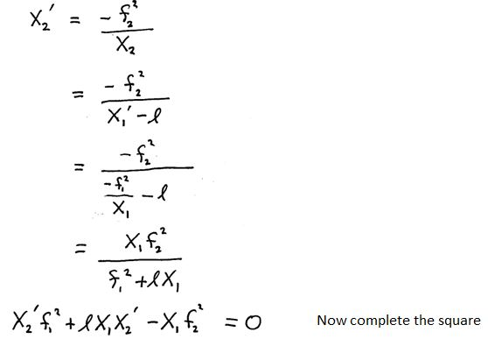
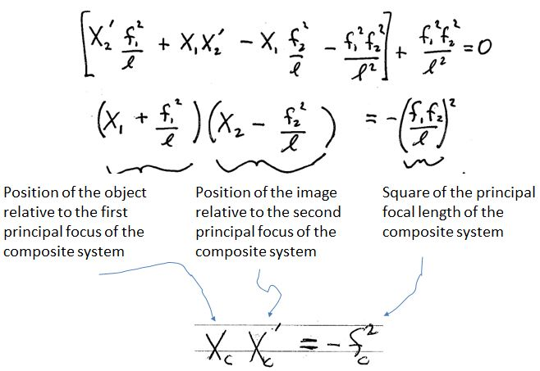
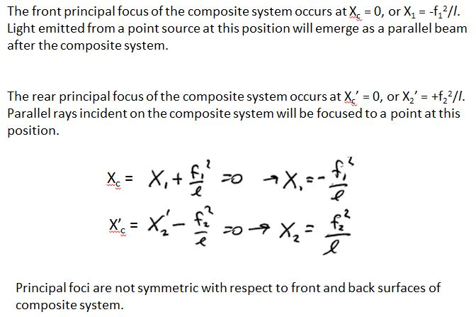
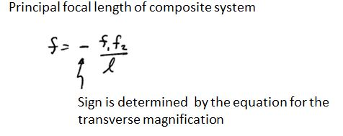

Appendix B

Example Results collected by Alex Terseck (2015).

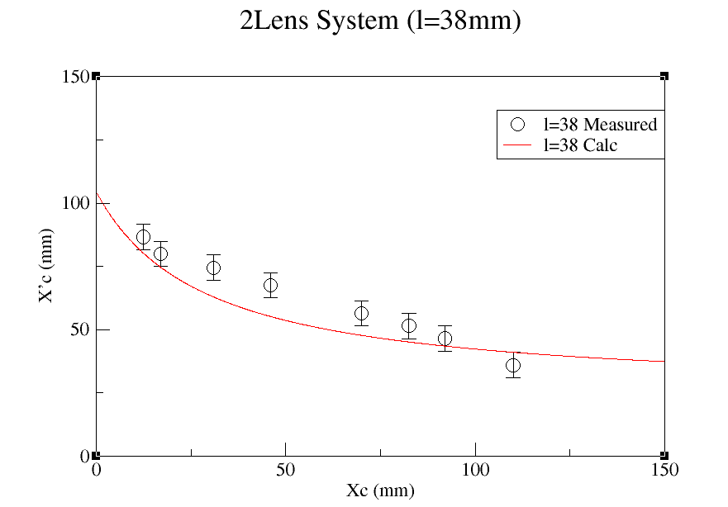
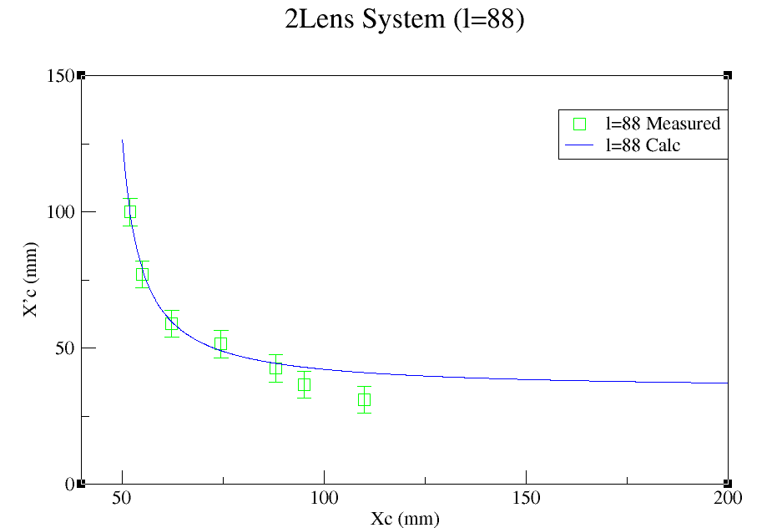

Inividual lenses had focal lengths of 33 and 55 mm. The data collected is compared with calcluations executed in Fortran. The data are agree better for larger the larger l and for smaller X_{C}, which makes X_{C}’ larger and easier to measure accurately.

Fortran Code:
c program in Fortran 77
c Optics

implicit real(a-h,o-z)
parameter (n=1500)
double precision x2,xi,xf,f1,f2,l,fc,s1,s2

f1 = 33.0d0
f2 = 55.0d0
xi = 0.0d0
l = 38.0d0
fc = (f1*f2)/l
s1 = (f1*f1)/l
s2 = (f2*f2)/l

write(6,*)fc,s1,s2

do i = 1,n

xf = (fc*fc)/(xi-f1-s1)
x2 = xf + s2
xi = xi + 0.1
write(7,*)xi,x2
end do

stop
end

