Electrodynamics II Exam 4 problems
Section 75.
- Determine whether intrinsic semiconducting Ge (relative permittivity=16, resistivity = 40 ohm-cm) behaves like a metal or a dielectric for photon energies below its band gap (λ_{g}=2 μm). This problem requires you to determine the appropriate Maxwell equation in SI units.
- Determine whether the semiconductor Si (relative permittivity = 11.7), which is sufficiently heavily doped to give it a resistivity of 0.01 ohm-cm, behaves like a metal or a dielectric for mm-waves. What about for 1 ohm-cm at cm wavelength? Would this material make a good window for a microwave transceiver?
- See “Scanning Fabry-Perot filter for terahertz spectroscopy based on silicon dielectric mirrors,” J. W. Cleary, et al. in Terahertz and Gigahertz Electronics and Photonics VI, edited by K. J. Linden, L. P. Sadwick, Proc. SPIE 6472 (2007). How was the present section in your text used in this paper?

Section 77.
- Suppose that the time-varying monochromatic fields in a dielectric are small. For slowly varying fields we assumed D = ε(0)E with the static value of permittivity ε(0), but more generally we should use ε(ω) = 1 + ∫₀∞ f(τ) e^{iωτ} dτ, where τ is the interval of time from the present to some moment in the past. In order for ε(ω) to equal ε(0), what must we take for the function f(τ)? What is the physical significance of this choice?
- Determine the frequency-dependent permittivity of a metal for the low-frequency limit in SI units.
- Which curve is a probable permittivity for a metal and why?
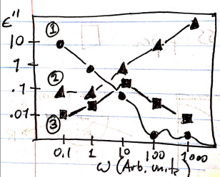

Section 78
- Determine the limiting form of the high frequency dielectric constant in SI units. Plot this function vs. frequency for a metal with electron concentration 10²² cm⁻³ over a physically meaningful range of frequencies. Determine the “plasma frequency” and find a numerical value for the corresponding wavelength. What part of the electromagnetic spectrum does this correspond to? Is ε(ω)>1? See Sections 6 and 14 and discuss your answer.
- At high frequencies, the permittivity approaches unity according to ε(ω) = 1 – ω_{p}²/ω², where ω_{p} is the plasma frequency. Generally, we also have ε(ω) = 1 + ∫₀∞ f(τ) e^{iωτ} dτ, as in the previous problem. For times τ from the present out to at least a few periods of oscillation for the monochromatic fields into the past, determine and sketch a possible function f(τ) that gives correct form for the high frequency permittivity.
- Glass (SiO₂) is transparent up to near-UV frequencies, where electronic absorption of electromagnetic radiation begins. Make a theoretical estimate of the wavelength (numerical value in nm) at which glass begins to be transparent again as frequency is increased beyond the near-UV. What part of the electromagnetic spectrum does this wavelength fall within (near-UV, far-UV, soft x-ray, hard x-ray, γ-ray)? Assume that there are 10²² atoms/cm³, determine and use the average number of electrons per atom (Z_{O} = 8, Z_{Si} = 14), m_{e} = 9.1 x 10⁻³¹ kg, ε₀ = 8.85 x 10⁻¹² C²/N-m², e = 1.6 x 10⁻¹⁹ C.
- Using the Drude Model for the permittivity of free-electron metals, ε = 1 – ω_{p}²/ω²(1+i/ωτ)], the plasma frequency ω_{p} and relaxation frequency 1/τ from Ordal et al. Applied Optics 24, 4493 (1985), determine the range of wavelengths for which (77.9) is valid. Use and plot | ε’| and ε” for gold as a concrete example.
- The plot presents real and imaginary parts of the permittivity for heavily-doped p-type silicon of different carrier concentration, as indicated in the legend. From both the curves and the concentration values, determine the plasma frequency in each case. Do the Re[ε] curves follow the relation (78.1)? Are the Im[ε] curves doing what you expect in terms of sign and limits (explain)? Data from “Infrared surface plasmons on heavily doped silicon,” Monas Shahzad et al., J. Appl. Phys. 110, 123105 (2011).
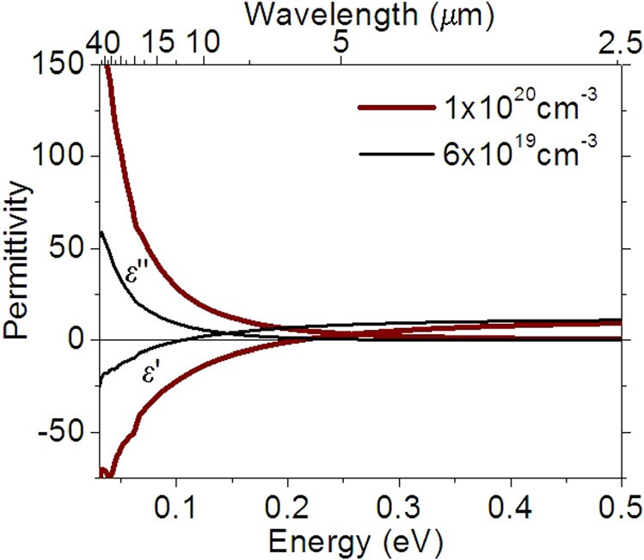
- The plots present real and imaginary parts of permittivity for the semimetal Sb. What is the plasma frequency? What is the carrier concentration? Do the curves follow the relation (78.1)? Is the Im[ε] data doing what you expect a long wavelength? What does the bump at around 2 microns suggest? Data from “Infrared surface polaritons on antimony,” J. W. Cleary et al., Optics Express 20 (3), 2693-2705 (2012).

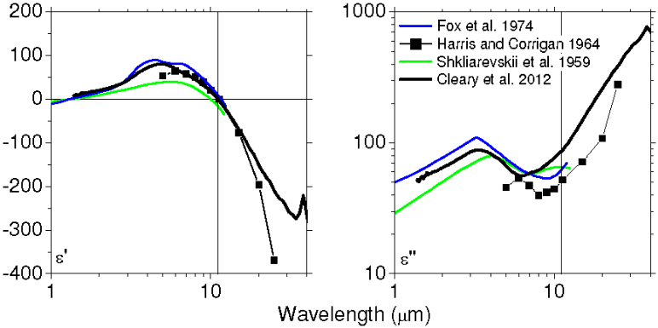

- Permittivity spectrum of the semimetal Bi from “Infrared surface polaritons on bismuth,” by Farnood Khalilzadeh-Rezaie, et al., J. Nanophotonics 093792-1 (2015). From the data, estimate the plasma frequency of bismuth. Then look at the paper and discuss the subtleties of that estimate.
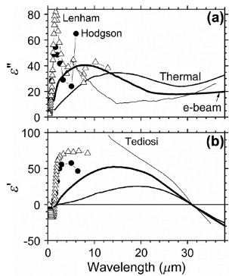

Section 80.
- Derive the formula for the energy dissipation in a non-monochromatic field which tends sufficiently rapidly to zero as t→ ± ∞ in SI units.
- Show that d(ωε)/dω = ε(1+dlnε/dlnω). If ε(ω) varies slowly with ω, argue from this that dωε/dω is approximately equal to ε. In this case, the Brillioun correction to the field energy is small.
- In the high frequency limit of the permittivity, above the plasma frequency, show that the medium is transparent, so that the EM fields freely penetrate the medium. Show that by the (incorrect) static form of the energy density, there would be no electric contribution near the plasma frequency. What is the correct contribution according to the Brillouin formula?
- Find and summarize the paper by L. Brillouin (1921) that presents formula (80.12).

Section 82
- The spectrum shows real data for the semiconductor CdS. The peak corresponds to loss due to absorption by optical phonons in the material. Assuming this is the only loss in the media, i.e. ignoring the fundamental optical absorption at the band gap, estimate the static dielectric constant. Why might your value differ from the accepted value of ε_{CdS} = 8.9?
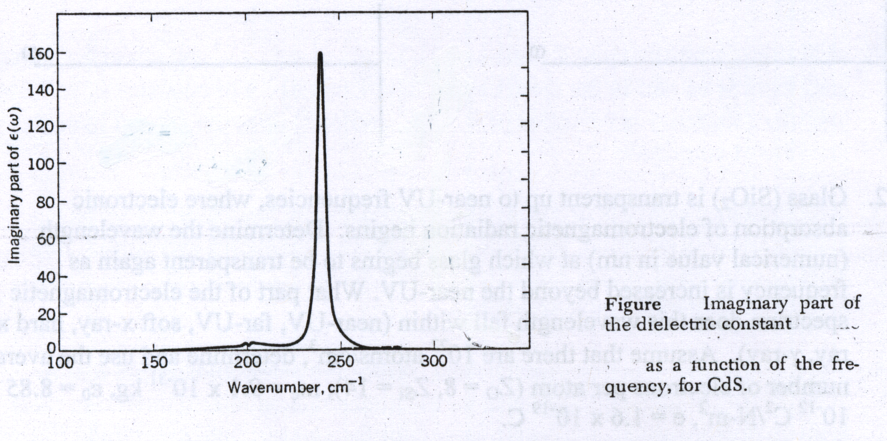
- For a monochromatic electric field in a dispersive medium, write the general expression for the frequency dependent electric susceptibility κ(ω). What is the limit of κ(ω) as ω → infinity? What is the high frequency limit of the dielectric polarization P?
- Write Newton’s equation for the motion of the i^{th} electron bound in a molecule with resonant frequency ω_{i} and with a damping force –mγ_{i}(dr/dt), driven by a monochromatic electric field. Find the amplitude of motion in terms of m, ω, ω_{i}, γ_{i}, and the driving force. What is the molecular polarizability? If there are N molecules in the substance per unit volume, Z electrons per molecule, what is the total electric moment? What is the polarization? What is the electric susceptibility κ(ω)? What is the frequency dependent permittivity? What are ε’ and ε’’? What is the oscillator strength in the frequency range dω?
- Suppose a generalized susceptibility, or response function, α has the following properties. The poles of α(ω) are all below the real axis; the integral of α(ω)/ω vanishes when taken around an infinite semicircle in the upper half of the complex ω-plane. (It suffices the α(ω) -> 0 uniformly as |ω| goes to infinity; The function α’(ω) is even and α”(ω) is odd with respect to real ω. Show that α(ω) = (1/πi) P Integrate[α(x)/(x-ω), {x,-Infinity, Infinity}]. Find the Kramers-Kronig relations by equating Re and Im parts.
- The response of any linear passive system can be represented as the superposition of the responses of a collection of damped harmonic oscillators. Let the response function α(ω) = α’(ω) + i α”(ω) of the collection of oscillators be defined by xω = α(ω)F_{ω}, where applied force F is Re[F_{ω}e^{-iwt}] and the total displacement x = Re[x_{ω}e^{-iωt}]. From the equation of motion with damping coefficient γ show that the complex response function is α(ω) =(1/m)/[ω₀² – ω² - iωγ].
- Consider a gas of free electrons in the limit as the collision frequency goes to zero. Show that the response function is α(ω) = (-1/mω)[1/ω – iπ δ(ω)] and that this satisfies the Kramer’s Kronig relation for α’. Hint: Start from section 82 extra problem 5, take the appropriate limit, and use the Dirac Identity Lim_{γ->0}[1/(ω+iγ)] = [1/ω – iπ δ(ω)].
- Show why the generalized susceptibility, or response function, of a linear passive system is (apart from a constant factor) ε-1 and not ε, where ε is the complex permittivity.
- Show how (82.2) may be written as an integral over positive frequencies only.
- In section 86 extra problem, we’ll show that e can be determined from knowledge of normally reflected power R and phase θ for an E-M wave. Reflectivity is easy to measure, but phase is not. Show how θ(ω) can be detemined from an integral over R(ω). Hint: Consider the natural log of r = E₁/E₀ = Sqrt[R(ω) e^{iθ(ω)}] to be a generalized susceptibility, use (82.7), extra problem 82.8, and integration by parts.

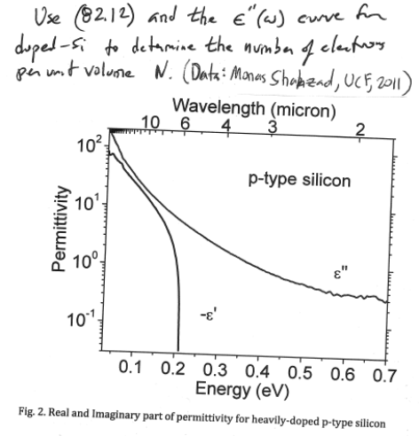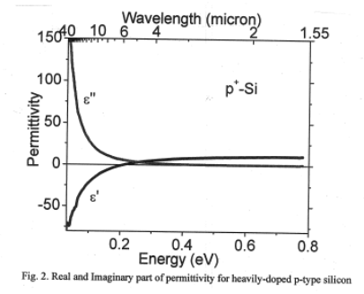
- Find the original paper by H.A.Kramers and R. de L. Kronig 1927 and summarize.
- Refer to the complex frequency plane below. In each numbered region, answer the following. 1) Discuss possible singularities for ε’ here. 2) What happens here to ε for metals? 3) Discuss validity of Eq. 82.1 in this half plane. 4) What is ε (-ω*)? 5) Is ε real, imaginary, or complex on this axis? 6) What is sign of ε” here? 7) What is sign of ε” here? 8) What is ε” for dielectric and metal near the origin? 9) What is the limit for ε as ω’ goes to infinity? 10) What is the limit for ε as ω” goes to infinitiy? 11) What is ε” here, and does it have this value anywhere else? 12) Discuss zeros of ε in this half plane.

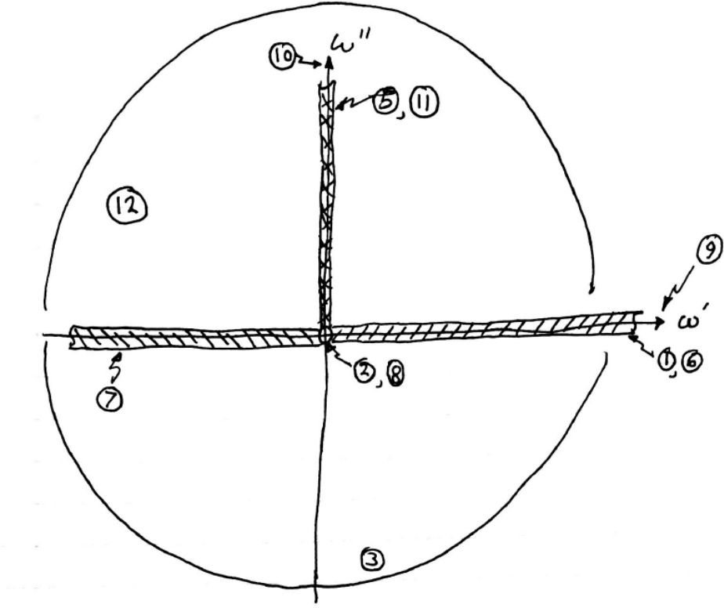
Section 83
- In a non-absorbing homogeneous medium show that complex fields of an electromagnetic plane wave satisfy εE.E* = μH.H* .
- Derive equations (83.9).
- Derive (83.4) from (83.3).
- Derive (83.6) from (83.3), (83.4), and (83.5).
- Derive the expressions for the real and imaginary parts of the complex wavevector for a plane monochromatic wave propagating in a semiconducting or electrolyte solution at a frequency where conduction and displacement currents are comparable, in SI units. Hint: see (75.10).
- A transmittance spectrum is the ratio of the electromagnetic power spectrum with and without the sample in the beam. The transmittance spectrum of a sample of glass doped with Nd³⁺ ions for laser amplifier applications is found to have a sharp absorption line at a wavelength of 1 μm. The optical beam travels a distance of d = 10 cm in passing through the sample from source to detector. At the peak of the line, the transmittance has the value 0.37. Beer’s law, T=e^{-αd} gives the relation between T and the absorption coefficient α. The refractive index in wavelength regions far from the line has the value 1.5. Assume that this value holds at line center also. Find the imaginary part of the permittivity at line center. Is the assumption regarding the refractive index justified?
- An example of an inhomogeneous EM plane wave is a surface plasmon polariton. Find an expression for its wavefunction in the literature.

Section 84
- Consider a dielectric. On the graphs like those below, indicate values of the real and imaginary parts of the permittivity for static fields. Indicate the behavior in the high frequency limit. Sketch possible frequency dependences for the two permittivity functions at intermediate frequencies. What can you say about the sign of ε” and why?
ε’
ω
ε’’
ω

Section 86. Laudau problem 1.
- For reflection at the boundary between two transparent media, show that E₁ = E₀ Sin[θ₂- θ₀]/Sin[θ₂+ θ₀] and E₂ = E₀2Cos θ₀Sin θ₂/Sin[θ₂+θ₀], when the polarization is perpendicular to the plane of incidence.
- Derive the Fresnel Equations when E lies in the plane of incidence (Eqs. 86.6).
- When the media on both sides of an interface are transparent, and the E-field lies in the plane of incidence, find the Fresnel equations (86.7) for the H-field of the reflected and transmitted beams.
- For normal incidence of a plane electromagnetic wave on the interface between two media, find the expression for the reflectivity in terms of the permittivity. If ε₁ = 1 and Sqrt[ε₂] = n₂ + iκ₂, find R. What is R for 10 Ω-cm silicon at 10 μm wavelength? Hint: can conductor losses be neglected?
- For general angles of incidence for a monochromatic wave at the interface between two transparent media, show that the phase change for the transmitted beam is always zero, and find the conditions for when the reflected wave has a phase change of zero or Pi.
- Use a sheet polarizer (polarized sunglasses or a polarizer borrowed from the lab) to experimentally determine the index of refraction of some dielectric (e.g. glass, cement, formica, asphalt). High accuracty is less important than original data taken by you with a clear description of method.
- Derive (86.12).
- Calculate the reflectivity of Ag using (86.8) and data from the figure at λ = 1, 10, and 100 μm. From J. Cleary et al. J. Opt. Soc. Am. B 27, 730 (2010). 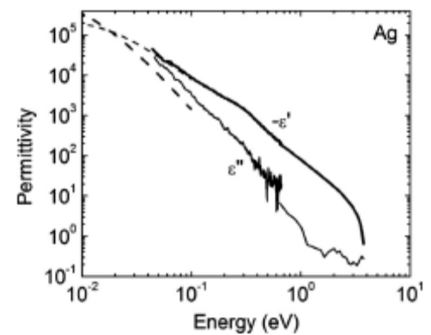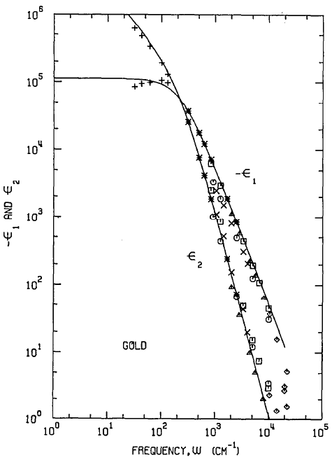
- Show how to determine the complex permittivity from knowledge of the reflectivity and the phase θ(ω) of the wave reflected at normal incidence from a medium.
- Using the permittivity spectra for gold plotted below [from Ordal et al. APPLIED OPTICS 22, 1099 (1983)] determine the complex index of refraction and the normal incidence reflectivity at wavelengths of 1 micron and 100 micron.

Section 87. Landau problem.
- What is the conduction electron mean free path in Cu at 300 K? Around what wavelength is Eq. 87.2 not valid for the surface impedance?
- Show that for non-magnetic metals, the imaginary part of the surface impedance is negative.
- Derive the expression for the reflection coefficient from metal for light polarized perpendicular to the plane of incidence (i.e. Eq. 87.13) in SI units.
- What is the normal-incidence reflectivity of a superconductor and how does it depend on wavelength?
- Find the minimum value of R|| (87.16) and the angle φ₀ where this minimum occurs.
- Show how the complex surface impedance for a metal can be found from a measurement of the normal incidence reflectance and the minimum reflectance angle for R||.
- Show how the complex permittivity in the optical range can be determined from an experimental determination of the complex surface impedance.
- Use the permittivity spectra for gold (see sec 86 problems) to determine its complex surface impedance and the normal incidence reflectivity at wavelengths of 1 and 100 microns. Hint: Express complex values in polar form. You should get for solutions due to the square roots. Only one of these has the right signs.
- For gold a 1 micron wavelength, at what angle of incidence is the reflectivity a minimum. Consider both polarizations. Use complex surface impedance values from Problem 8.
- Find the original paper by M. A. Leontovich (1948) and summarize.

Section 88. Landau problem.
- Derive (88.2).

