**ED1 Exam 2 Problems Fall 2016**

Section 16.

1. Find the scalar and vector potentials of a point charge e moving at constant velocity **V** relative to the lab reference frame. In its own reference frame, the potentials of the charge are ’=e/r’ and **A**’=0. How would you solve for **E** and **H** in the lab frame?
2. Find the scalar and vector potentials of a point electric dipole **p** moving at constant velocity **V** relative to the lab. In its own reference frame, the potentials of the dipole are ’=**p**•**r**’/r’3 and **A**’=0. Express answer in terms of the separation vector between the dipole and the field point in lab coordinates.
3. An ideal magnetic dipole moment **m** is located at the origin of an inertial system K’ that moves with speed V in the X direction with respect to inertial system K. In K’ the vector potential is **A**’= (**m** x **r**’)/r’3, where **r**’ is the location of the field point in K’, and the scalar potential ’=0. Find the scalar potential in the K system in terms of **R**, the instantaneous vector from **m** to the field point in the K system. Let **r** be the location of the field point in K.

Section 17.

1. Derive the vector identity grad(**a.b**)=(**a.**)**b** + (**b.**)**a** + **b** x curl **a** + **a** x curl **b** using the e tensor method.
2. Show that dkin/dt = **v**.(d**p**/dt).
3. A wave packet represented by the potentials **A**(x,t) = f(x-ct) **e**y,  = 0, where the function f(x) approaches zero as x 🡪  , hits an electron (-e, m, **r**0=0, **v**0=0). What are the equations of motion for the three components of v (assuming v <<c)? Show that vz(t) = 0. Show that vy(t) = (e/mc) f(x-ct), where x is the position of the electron at time t. Show that vx (1-vx/(2c)) = (e2/2 m2 c3) [f(x-ct)]2. Describe in words the trajectory of the particle. What is the sign of the displacement along x? What happens at long times?
4. Suppose =0 and **A**=A0 Sin[k x –  t] **e**y. Find **E** and **H**.
5. (a) Express the acceleration of a particle in terms of its velocity and the electric and magnetic field intensities. (b) What does this expression become to first order in (v/c)? (c) Suppose H=0, E=1 MV/m (which might be produced by a big van de Graaf generator), and the particle is an electron initially at rest. How long does it take for the electron to reach a speed of (4/5) c as predicted by the exact relativistic expression and as predicted by the non-relativistic expression?

Section 18.

1. Show that the four potentials Ai = (e/r,**0**) and (0,-cet**r**/r3) give the same fields. Starting from the Lagrangian in terms of these potentials, show that the equation of motion for a charge in fields given by these potentials is the same in each case.
2. The potentials for a point charge at the origin are usually given as Ai = (e/r, 0) in Gaussian units. Make a gauge transformation with f = cet/r. What are the new potentials? Anything surprising, given that this is an electrostatic situation? What are the fields **E** and **H** calculated from the new potentials, and how do they relate to the fields from the old potentials?

Section 19.

1. Consider the vector potential **A**[**r**] = **c** x **r** / 2, where **c** is a constant vector. What is the magnetic field?
2. The vector potential for a spinning sphere (radius a, angular velocity ****) with surface charge density  is (in SI units) **A**(**r**) = (0  a/3) (**** x **r**) for r<a and (0  a4/(3 r3)) (**** x **r**) for r>a. Calculate **B**(**r**) inside and out, sketch the field lines, and describe in words.
3. An electron starts from rest and is accelerated through a region of space with a 1 million volt potential drop. After passing through this region, what is the electron’s velocity? Compare results of classical and relativistic calculations.
4. Suppose the 4-potential is Ai = (0,(A0 a/r) Exp[-r2/a2] **e** in cylindrical coordinates. Calculate the fields **E** and **H**.
5. The 4-potential of a finite uniformly charged wire, length = 2 *l*, =charge per unit length, is Ai=( Log[*l* + Sqrt[r2 + *l*2]/(-*1* + Sqrt[r2+*l*2])], **0**). Find the fields **E** and **H**.
6. Consider the image. What is it? (Hint: “1895”). What particles are emitted by the cathode? What is shown exiting the bulb? At typical high voltage in modern versions of this device is 70 kV. What is the maximum velocity of the particles that hit the anode? Are they relativistic? What is v/c exactly? What is it classically? What is the % difference?



1. What particles are accelerated by the Cockroft-Walton machine from 1928 and used more recently as pre-accelerators? If the maximum accelerating voltage is 1.4 MV, what is the velocity these particles achieve? Is it relativistic? What is v/c exactly? What is it classically? What is the % difference? Explain how the Villard-cascade voltage multiplier consisting of a single transformer, diodes, and capacitors is used to achieve the necessary high voltage.

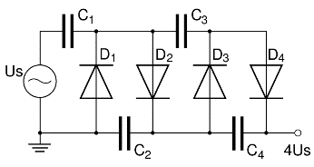

1. The Van de Graff generator can charge its dome up to 7 MV and is used to accelerate ions. Supposing these to be protons obtained by ionizing hydrogen gas, do they reach relativistic speeds? What speeds do they reach? What is v/c exactly? What is v/c classically? What is the % difference?

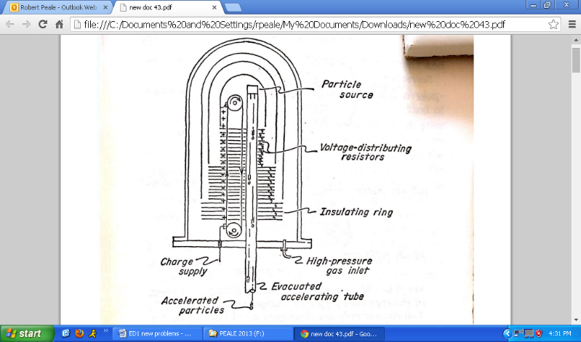 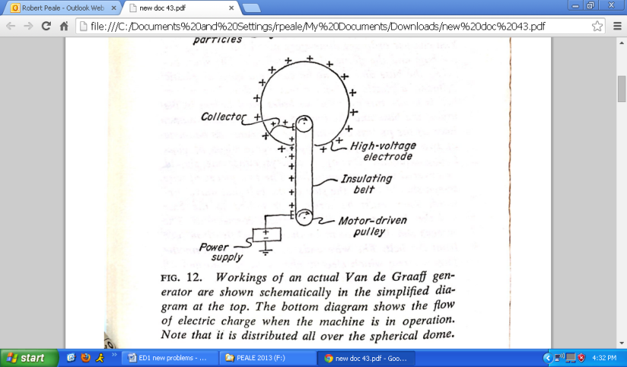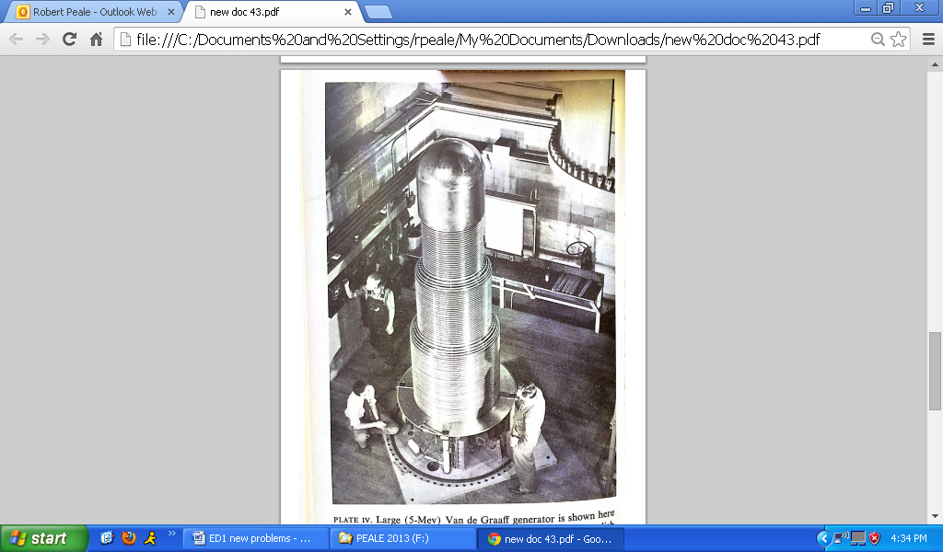

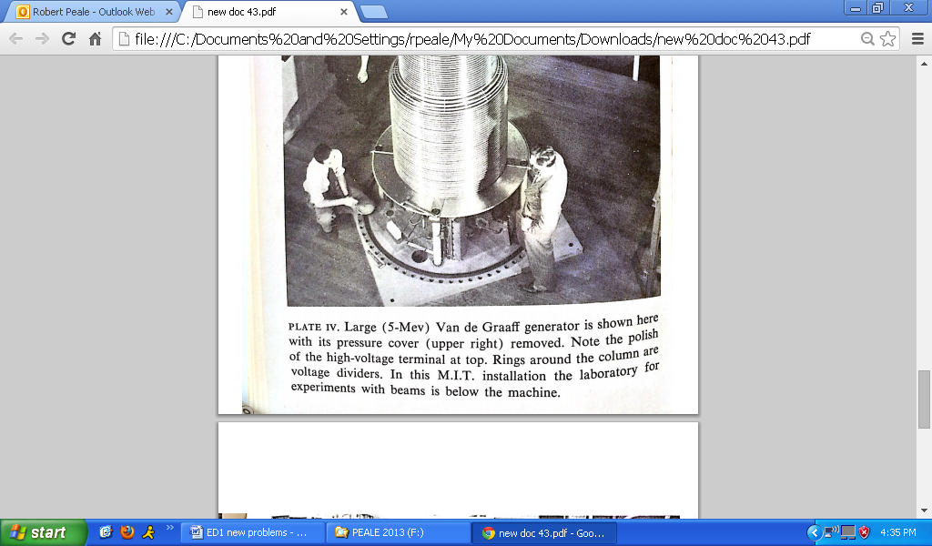

1. The tandem van de Graff gives twice the energy to ions as does the simple van de Graff. If the electrostatic potential achieved is 7 MV, what is the velocity that protons achieve. What is v/c exactly? What is v/c classically? What is the % difference?



1. In the linear particle accelerator (LINAC), the acceleration happens in the space between accelerating tubes, which are oppositely biased by being 180 deg out of phase in the applied AC. By accelerating the particles in a series of small steps, high energies can be achieved without high voltages. Particles travel at constant velocity inside the drift tubes. How many sections are needed to achieve a final proton energy of 20 MeV if the amplitude of the 20 MHz applied AC is 500 kV? What is the length of the final tube, and how much longer is it than the one previous?



1. An early Stanford LINAC accelerates electrons to 600 MeV. What velocity do the electrons achieve? How many sections do we need now if the voltage amplitude is 500 kV? What is the length of the final tube, and how much longer is it than the previous one? The more recent Stanford LINAC accelerates electrons to 50 BeV. What would be the most obvious design difference with the earlier one?

Section 20.

1. Assuming an electron starts from rest, how long does it take for it to become relativistic (say v = 0.9 c) in an E-field of 100 kV/m? How far will the electron have traveled during this time? (Hint: add constant of integration to assure initial condition is satisfied.) How far would the electron have gone according to classical physics?
2. Consider an electron starting from y = - infinity with momentum p0. For y>0 it encounters a uniform electric field **E** = 100 kV/m **e**x. Plot and compare exact and classical trajectories for p0 = 10 mc, mc, and mc/10 for distances traveled in the x direction for which vx remains below 0.9 c (see previous problem). Comment on the differences in each case.
3. A lens for focusing a beam of ions is shown in the figure. It consists of a slit in a metal plate of thickness d. The slit is long in comparison with its height y0. It separates a region in which the electric field is E1 from a region in which the electric field is E2. An ion beam originating from a focus at a distance x1 to the left of the lens is refocused at a distance x2 to the right, where x1 and x2 >> y0. The voltage through which the ions were accelerated before reaching the lens is V0 >>E1x1 and E2x2, which allows us to take the trajectory as a straight line except inside the slit. Note that by symmetry, the transverse field is zero at the center of the slit y=0. (a) Find the transverse electric field Ey near the center of the slit using div(**E**)=0 and approximating Ey as linear in y. (b) Find the transverse force Fy acting on an ion of charge e that enters the slit at height y, determine the net impulse p given the ion, and find the deflection angle  = p/p. (c) Show that for non-relativistic ions, 1/x1 + 1/x2 = (E2-E1)/2V0, which is a thin lens equation for ion beam focusing.



Section 21.

1. Consider a proton with kinetic energy 10 MeV (which does not include the proton's rest energy) in a magnetic field of 1 T. Is the proton relativistic? Calculate the cyclotron frequency and the radius of the orbit. Repeat the calculation for an electron with energy 50 GeV, such as are produced at CERN.
2. A magnetic quadrupole field can be used as a focusing field for a charged particle beam. The cross section of the pole faces is shown in the figure. The pole faces are hyperbolas of the form xy = constant. There are two north poles and two south poles, marked on the figure. The dimension of the magnet perpendicular to the cross section is *l*. The magnetic field in the region 0<z<*l* is **H**(x,y,z)=h(y **e**x + x **e**y), in which h > 0; the field is 0 for z<0 and z>*l*. Particles enter from negative z with velocity **v0** = v0 **e**z and are deflected by the force **F** = (e/c) **v0** x **H**. Neglect the small components vx and vy in calculating the force. (a) Sketch the **H** field lines in the xy plane. (b) Explain qualitatively why **H** gives focusing in the **x** direction and defocusing in the **y** direction, assuming the beam particles are positively charged. (c) Write the equations of motion for a beam particle with charge e and mass m, using the approximate force given above. Solve for x as a function of z for z>0, assuming x=x0 and vx=0 at z = 0. Sketch a graph of x (z).



1. The figure shows the essential features of an early mass spectrograph of A. Dempster. Singly positive ions enter the vacuum chamber vertically through the slit, after having been accelerated through a voltage of 20.0 kV. Their paths are bent by the magnetic field **B** and they are deposited a distance s from the slit on a photographic plate. (a) If s = 25 cm for ions of Samarium with mass number 150, i.e., 150Sm62, what is B? (b)What is the range of s for the stable isotopes of Sm, whose mass numbers range from 144 to 154?



1. The magnetron is a vacuum-tube device that is used to generate ultra-high frequency currents in microwave sources, like microwave ovens or radar transmitters. The frequency range is 109 Hz to 1011 Hz. A schematic design for a magnetron is shown in the Figure. An electron bunch circulates in a constant magnetic field B, passing electrodes at opposite ends of a diameter of the orbit. The potential V at either electrode oscillates with the distance from the electron bunch. (a) Determine the frequency of the alternating potential. (b) Determine B for a microwave frequency of 1010Hz.



1. A beam of hydrogen isotopes enters a mass spectrometer. The protons and deuterons have been accelerated from rest by a potential drop V0. The radius of the proton orbit is 10 cm. Calculate the radius of the deuteron orbit.
2. The equations of motion of a charge e in a magnetic field H0 **e**z are dx/dt=vx, dy/dt=vy, dvx/dt=vy, dvy/dt=-vx where  = eH0/m in SI units. Solve the equations numerically on a computer. Set =1 and take initial values (x0,y0,v0x,v0y)=(1,0,0,1). You might integrate the equations stepwise for a small time step. Or, more simply, use an analytic computer program with a built-in differential equation solver. Plot the trajectory, i.e. x(t), y(t) as a function of t. It should be a circle.
3. The typical trajectory of a charged particle in a uniform magnetic field is cyclotron motion. The magnetic force pointing toward the center F = e (v/c) H provides the centripetal force, but this does NOT equal m v2/R as in classical mechanics. (a) What does it equal in terms of p, v, and R? (b)Show that the classical expression is recovered when v<<c. (c) Find the momentum p in terms of e, H and R. (d) How does it compare to the classical expression?
4. An ion moves in a helical path around the axis of a long solenoid wound so that the ion encounters a region in which the field intensity increases gradually from H1 to H2. Derive the condition that the ion will be reflected somewhere in terms of H1, H2, and the longitudinal and transverse momentum components.
5. Determine the frequency of vibration of a charged spatial oscillator, placed in a constant uniform magnetic field; the proper frequency of vibration of the oscillator (in the absense of the field) is 0. Estimate the change (absolute and relative) in the vibrational frequency of the CO2 molecule (2350 cm-1) due to a magnetic field of 1 T. (In S.I. units the cyclotron frequency (21.8) becomes eB/m.) What spectral resolving power / would be needed to observe your estimated shift, and is this available in commercial infrared spectrometers?
6. The inner van Allen belt traps a lot of cosmic ray protons, and even some antiprotons, as discovered recently by the satellite-borne spectrometer PAMELA (see Physics Today Oct 2011). Trapped protons have energies up to a few GeV. Is a 3 GeV proton relativistic? The altitude of the inner van Allen belt is 10000km at the equator. What is the magnitude of the Earth’s magnetic field there if the field surface-field at the equator is 0.5 G (see section 44 for dipole field)? If the angle between the proton’s momentum and the local magnetic field lines at the equator is close to 90 deg, what is the frequency of the helical motion in Hz for a 3 GeV proton? What is the radius of the helical motion? What is the radius for a 1 GeV proton? PAMELA accesses the inner van Allen belt only near the magnetic pole at an altitude of ~600 km. What is the magnetic field there? What is the radius of helical motion in this region for 1 GeV protons? Describe qualitatively the nature of the proton motion over long times.



1. A proton of velocity 107 m/s is projected at right angles to a uniform magnetic induction field B of 0.1 T. How much is the particle path deflected from a straight line after it has traversed a distance of 1 cm? How long does it take for the proton to traverse a 90 deg arc?

Section 22.

1. (a)Use a computer program to plot the cycloid curve in the xy plane given by x = t-Sin[t], y = 1-Cos[t]. (b) For a charge e moving in orthogonal E and H fields, starting from rest at the origin, plot the kinetic energy as a function of time. (c) Plot also modified functions as in (a) that give trochoid curves as in section 22, Fig. 6 a&b.
2. The experiment by which Thomson discovered the electron consisted of a cathode ray passing between parallel capacitor plates in a uniform magnetic field. The electrons travel parallel to the plates and B is perpendicular to both E and v. Derive the condition (in S.I. units) relating the potential difference V0 between the plates and the magnetic field strength, along with any other relevant parameters, such that the cathode ray is undeflected, assuming the cathode ray is a beam of electrons. This is the principle of the velocity selector in a mass spectrometer. A Bainbridge mass spectrometer includes a velocity selector in the vacuum chamber through which the positive ions pass. The selector uses a horizontal E-field and the same B field that bends the path of the ions in the spectrograph proper. What is the mass of the ions that impinge on the photographic plate a distance s from the slit?
3. The equations of motion (SI units) of a charge e in crossed electric and magnetic fields E0 **e**y and B0 **e**z for motion with vz=0 are dx/dt=vx, dy/dt=vy, dx/dt=vy, dvy/dt=a-vx, where =e B0/m and a = e E0/m. Solve the equations numerically on a computer. For illustration purposes choose units with =1 and a=1. If the particle starts at rest at the origin the trajectory is a cycloid. Explore what happens for different initial values of v0x, both positive and negative, keeping v0y=0. Explain why if v0x = 1 (in these units) the particle moves in a straight line.
4. (This is Landau problem 1.) Determine the relativistic motion of a charge in parallel uniform electric and magnetic fields. Sketch the motion and discuss qualitatively. (This is the configuration of fields and characteristic motion of relativistic electrons in a vacuum gyrotron, a high power microwave source.)

Section 23

1. Determine the components of the electromagnetic field tensor from its definition Eq. (23.3).
2. Show that the space components for the equation of motion (23.4) give the relativistic Lorentz force law. Show that the time component of the equation of motion (23.4) gives the work equation.
3. Find the tensor Fik  (1/2) eiklmFlm that is dual to the electromagnetic field tensor Fik.
4. Show that uiFikuk = 0.
5. Complete the entries in the electromagnetic field tensor below. What scalar is found from the product of the electromagnetic field tensor with itself, i.e. FikFik=? How does this change when one changes between different inertial reference frames?

             ⬆0 -Ex -Ey -Ez 

Fik = ⇦ -Hz Hy ⇦

             ⇦ -Hx ⇦

                     ✗

1. Determine the relationship between the Lorentz force law and the energy equation, starting from the 4-D equation of motion.

Section 24

1. Derive the Lorentz transforms for the components of **E** and **H** equations (24.2) and (24.3). What are the Lorentz transformations of the fields in SI units? Verify their vector form (24.4) when V<<c.
2. Derive the relation (24.5) between **H** and **E** when **H**’ = 0 in the K’ system. Derive the relation (24.6) between **E** and **H** when **E**’ = 0 in the K’ system.
3. Show that if **E**  **H** are perpendicular in some system K and E>H, that there exists a system K’ where the field is purely electric and the velocity of that system relative to K satisfies **V****E**, **V****H**, and V=cH/E. Show that if EH in some system K, and E<H, there exists a system K’ where the field is pure magnetic, with **V****E**, **V****H**, and V=cE/H.
4. An observer at rest in inertial frame K finds himself to be in an electric field E = (0,E,0) with no magnetic field. An observer in K’ moving along the common X, X’ axes with speed V finds electric and magnetic fields **E**’ and **H**’. Find these fields and show that **H**’ = (-1/c) **V** x **E**’, which is (24.5) with **V**🡪-**V**.
5. Two large non-conducting parallel plates, separated by a distance d and oriented perpendicular to the Z axis move together along the X axis with velocity V, which is not necessarily small compared with c. The upper and lower plates have uniform surface charge densities + and – respectively in the rest frame K’ of the plates. Find the magnitude and direction of the electric and magnetic fields between the plates according to an observer in the lab frame K (neglecting edge effects).
6. In the lab, an electron moves with constant velocity ***v*** in crossed ***E*** and ***H*** fields. What are the fields and force on the electron in its rest frame?

Section 25

1. What scalar is found from the product of the electromagnetic field tensor with itself, i.e. FikFik=?
2. Show that the product of the electromagnetic field tensor Flm with its dual (1/2) eiklmFik is a 4-divergence.
3. What pseudoscalar is found from the product of the electromagnetic field tensor with its dual tensor, i.e. F lmFlm=?
4. Derive the Lorentz transform for the complex vector **F** = **E** + i**H** in the form (25.6).
5. The axes of frame K’ are aligned with those of frame K. K’ moves with respect to K along the common X,X’ axis with speed V. In K there is a uniform electric field **E**=[0,E,0] and a uniform magnetic field **H**=[0,0,H]. Show that it is possible to choose H so that the field in K’ is entirely magnetic with magnitude (H2-E2). What is the direction of **H**’ in K’? What is the relation between the chosen H value and the values of E & V?
6. Determine the velocity of the system of reference in which the electric field **E** and magnetic field **H** are parallel. In the lab you connect a battery to some parallel plates, then stick these between the poles of a magnet, such that the field strengths are E=1V/cm and B=0.1 T, while the field vectors are at 30 degrees with respect to each other. How fast do you have to run to make the fields appear parallel to you? (To convert your formula from the first part to SI units, make the substitution H🡪cB.)
7. Show that the equation **F** = **E** + i **H** = a **n**, where **E** and **H** are given, a is complex, and **n** is a complex unit vector, gives 8 equations for 8 unknowns.
8. If = **F** = **E** + i **H** = a **n** = (a’ + i a”)(**n**’ + i **n**”), and by choice of coordinates **n** is real, show that **E** and **H** are parallel.

Section 26.

1. (a) Show from the definition of the electromagnetic field tensor that Zikl  Fik/xl + Fkl/xi + Fli/xk = 0. (b) Show that Zikl is antisymmetric in all three indices. (c) Show that Zikl is non-zero only when all three indices are different. (d) What 4 equations for **E** and **H** components are obtained by setting i=0,1,2,3 in Zikl=0? (e) The 4-vector eiklmFlm/xk = 0 is dual to the rank 3 tensor Zikl = 0 and gives the same Maxwell equations (26.1) and (26.2), i.e. the first two Maxwell equations. Find the equation results from setting i=1.
2. There is a time dependent current Is(t) in a long and densely wound solenoid. (a) Determine the electric field at radius r on the midplane of the solenoid, both inside and outside the solenoid. (Hint: The direction of E is azimuthal; use the Amperian loop trick.) (b) From your result of (a) calculate the curl of **E** at radius r.
3. A long straight wire carries an alternating current I(t) = I0 Cos[ t]. Nearby is a square loop. The wire lies in the plane of the loop, parallel to two sides of the square, which are at distances a and b from the wire. (The side of the square is b-a.) Determine the current induced in the square loop if its resistance is R.
4. A circular loop of wire with radius a and electrical resistance R lies in the xy plane. A uniform magnetic field is turned on at time t=0; for t > 0 the field is H(t)=(H0/Sqrt[2]) **(ey+ez**) (1-Exp[- t]). (a) Determine the current I(t) induced in the loop. (b) Sketch a graph of I(t) versus t.
5. A metal disk of radius a, thickness d, and conductivity  is located in the xy plane, centered at the origin. **J**= **E**. There is a time dependent uniform magnetic field **B**(t)=B(t) **ez**. Determine the induced current density **J**(x,t) in the disk.

Section 27

1. The Lagrangian for a system of particles is the sum of individual Lagrangians: L=a La. If particles are replaced by mass and charge densities, then the Lagrangian is replaced by an integral over Lagrangian density, L(t) =  ☹(r,t) d3r. The trajectories of individual particles are replaced by the velocity field for the continuous matter filling the space. Variation of trajectory is replaced by variation of velocity field. This idea holds also for E-M fields. Identify the Lagrangian density D for the E-M field.
2. The action for the E-M field is S=(1/c)  D d, where d= the differential volume in 4-space, which is a Lorentz invariant scalar (see eq. 6.13). S is also an invariant scalar (see section 8). Therefore, D must be a scalar, and from section 27 it must be quadratic in the fields. We can form such a scalar from the 4-potential and its derivatives as AiAi, FikFik, and (1/2) eiklmFlmFik. What are these three scalars in terms of the potential or field components? (The first and last terms are excluded from D. Exclusion of the last term has two reasons: It is a psuedoscalar, while both S and d are true scalars. And, it is a 4-divergence (see section 25 Problem 3), so when integrated it gives just a constant, which when varied gives zero. Hence it contributes nothing when finding the field equations from Hamilton’s principle.)

Section 28

1. A solid sphere of radius *a* has total charge Q uniformly distributed throughout its volume. The sphere rotates with angular velocity  =  **ez**. Find the current density **J**(**r**). Use spherical polar coordinates.
2. Determine the Lorentz transformation of the charge density ** and current density **j**. If **j**’=0 but **’ is nonzero in frame K’, which moves at speed V relative to frame K, what are ** and **j** in frame K? Show that **j**=****V**. Explain why ** is greater than **’.
3. Why must the electron be a stable fundamental particle? See G. Feinberg and M. Goldhaber, Proc. Natl Acad. Sci. USA 45, 1201 (1959). Hint: What particles are lighter than electrons and what are their charges?

Section 29

1. Show that setting the 4-divergence of current four vector equal to zero gives the equation of continuity.
2. Show that due to charge conservation, the gauge transformation Ai🡪Ai-f/xi has no effect on the equation of motion for a charge in given fields.

Section 30

1. A capacitor with circular parallel plates, with radius a and separation d, has potential difference V(t). (a) Determine the magnetic field on the midplane of the capacitor, at radius r from the symmetry axis, for r>a, in terms of dV/dt, in both Gaussian and SI units. (b) Show that H is the same as the field of a straight wire carrying current I=dQ/dt, where Q is the charge on the capacitor.
2. Show that the discontinuity of B across a capacitor plate as the capacitor is being charged with current I is (in SI units) equal to 0 **K x n** where **K** = **e**r I (1/r – r/a2) /(2). Determine the surface charge density on the capacitor plates (assumed circular) as a function of time, and comment on the radial distribution of charge.
3. Deduce the equation of continuity from the 2nd pair of Maxwell equations, both in 3-D and 4-D form.
4. A cylindrical non-magnetic wire, radius R, carries a uniform steady current I. Find **H** inside and outside the wire. If the current is 30 kA, what is the field in T at a distance of 1 m?
5. A long non-magnetic cylindrical conductor, inner radius *a*, outer radius *b*, carries a uniform current I. Find the magnetic field **H**(r) inside the hollow space, within the conductor, and outside the conductor.
6. Three straight, co-planar, infinitely long, equally spaced wires (with zero radius) each carry a current I in the same direction. Calculate the location of the two zeros in the magnetic field. Sketch the magnetic field line pattern.