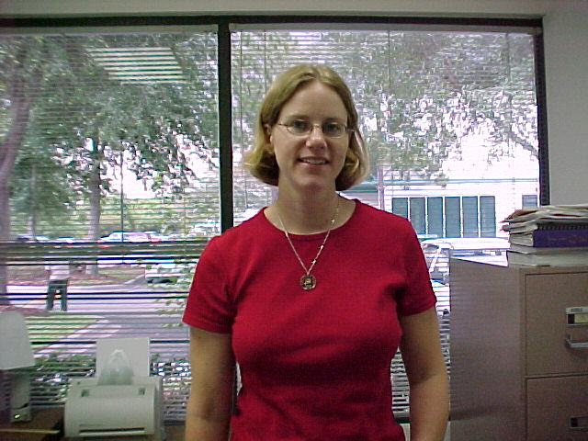
Frida Stromqvist
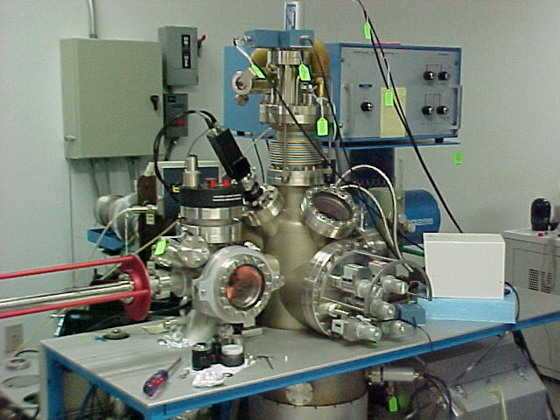
The SIMS

Frida Stromqvist is an exchange student from Sweden. She formerly attended the Royal Institute of Technology in her hometown of Stockholm. She majors in engineering and physics. Frida is working for her Master’s degree. This year, Frida has worked on the SIMS and XPS. Her current project is AC Magnetic Susceptibility Measurements. Frida says that she likes the variety of things to do in Orlando. She also enjoys the unique nature and being close to the beach. Her main hobby is basketball. Frida’s favorite scientist is the ever-popular Albert Einstein.

