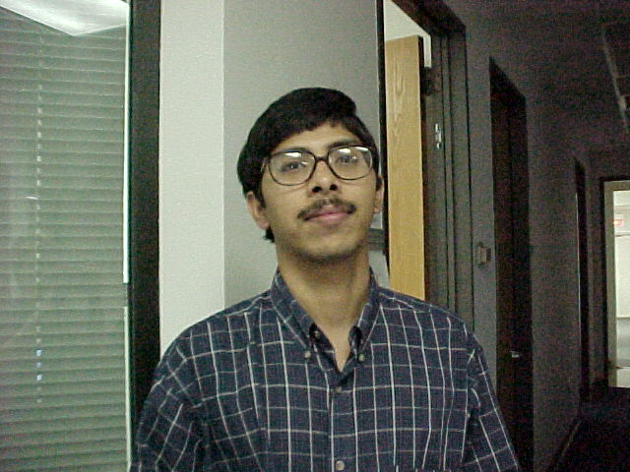
Md R Islam
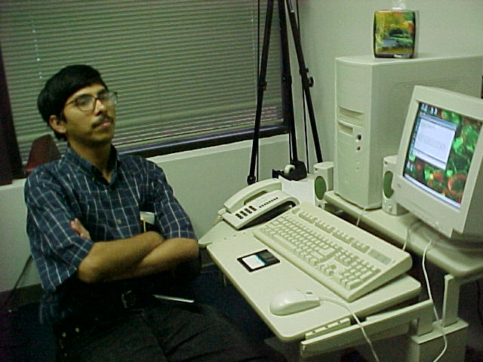

Mohammad Islam at work.
Md R Islam is a graduate student from Bangladesh. He was formerly a lecturer for Applied Physics and Electronics there. Mohammad majors in physics and is working towards his Master’s degree. He likes UCF very much, and enjoys the beaches and theme parks of Florida. Md’s hobby is chess. His favorite scientist from history is Albert Einstein.

