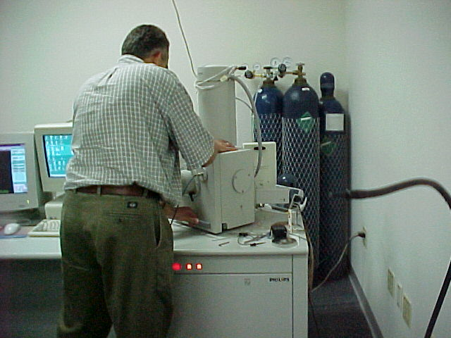Dr. Leonid Chernyak works at the SEM.
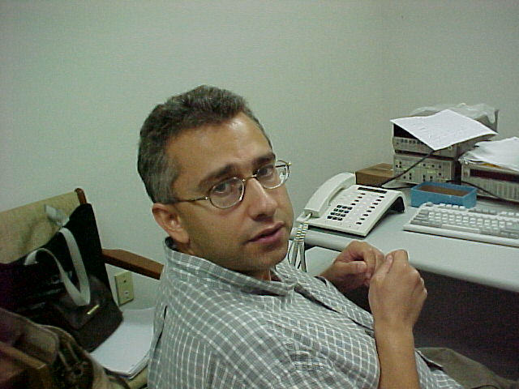
Dr. Leonid Chernyak

Professor Leonid Chernyak lived in Lvove, Ukraine as a child. Before joining UCF, he worked for Intel. Dr. Chernyak is currently researching Semiconductors, materials that conduct less than metals, but more than insulators. Dr. Chernyak says that he likes Orlando because of the warm weather and because of Disney World. He says that his work is also his hobby. Dr. Chernyak’s favorite scientist is Albert Einstein.

