Signal Generator

A goal of this course is to introduce data acquisition and process control using Labview. This requires a knowledge of how signals are interpreted by the computer. Later this semester, you will measure a time varying voltage using a transducer. In order to obtain results that make sense, you must be assured that your sampling rate allows you to accurately reproduce the original waveform. You should have some understanding of the frequency content of the signal you are sampling and ensure that the data acquisition system is capable of accurately reproducing waveforms of the frequencies of interest.

In this exercise, you will experiment with the “Signal Generator by Duration” vi in order to help visualize the relationship between the frequency content of the original signal and the sampling rate of the data acquisition system. The signal generator calculates the values of a given periodic function at equal intervals. The frequency of the function is an input and the output is an array of the given “number of points” input, sampled at equal intervals, over the given “duration” input. Thus, the signal generator vi can be used to some extent to model a data acquisition system. We can control the input frequency of a waveform (simulation of an analog input signal) and the rate at which the signal is sampled (simulation of digital conversion of the analog signal) separately.

The sampling rate of the signal generator vi is defined by the ratio of the number of samples acquired to the duration of sampling. Acquiring 100 samples over a duration of 1 second gives a sampling frequency of 100 Hz. Likewise, acquiring 10 samples over a duration of 100 ms is also a sampling frequency of 100 Hz.

We are interested in the following: What sampling rate should be used in order to accurately reproduce a signal of a given frequency (or band of frequencies)? The Nyquist criterion is generally taken to mean that the sampling rate (samples/second) must be at least twice the highest frequency (Hz) you expect to measure. The “Signal Generator by Duration” vi will not produce an output unless the sampling rate is more than twice the frequency of the waveform. Using this vi, we will produce an “ideal” waveform – there is virtually no limit on the frequency, and the resulting waveform will contain a single frequency. Likewise, there is virtually no limit on the sampling rate. In reality, these quantities will be subject to the limits of the hardware being used. In addition, the waveforms will contain some noise and in most cases, more than one frequency.

Procedure:

Start a new vi. Place the “Signal Generator by Duration” vi on the diagram. You can do this by right clicking on an open area in the diagram and proceeding as below:

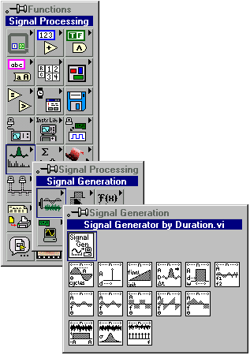

This vi has a number of inputs and outputs. Positioning the wiring tool over the icon will reveal the terminal connections for the vi. When the wiring tool is positioned over a terminal, the name of the terminal will pop up near the cursor. 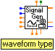

Select Help >> Show Help from the main menu. This will bring up the show help window. When the cursor is positioned over the vi on the diagram, a brief description of the vi will appear in the Help window.

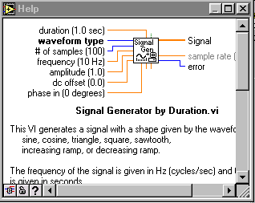

A more thorough description can be found by right clicking on the icon in the diagram and selecting Online Help from the menu.

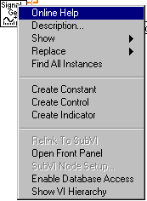

On the diagram, right click on the “duration” terminal and select “create control”. A numeric control of the appropriate data type will be wired to the terminal. Proceed in this manner to create controls for the following: waveform type, number of samples, and frequency. Leave the amplitude terminal unwired – the default value is 1, and we will use this amplitude throughout. Likewise, the other unwired inputs can remain at their default values.

Following the procedure above, create indicators for the Signal and Sample Rate. You can now arrange the terminals corresponding to the controls and indicators you have just created. A convenient configuration is with the inputs on the left and the outputs on the right. The left–to–right and top–to–bottom convention may help you to keep track of the flow of data.

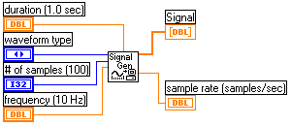

Bring the front panel to the top. Note the difference between the indicators for the sample rate and the signal. The indicator for the Sample Rate is a box that displays a single number. 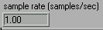 The indicator for the Signal is an array indicator. 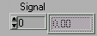

The up/down arrows are used to navigate through the array of values. The number immediately to the right of the up/down arrows is the array index. Placing the positioning tool over the bottom right hand corner of the array indicator will allow resizing of the indicator. Resize the indicator so that 5 or 6 values are shown. 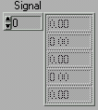

The “Signal Generator by Duration” vi begins with a waveform of preset frequency. The output (at the signal terminal) is a 1-D array of numerical values corresponding to the sampled value of the function. The number of points acquired sets the length of the array, and the duration of the acquisition determines the length of the interval between samples. The first point in the array has index 0, the second point has index 1, etc.

Using the values shown on the front panel below, run the vi once.

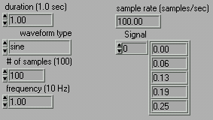

Use the up/down arrow keys to scan through the array. The number in the array index box corresponds to the array element to the right of the index. For an array of 100 points, the index of the last element in the array is 99.

Last week, we used a Waveform Chart with the pseudo random number generator – each time through the While loop, a single number was generated and added to the chart. The x axis displayed integers from 0 to N – if those pseudo random numbers were to be stored in an array, the numbers on the x axis would correspond to the indices of the array elements.

In this exercise, we are plotting the function sin(ωt), sampled at even intervals of time (Δt). Rather than displaying the data as a function of the array index, we can use a Waveform Graph to display the data as a function of time. The waveform graph can be set with x₀ (or t₀ – the first time element), Δx (Δt – the time between samples), and the array of y values.

On the front panel, right click in an open area. Select Waveform Graph.

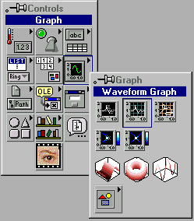
Place it in a convenient location on the front panel. Right click on the Waveform Graph and select “Find Terminal” from the menu.

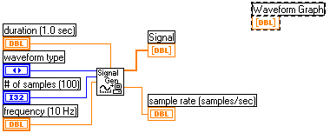

By default, the data type of the Waveform Graph is double precision floating point . This indicator will accept a 1-D array of double precision floating point numbers (such as the output at the “Signal” terminal). In order to see the relative time on the x axis, we must bundle two quantities with the Signal output.
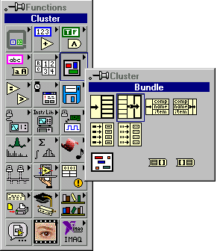

Place the bundle icon on the diagram. With the positioning tool, grab the lower right hand corner of the icon and expand it until there are three input terminals. Alternatively, you can right click on one of the input terminals and choose “Add Input” from the menu.

Place a numeric constant on the diagram from the functions palette (Functions >>Numeric >> Numeric Constant). This will be used for x₀ (initial time). For the time interval, we could use the inverse of the sample rate. If the sample rate is 100 Samples per second, then the time between samples is 10 ms. Wire the terminals as shown below.
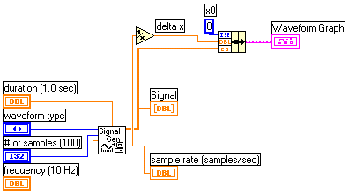

Notice that the data type of the Waveform Graph changes when it is wired to the bundle. Return to the front panel and press the run button . The display should look as it does below.

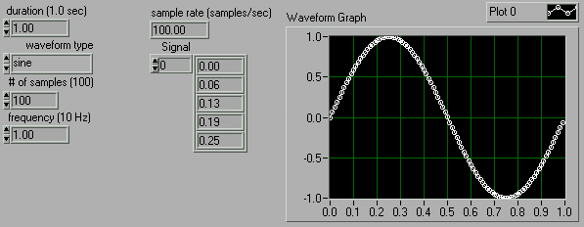

Experiment with the controls – be aware of the relationship between the frequency of the function, the number of samples, and the duration of sampling. You can run this vi interactively by pressing the continuous run button . Change the numeric controls and view the output on the waveform graph.

In practice, sampling rates are generally chosen to be at least 10 times the highest frequency you expect to measure. Try these inputs: frequency 1 Hz, duration 1 second, 100 samples; frequency 1 Hz, duration 1 second, 10 samples; then, decrement the number of samples until there is no waveform displayed. Left click on the up arrow and hold it down. Watch the waveform evolve. Change the duration, frequency, and waveform type.

