MOSFET Curve Tracer

Create a VI to measure and display a set of characteristic curves for a MOSFET. The circuit is shown below.

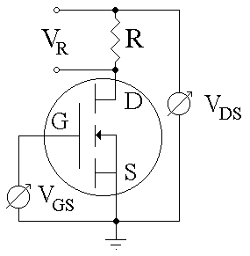

A variable voltage source is connected to the gate, G. A second variable voltage source is connected between the drain, D (through resistor R), and the source, S, which is connected to ground.

Each curve is generated by setting the gate voltage at some constant value then measuring the drain current while sweeping through a range of drain-source voltages. A family of characteristic curves can be generated by changing the gate voltage, then repeating the drain current measurements. A typical family of characteristic curves is shown below.

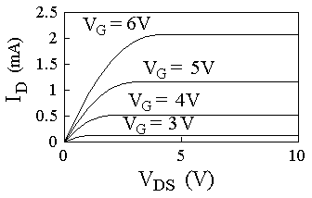

The HP33120A Arbitrary Waveform Generator can be used to supply the drain-source voltage. This instrument can be controlled by a Labview VI through the GPIB interface. The gate voltage can be supplied by an analog output of the National Instruments 6024E card. The drain current can be measured (via the voltage across resistor R) through an analog input of the 6024E card.

The VI should set the output voltage of the analog output, set the HP33120A to step through a range of drain-source voltages, and measure the voltage across R through an analog input. The characteristic curves should be plotted and displayed in Labview. The VI should also save the curves to a spreadsheet file.

