1 Equipment setup 1
2 Preparation for startup 6
3 Sample transfer 7
3.1 Removing sample from analysis chamber 7
3.2 Inserting sample into analysis chamber 8
4 Sputtering 10
4.1 Sputtering - sample preparation 10
4.2 Sputtering shutdown 11
5 XPS Spectrum 12
5.1 Electronics 12
5.2 Taking XPS spectrum 12
6 Electron Gun for Imaging or Neutralization 15
7 Convert data to ASCII format 16
8 Shut down 17

Equipment setup
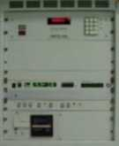
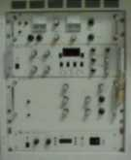
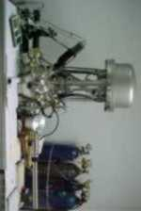
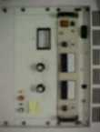
Control Rack 1
Control Rack 2
Control Rack 3
Instrument Table
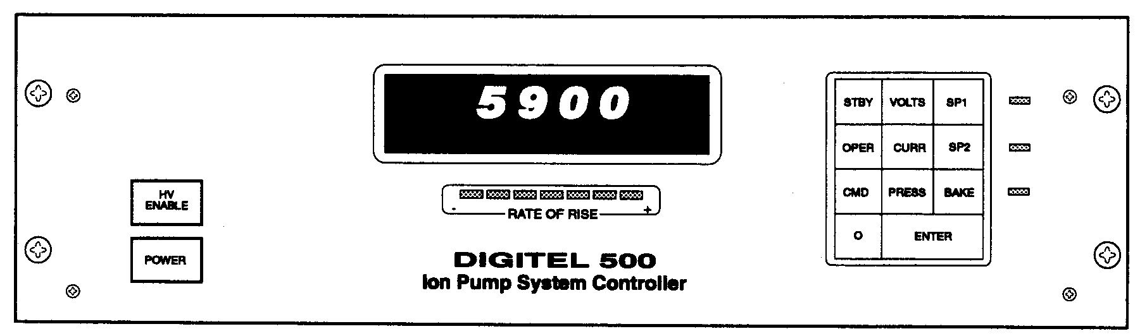
Figure 1.2 - The digital IPS500 Ion Pump Controller unit (Control Rack 1)

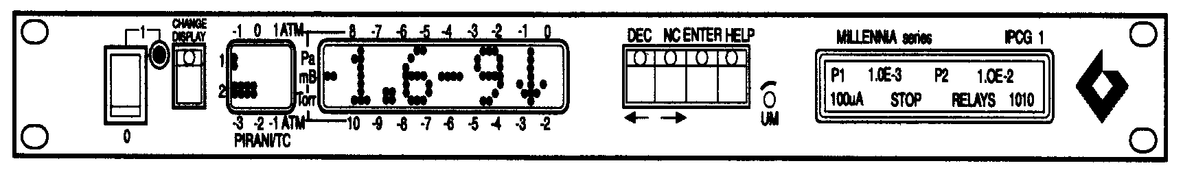
Pressure in Analysis chamber
Pressure in FEAL

Figure 1.3 - Millennia IPGC01 unit (Control Rack 1)

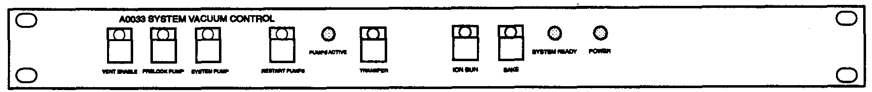
Figure 1.4 - A0033 System Vacuum Control unit (Control Rack 1)

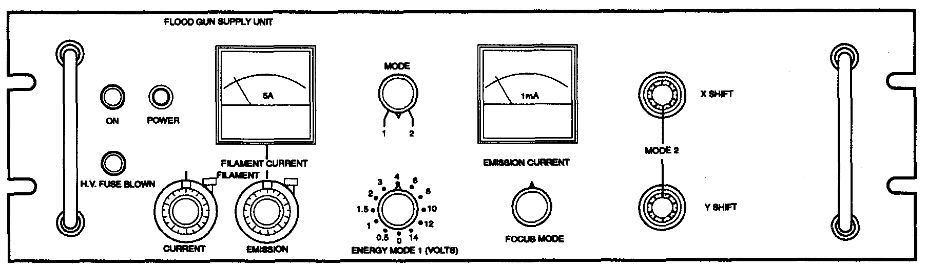

Figure 1.5 - 401/B Flood Gun Supply unit (Control Rack 2)

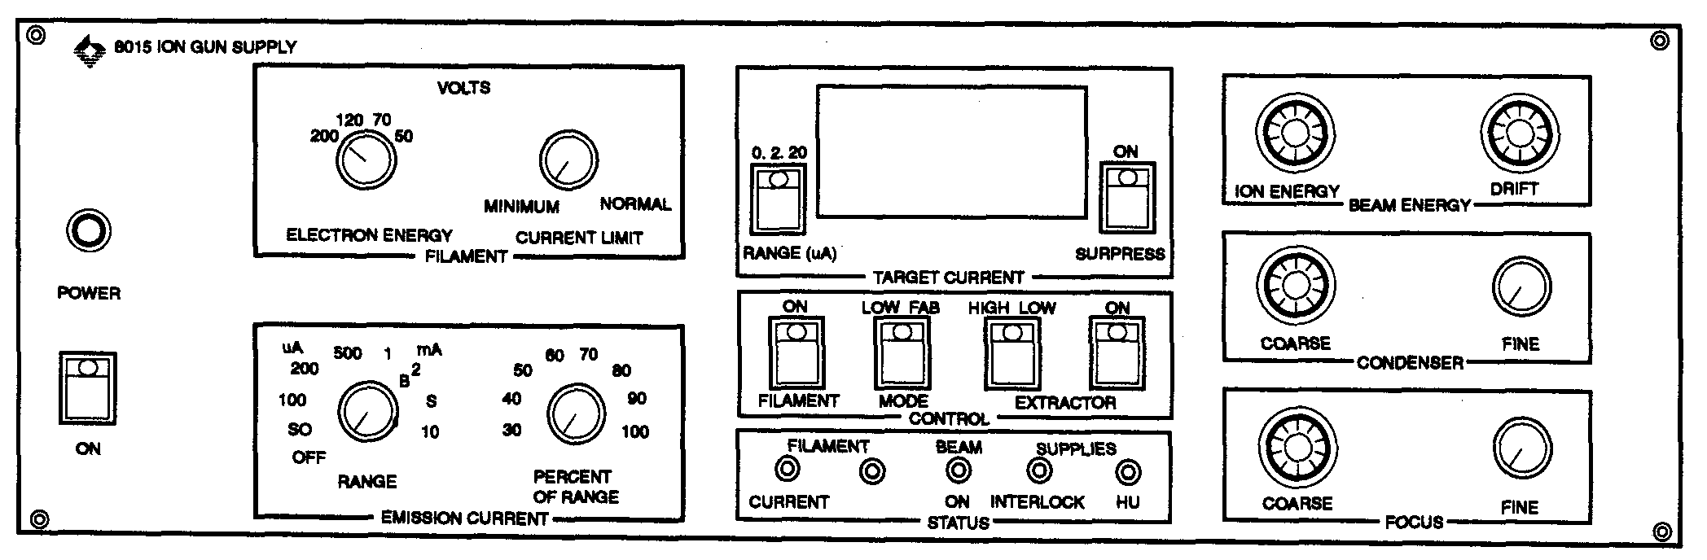
Figure 1.6 - 8015 Ion Gun Power Supply unit (Control Rack 2)

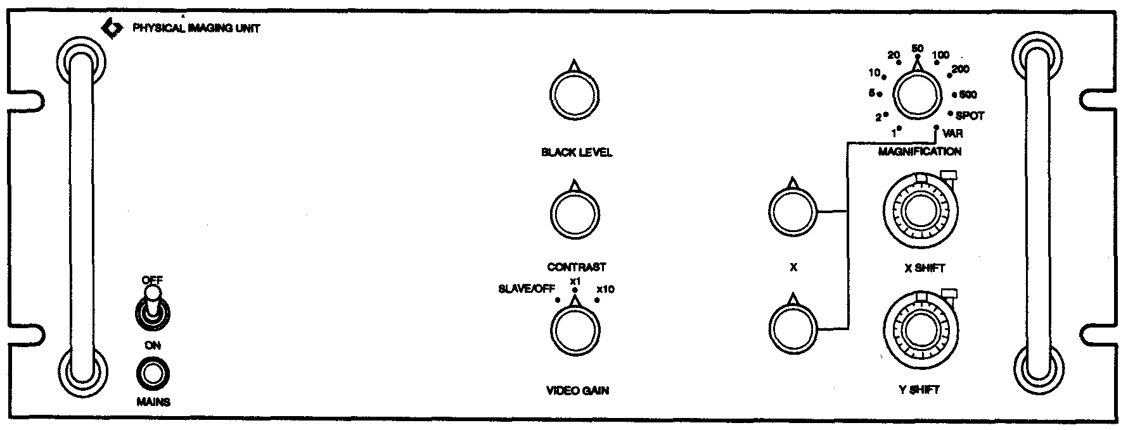

Figure 1.7 - 346 Physical Imaging unit (Control Rack 2)

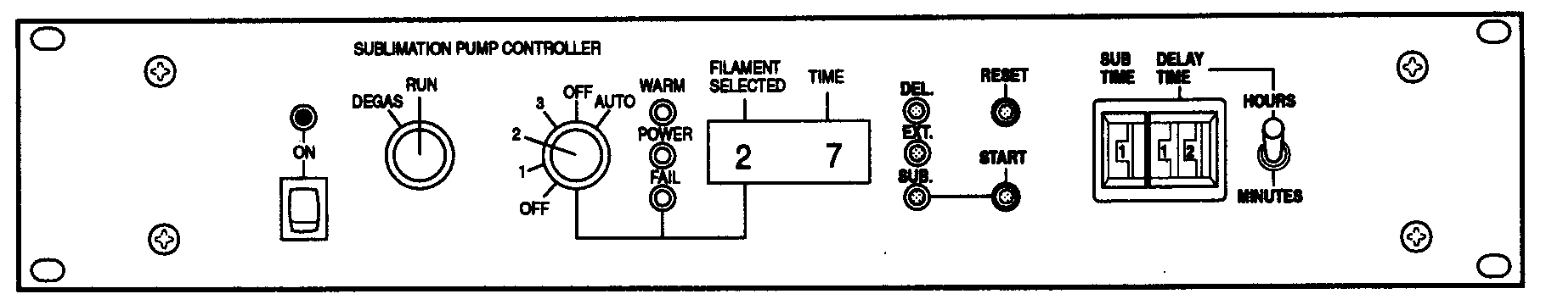
Figure 1.8 - SPS7 Sublimation Pump Controller unit (Control Rack 2)

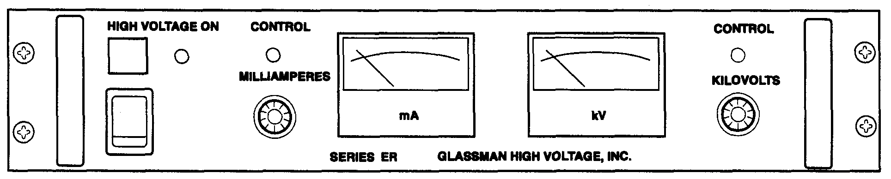
Figure 1.9 - Glassman HV Supply unit (Control Rack 3)

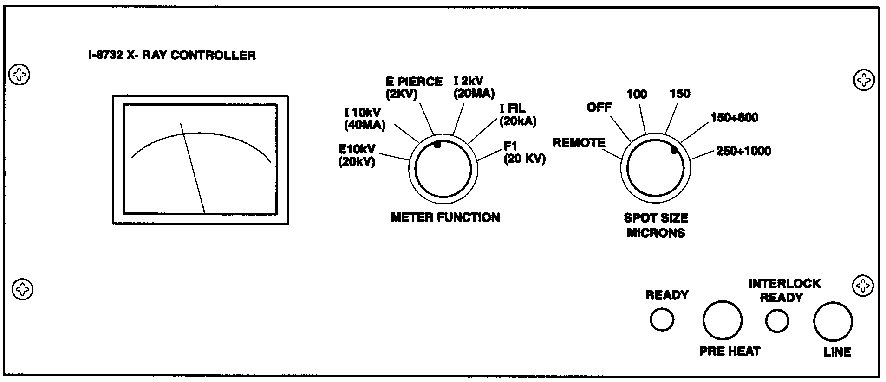
Figure 1.10 - 8732 X-Ray Controller unit (Control Rack 3)

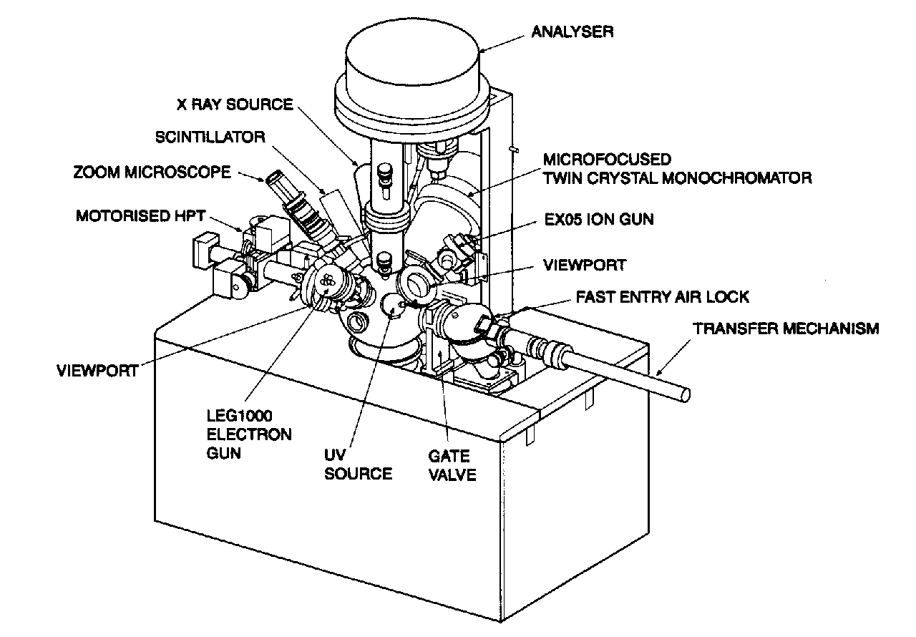

Figure 1.11 - Front view of ESCALAB 220I (Instrument Table)

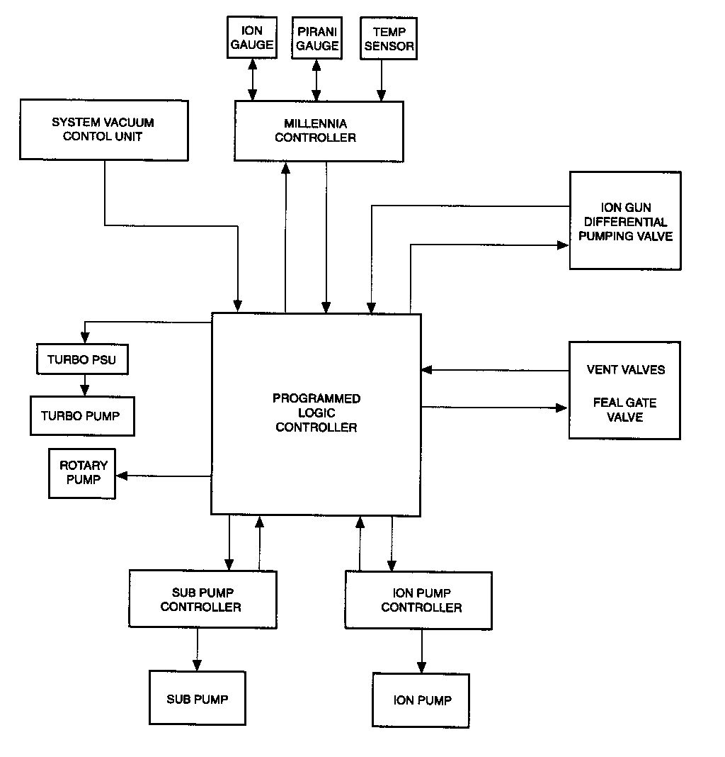
Figure 1.11 – The Vacuum System Schematic Scheme

Preparation for startup
• Turn on the following gas tanks:
- The nitrogen tank for the valves (red tube). Pressure should be 80 psi (preset)
- The argon tank for etching (transparent tube). Pressure should be about 1-2 psi.
- The nitrogen tank for venting (transparent tube). Pressure should be 1 LPM.
• Turn on the main water supply. Go behind the computers and press the power button on the water supply unit.
• Check pressures on the Millennia unit (Figure 1.3) on Control Rack 1
- FEAD: 10⁻² Torr
- Analysis chamber: 10⁻⁹ - 10⁻¹⁰ Torr
• Turn on the HITACHI monitor (connected to the CCD camera).
• Turn on the computer. Use the first operational program. It will start by itself. Do not switch to the second program.
• Double click the “Eclipse V2.1Rev06” icon on the computer. The Eclipse menu shown in Figure 2.1 will appear on the screen.

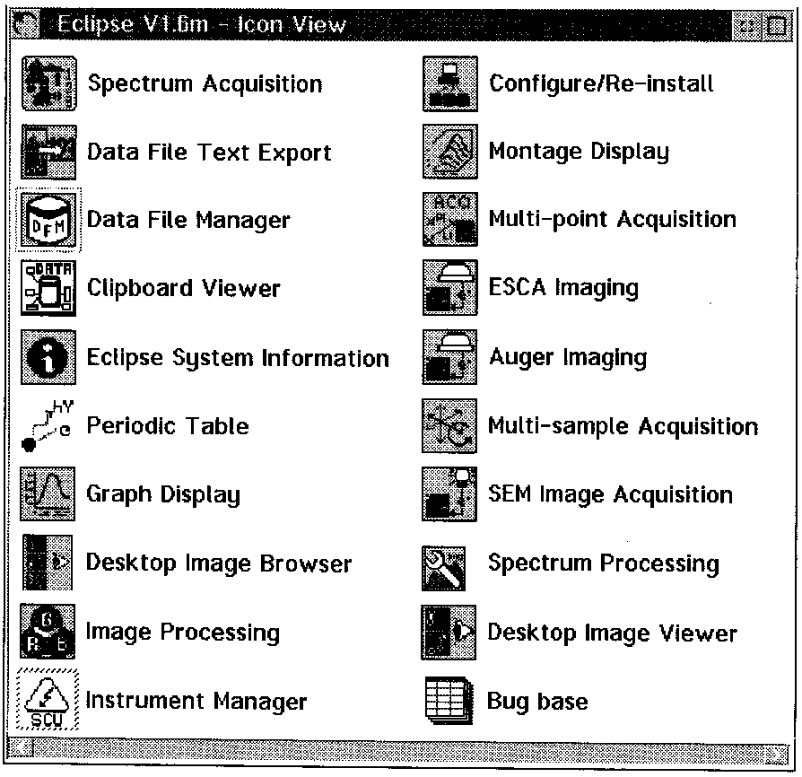
Figure 2.1 - The Eclipse menu

Sample transfer

    - Removing sample from analysis chamber
Check the following before removing the sample:
• Pressure in analysis chamber should be <= 5⋅10⁻⁹ Torr.
• “HV Enable” on the Ion Pump Controller unit (Figure 1.2) on Control Rack 1 should be ON.
• The following lamps on the A0033 unit (Figure 1.4) on Control Rack 1 should be lit (ON):
- Preplock pump
- System pump
- System ready
- Power
All other lamps should be off
Always wear UHV compatible gloves when handling specimens or specimen holder.
• Return the sample holder to “home” position by pressing “LOAD”, “99” and “ENTER” on the Nyquist Control.
• Press “Transfer” on the A0033 unit (Figure 1.4) on Control Rack 1 to open the FEAL (Fast Entry Air Lock) gate valve. Visually confirm that the valve is open.
• Advance the transport arm into the analysis chamber by turning the “Drive control” knob on the side of the transport arm CCW (Figure 3.1).
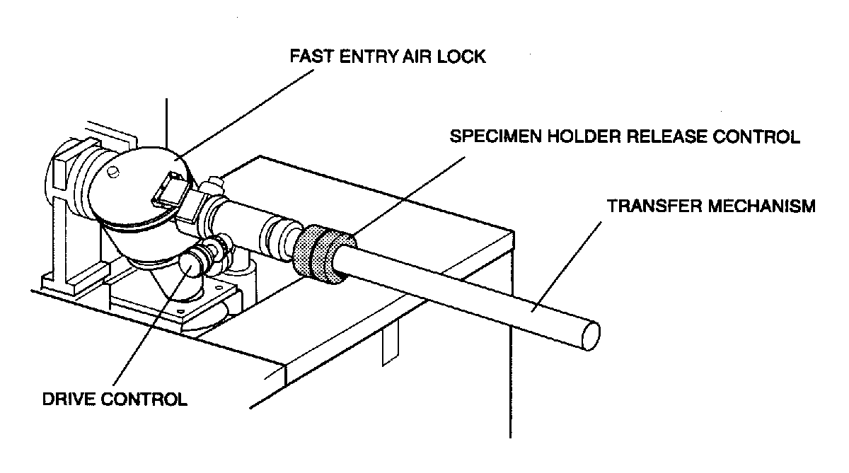

Figure 3.1 – The transfer mechanism

• Carefully check the alignment of the sample holder and the transport arm.
• Gently advance the transport arm until the spring retaining clip latches onto the specimen holder.
• Fully withdraw the transport arm/sample holder from the analysis chamber by turning the “Drive control” knob CW. Visually confirm that the sample holder is clear of the FEAL gate valve.
• Press “Transfer” on the A0033 unit (Figure 1.4) on Control Rack 1 to close the FEAL gate valve. Visually confirm that the valve is closed.
To open the FEAL door:
• Press the following buttons on the A0033 unit (Figure 1.4) on Control Rack 1:
- “Preplock pump”, to turn off the Turbo Molecular Pump (light goes off).
- “Vent Enable”, to vent the FEAL (green light should flash).
• A hissing sound indicates that vent gas (Nitrogen) is flowing into the FEAL. If no hissing sound is heard after several minutes, check that the nitrogen tank for venting (transparent tube) is charged and that the tank valve is open.
• Open the FEAL door when venting is complete.

• Remove the sample holder by turning the “Specimen Holder Release Control” on the transport arm (Figure 3.1). This will release the spring retaining latch, which locks the specimen holder to the transport arm.
• Close the FEAL door.

    - Inserting sample into analysis chamber
Always wear UHV compatible gloves when handling specimens or specimen holder.
• Do the following if the sample holder was NOT previously REMOVED:
- Visually inspect the analysis chamber to insure that no sample holder is currently in place. If one is present, go to “Removing sample from analysis chamber” (Section 3.2) before proceeding.
- Check if the FEAL door can be opened. If not, follow the instructions in “To open FEAL door” in Section 3.2.
• Open the FEAL door and fit the sample holder to the end of the transport arm (Figure 3.2).
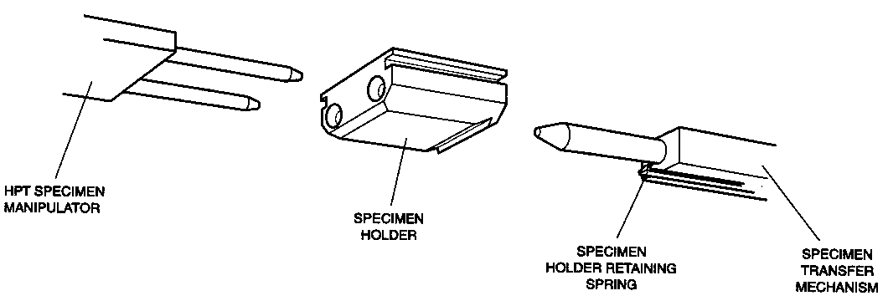

Figure 3.2 – Sample holder alignment

• Gently push the holder until you hear a distinct “click”, indicating that the spring retaining latch is engaged.
• Close the FEAL door.
• Press the following buttons on the A0033 unit (Figure 1.4) on Control Rack 1:
- “Vent Enable”. The green light should stop blinking and go out.
- “Preplock Pump”. The green light should be lit.
- “Restart Pumps”. The “Pump Active” light should be lit and the FEAL should begin pumping down vacuum (noisy).
- “Transfer”, to open the FEAL gate valve. Visually confirm that the valve is open.
• Advance the transport arm into the analysis chamber by turning the “Drive control” knob on the side of the transport arm CCW (Figure 3.1).
• Use the joystick on the Nyquist control to align the pegs on the manipulator with the holes in the sample holder (Figure 3.3). Advance the sample holder so it latches onto the manipulator.
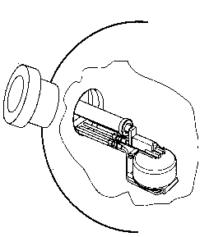
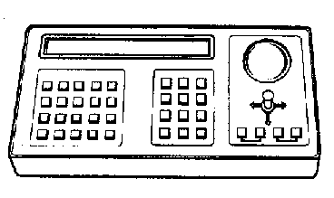
Z
Z
Y
X
X
Y
Manipulator
Nyquist Control

Figure 3.3 – The Nyquist Control controls the manipulator in the analysis chamber.

• Turn the “Specimen Holder Release Control” on the transport arm (Figure 3.1). This will release the spring retaining latch, which locks the specimen holder to the transport arm.
• Carefully withdraw the transport arm by turning the “Drive control” knob on the side of the transport arm CW (Figure 3.1). Make sure that the sample holder remains mounted on the manipulator.
• Fully retract the transport arm and visually confirm that it has cleared the FEAL gate valve.
• Press “Transfer” on the A0033 unit (Figure 1.4) on Control Rack 1 to close the FEAL gate valve. Visually confirm that the valve is closed.

Sputtering

    - Sputtering - sample preparation
• Do the following on the computer:
- Go to the Eclipse menu (Figure 2.1).
- Double click “Instrument Manager” (it will take some time for the program to load).
- Click on “Control” and choose “Ion Etch Control” (Figure 4.1). The window shown in Figure 4.2 will be shown.

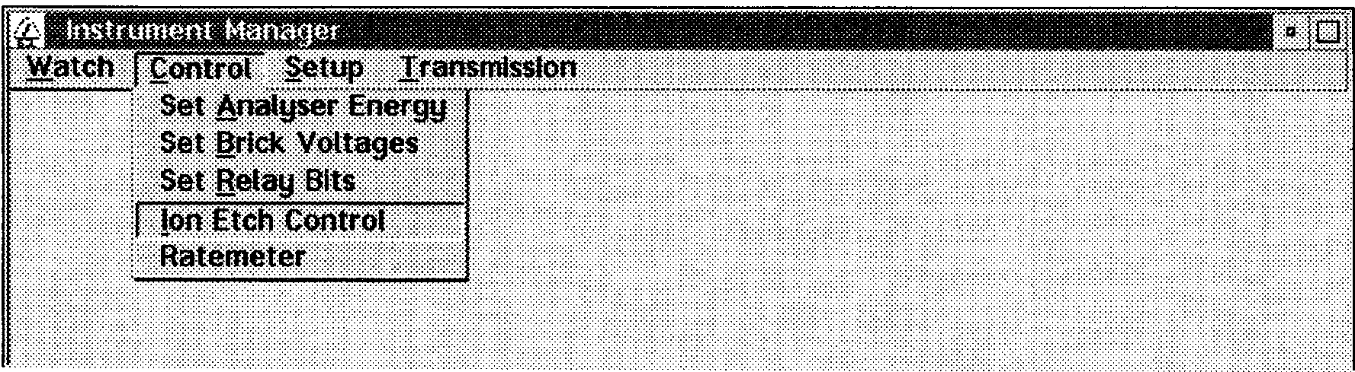
Figure 4.1 – Instrument Manager window
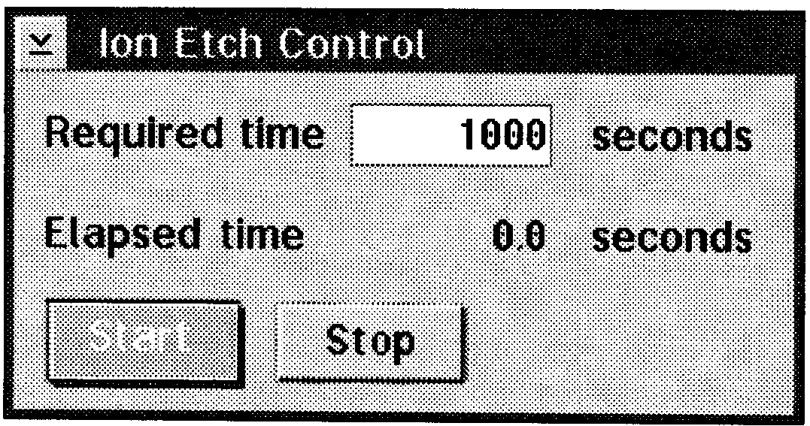
Figure 4.2 – Ion Etch Control window

• Ion Gun Power Supply unit (Figure 1.6) on Control rack 2:
- Check default settings:
“Emission Current – Range”: 50 μA.
“Emission Current – Percentage of range”: 80
“Filament – Electron energy”: 70 V
“Filament – Current limit”: set to min
“Beam energy – Ion energy”: 0
“Beam energy – Drift”: 0
“Condenser” and “Focus” knobs are locked in preset positions
- Press the power button
- Check preset values:
“Target current – Range”: 20 μA
“Control – Mode”: Ion
- Set “Control – Extractor” to “High” by clicking.
• Open the ion gun valve by clicking “Ion Gun” on the A0033 unit (Figure 1.4) on Control Rack 1. The green light should lit (means open). The pressure in the main chamber will increase to 2-4⋅10⁻⁸ Torr.
• Open the leak valve SLOWLY. Stop when the pressure in the main chamber has increased to 5⋅10⁻⁵ - 1⋅10⁻⁶ Torr (about a quarter of a turn). Read the pressure on the gauge on the Millennia unit (Figure 1.3) on Control Rack 1. Keep in mind that the display of the pressure is delayed.
• Go to the computer. Set “Required time” (Figure 4.2) to 1 sec.
• Ion Gun Power Supply unit (Figure 1.6) on Control Rack 2:
- Click on “Controls – filament”. The “Status – Current” LED should lit green.
- Click on “Controls – H.V.”. The “Status – H.V.” LED should lit green. The “Status – Emission” LED will start flashing red.
- Set the emission current by turning the knob “Emission Current – range” to 2-15 mA. (Small current if light sputtering, higher if sample is heavy contaminated).
- Turn knob “Filament – Current limit” CW until “Status – Emission” LED turn green.
- Increase the beam energy by turning knob “Drift” to maximum and setting the desired voltage with the “Ion energy” knob. A change of two units on the knob corresponds to 1V (i.e knob setting 8 gives 4V).
• Turn on the Physical Imaging unit (Figure 1.7) on Control Rack 2. Check that the “Magnification” rotary switch is set to 5 (corresponding to sputtering area 2×2 mm²). Leave the rest of the knobs in preset positions.

Proceed if the sample is in the analysis chamber. If not, insert the sample (Section 3.3).

• Go to the computer. Set “Required time” (Figure 4.2) to desired time for etching. Click “Start”.
• Check the Ion Gun Power Supply unit (Figure 1.6) on Control Rack 2. The “Status – beam on” LED should lit green and the current should be displayed.
• Close the window on the computer by clicking in the upper left corner and choose “Close”. Then close the “Instrument manager”.

    - Sputtering shutdown
• Close the leak valve all the way. Wait for the pressure in the analysis chamber to drop to 2-4⋅10⁻⁸ Torr.
• Close the ion gun valve by clicking “Ion Gun” on the A0033 unit (Figure 1.4) on Control Rack 1.
• Ion Gun Power Supply unit (Figure 1.6) on Control Rack 2:
- Minimize the beam energy by turning knobs “Energy” and “Drift” to minimum positions.
- Decrease the “Emission Current – Range” to 50 μA. Set the “Filament – Current Limit” to min.
- Click on “Controls – H.V.” and “Controls – Filament” to turn off.

Leave like this if more sputtering is going to be done the same day. If no, turn off the Ion Gun Supply unit and the Physical Imaging unit.

XPS Spectrum

    - Electronics
• Top of Control Rack 3:
- Turn on the “X-ray water control”.
- Click the black button to the right of it. “Flow” should lit and noise start.
• HV Supply unit (Figure 1.9) on Control Rack 3:
- Set knob “Kilovolts” to 0.
- Turn on the High Voltage unit by pressing “Power”. Do not touch the knob “Milliamperes”.
• X-Ray Controller unit (Figure 1.10) on Control Rack 3:
- Click “Line” on the X-ray Controller unit. “Interlock ready” should light green.
- Check that the rotary switches “Meter function” is set to “I fil (2 Amps)” and “Spot size” to “Off”.
- Click “Pre-heat”. Check that the current is increasing (meter is to the left). If not, press the button again. Wait for the filament to heat up and “Ready” is lit (it takes about 1 min). The filament current should be about 1.45 A (see meter).
• Press “High Voltage ON”, on the HV Supply unit (Figure 1.9). A red light next to it should lit. Increase the high voltage to 10 kV by turning knob “Kilovolts” CW.

    - Taking XPS spectrum
• Look at the HITACHI monitor. Use the Nyquist control joystick to position the sample (the track ball for fine adjustments). Then use the “Z” controls (up, down) to focus cross in the middle of the screen on the sample.
• On the computer, go to the Eclipse menu (Figure 2.1) and double click “Spectrum Acquisition”. The Multi-Region Spectroscopy menu will be shown (Figure 5.1).
• Click on “Options” and then “Lens Modes” (Figure 5.2). Choose a suitable mode for spectrum. The choice has to contain “XL” and should not include “Image”. (Choose any of the “Small AreaXL” if the sample is a small particle and “Large AreaXL” if the sample is uniform).

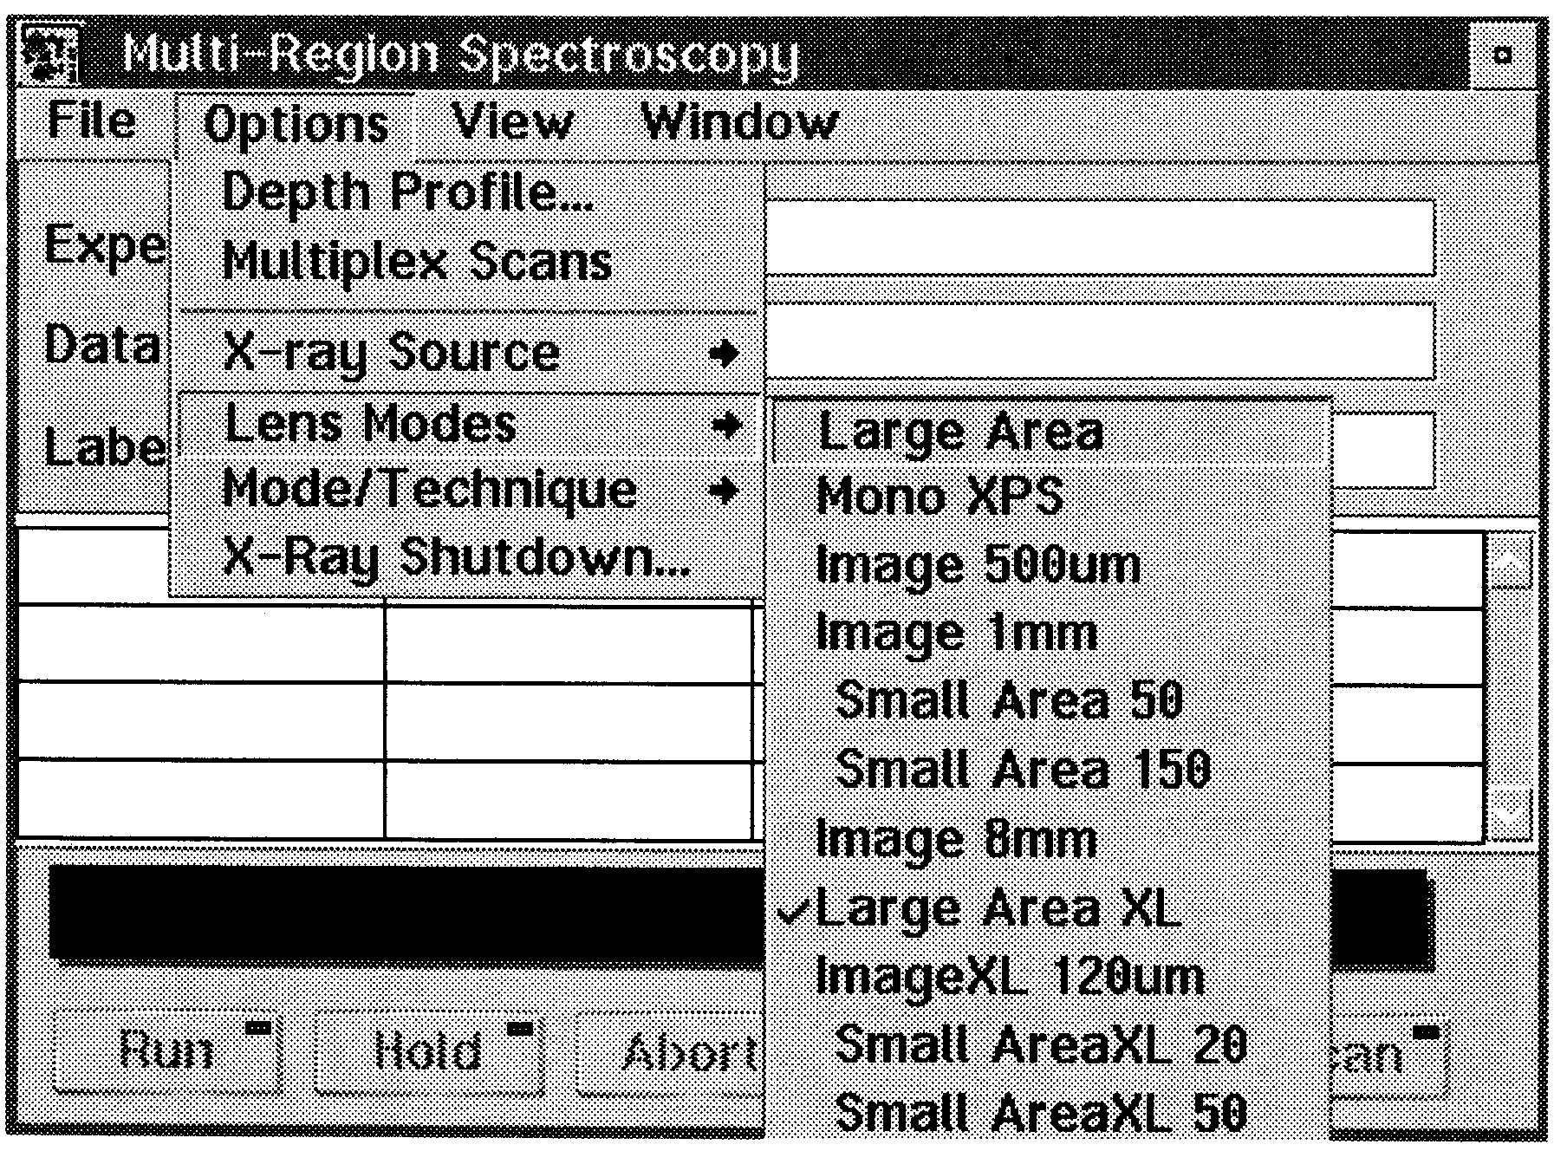
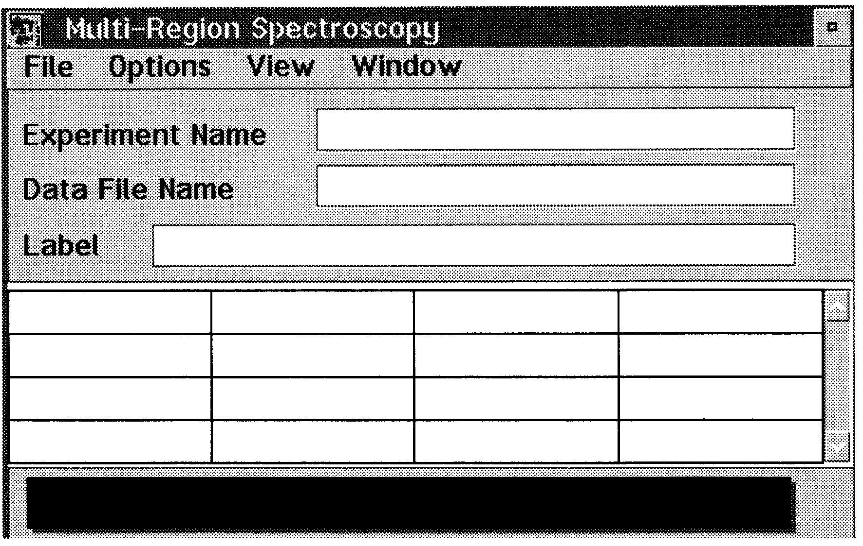

Figure 5.1 – Multi-Region Spectroscopy menu Figure 5.2 – Choice of Lens Modes

• Enter “Experimental Name” and “Data File Name” (use the same name).
• Double click on the top left region. The window shown in Figure 5.3 will be shown.
- Enter “Region Name”
- Click once on “Center Energy” to change settings from “Center Energy” and “Scan range” to “Start Energy” and “End Energy”. Set desirable values for the energies.
- Set “Channels” (number of steps)
- Set “Dwell” (time spent in each channel, usually set to 100)
- Set “Pass Energy” to:
100 for a survey scan (0-1200 eV)
20-40 for a narrow energy range.
- Set “No of scans” (can be changed during the experiment)
- Click OK

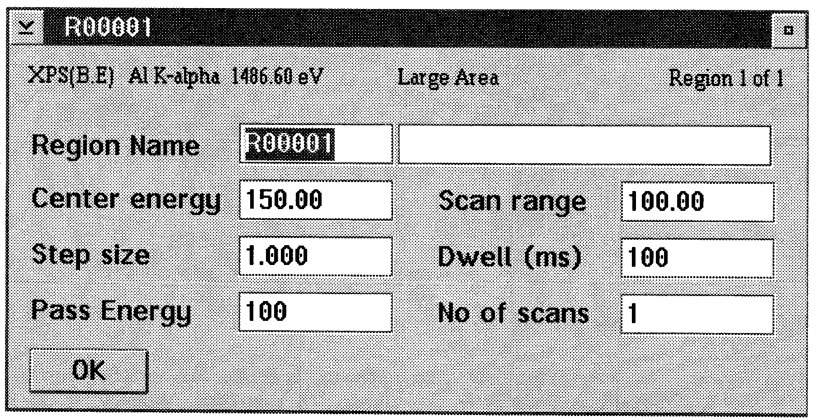 Figure 5.3 – The region window

• Repeat on other regions if more then one scanning range is desirable.
• Regions can be active or not active (no scanning will take place). To deactivate a region, click once on the region, press the “Space bar” key and the font will turn gray. Repeat to activate the region (font will turn black again).
• Go to the X-ray Controller unit (Figure 1.10) on Control Rack 3. Set the rotary knob “Spot Size” to a value comparable to the choice of the lens mode, see Table 4.1.

Table 4.1 Spot size corresponding to different lens modes.
Lens mode | Spot size
Large Area XL | 3 (150×800)

• Go back to the computer and click “Run”. A spectrum window will appear. A typical XPS-spectrum is shown in Figure 5.4.
• To stop collecting data before all scans are completed:
- Do NOT use “End Scans”
- To save collected data, click on the active region and change “No of scans”. Select a number close to, but not less than, the number of already completed scans.
- Click “abort” to end the scanning without saving collected data.
• When the spectrum is collected, turn the rotary switch “Spot Size” (on the X-ray Controller unit) back to “Off”. Close the windows on the computer (click upper left corner, select “Close”).

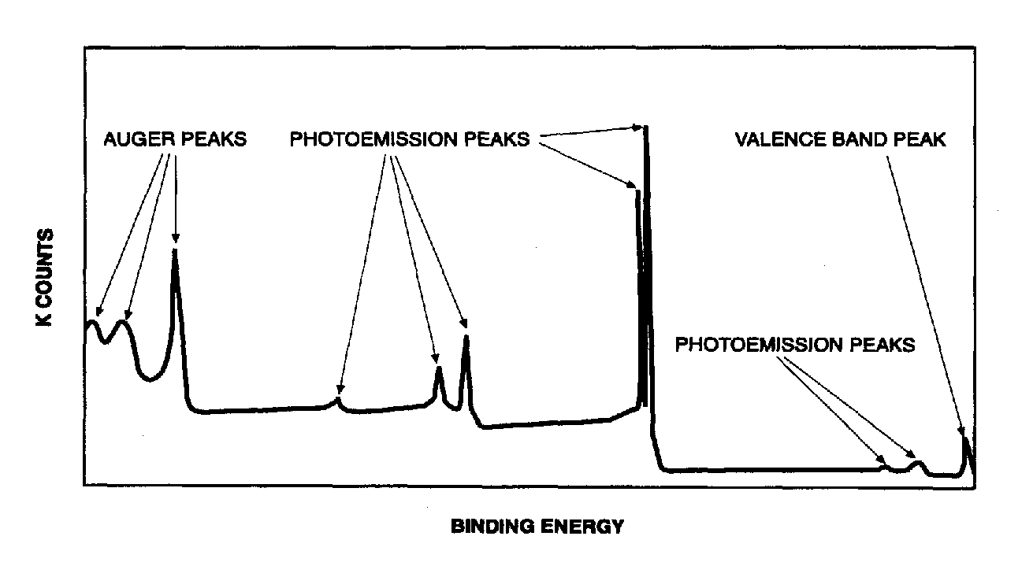
Figure 5.4 – A typical XPS-spectrum

Electron Gun for Imaging or Neutralization

Flood Gun supply unit 401 (rack 2)
• Set “filament – current” to “0.
• Set “mode”:
- To “1” for neutralization
- To “2” for imaging
• Press “power” to turn unit on
• Turn knob “filament – emission” fully CW to 10
• Increase “filament – current” to operating point. Do not exceed 3 A. Keep increasing until emission current appears. Turn on the Ion Gun supply unit and read the emission current on the “target current” display.

Convert data to ASCII format
• Go to the Eclipse menu (Figure 2.1). Double click on “Data File Text Export”. Two different transfer formats will be shown. Choose “Eclipse ASCII”.
• Click on “Data” and select “ASCII”.
• Click on “Load experiment”.
• Go to “Directories”. Double click on the directory you want to export. Go to “Files” and select a file. Each file corresponds to different regions of collected data. Click on “Load”
• The window “Save to ECLIPSE text file” will be shown. Enter filename. The default saving location is drive C: PBIN folder. Change to drive A (floppy) and insert a floppy disk.

Shut down
• Control Rack 3:
- Set “Spot size” to “off”
- Decrease the high voltage by turning knob “kilovolts” fully CCW to “0”.
- Turn “power” off.
- Turn “Line” off
- Turn “X-ray water control” off.
• Ion Gun Power supply unit: Section 4.2.
• Shut the HITACHI monitor off
• Computer:
- Close all windows on the computer by clicking in the upper left corner and select “Close”.
- Right click the mouse and select “shut down”.
- Turn off the computer
• Turn off the main water supply (water supply unit is behind the computer).
• Turn off the light on the Instrument Table.
• Close the nitrogen tank for the valves (red tube).
• Close the nitrogen tank for venting (transparent tube).
• Leave the argon tank open all the time!

