Spring 2011
STUDIO Unit 04
PHY 2054 STUDIO College Physics II

[Gauss’ Law]

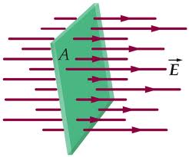

ELECTRIC FLUX AND GAUSS’ LAW
Objectives
- to understand that the area of a flat surface can be represented by a vector to understand the concept of electric flux qualitatively and quantitatively
- to understand Gauss’ Law qualitatively

Equipment:
1 sheet of graph paper
1 index card
Excel software
An Applet on Gauss’ Law

- Area Vectors
a. Obtain a sheet of graph paper and an index card.
Using a ruler, determine the area of the graph paper and the index card. Is there a unique way to represent the area of a flat surface by a vector? Is there a unique direction in which it would point? How long would it be? Explain if you can.


b. Consider a closed box three dimensional box. Is it possible to represent each surface of the box unambiguously by a vector? What is different from the previous question? Explain your reasoning. Again, is it possible to represent a flat single surface unambiguously by a vector? Draw a diagram and explain. We will discuss this in class so be prepared to participate.

SKETCH:

EXPLAIN:

c. Write a rule for representing the area of a surface by a vector if it is isolated and if it is a portion of a closed volume.
Prepare to discuss your rule.

d. Roll the graph paper into a cylinder. Is it now possible to represent the area of this surface by a vector? Explain your reasoning.

e. Could you represent the area of a small box on the graph paper by a vector when it is rolled into a cylinder? Explain.
The area of a flat surface can be represented by a single vector perpendicular to the plane of the surface. The length of the vector is proportional to the area but its direction is not clearly determined. Why?

- Electric Flux
It is useful to define a quantity called electric flux. Electric flux is defined as a measure of the number of electric field lines passing through a surface (whatever that means).
a. We can picture an arrangement of nails to represent the electric field lines in the center of a parallel plate capacitor. A capacitor is constructed by creating two charged surfaces that are parallel to each other with each surface having the same charge but each is of the opposite sign.
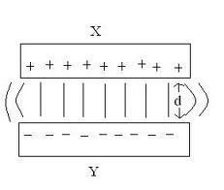
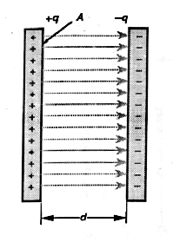
The Parallel Plate Capacitor
In such a configuration, the electric field is perpendicular to the surfaces and configured as shown. (We will prove this later.) The field is the same throughout the entire volume (except at the ends where we will ignore the differences shown in the figure to the above right).
We will represent a surface as the area surrounded by a perimeter that we will call a “loop”. The loop defines the boundary of the area. The boundary of the shaded area below is the loop defined above.

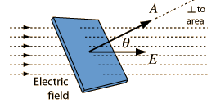

Imagine two flat areas, one 3 x 4 units and the other 8 x 8 units. The first one has 24 electric field lines passing through it while the second has 28. The electric field lines are perpendicular to the areas. (See the drawing on the cover page). Which area has the stronger electric field associated with it? Explain.
b. Consider a 10 x 10 unit surface and 100 evenly spaced electric field lines perpendicular to the surface. Consider a square loop 5 x 5 units in size held above this surface. What does the number of field lines passing through the surface depend on? Explain.

c. Imagine the 5 x 5 “loop” at different orientations in each of the “fields”. Which orientation has the least number of field lines through it? What is the direction of the vector that represents the area of the surface in this case? How does it compare to the direction of the electric field? Which orientation has the greatest number of field lines through it? What is the direction of the vector that represents the area of the surface in this case? How does it compare to the direction of the electric field?
d. For orientations in between those that have the maximum and minimum number of field lines passing through the loop, qualitatively, how does the number of field lines passing through the loop depend on the angle between the vector that represents the area of the surface and the direction of the electric field? Explain.
You can verify your conclusions and investigate them further by going to the following link: http://webphysics.davidson.edu/physlet_resources/bu_semester2/index.html and click on Electric Flux
which you can download from the class website or type the address into a browser. This is a great site for “Simulations in Physics” and you can refer to it for other subjects as well. When you get to the site, scroll down on the left until you find “Electric Flux” and click on it. You will find the following:
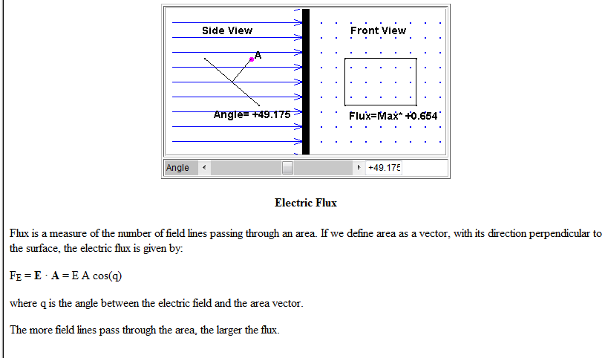

In this simulation you can rotate the “frame” and count the number of lines that pass through it as a function of angle. This provides you with a number that sort of represents the “amount” of electric field that passes through the surface. We call this the Electric Flux but this is not yet the proper definition for it. Fill in the following table:
Angle | Cos(angle) | Number of Dots
 |  | 25
 |  | 15
 |  | 5
 |  | 0
Show from this simple example that the number of dots is proportional to the cosine of the angle that the normal to the surface makes with the Electric Field Lines.
e. Refer to the following figure again:
What is the component of the electric field perpendicular to the surface? How does the component of the electric field perpendicular to the surface change (increases or decreases or stays the same) as the angle θ is increased?

f. Summarize what the number of field lines passing through a surface depends on. Does this relate to the simulation that you just completed?

The electric flux through a surface is defined as the magnitude of the electric field times the area of the surface times the cosine of the angle between the direction of the electric field and the area vector of surface
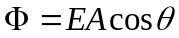
The unit of electric flux is 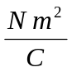 . Qualitatively; flux is the number of field lines passing through a surface. When the angle between the area vector of the surface and the direction of the electric field is greater than 90°, the flux is negative.

C. SOME PROBLEMS
a. Consider the situations shown below. Each picture contains some charge and an imaginary box. In each case, determine if there is net flux through the box. The total electric flux through the imaginary box is the sum of the electric flux through each surface of the box. Remember that when the angle between the area vector of the surface and the direction of the electric field is greater than 90°, the flux is negative. From a geometrical perspective, for a closed surface, the flux is positive if it is leaving the box and negative when it is entering. (We need to discuss this, so remind the instructor when you get to this point.)

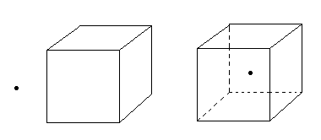

b. The dots in the figure above represent point charges. Qualitatively, what does the flux through the box depend on? When is there more flux and when is there less flux? When is there zero flux?
Explain your reasoning to an instructor.
Gauss’ Law states that the net flux exiting an enclosed surface is proportional to the amount of charge enclosed by the surface. The constant of proportionality is ε₀. The value of ε₀ is 8.85 ×10⁻¹² 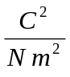. This can be written as

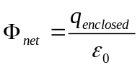
This equation is somewhat difficult to prove without calculus but it is possible to demonstrate. Consider a point charge and a spherical “Gaussian Surface” surrounding it.
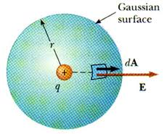
ΔA
We break the sphere’s surface into a gazillion small areas ΔA. What can you say about the direction of the electric field compared to the direction of the vector ΔA?
What is the small amount of flux leaving the sphere ΔΦ?
What can you say about how the magnitude of the electric field varies over the surface of the sphere?
We need to find the total flux leaving the surface of the sphere. This would be . Why did we drop the vector notation in this last equation? Why did we take E out of the summation?
What is the area of a sphere? A=______________________________.
Putting all of this together, what do you get for the flux leaving the sphere? Show all steps. Does this agree with Gauss’ Law?

What changes in the above demonstration if the charge in the sphere were negative?
Who do you think this is?

Answer_______________

On the next pages are a few exercises. If you have time, complete them in class; if not, complete them at home. These concepts are very important.
1) Consider the following boxes. The electric field vectors at the surface of the box are shown.

Determine if there is a net flux through each box. Determine if there is charge inside each box. Explain how you know.

(a)
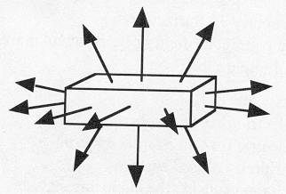

(b)
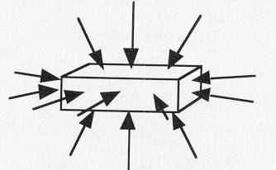

(c)
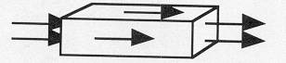
(pictures from Ruth Chabay and Bruce Sherwood, Electric and Magnetic Interactions, John, Wiley, and Sons Inc., NY, 1995)

2) (from Ruth Chabay and Bruce Sherwood, Electric and Magnetic Interactions, John, Wiley, and Sons Inc., NY, 1995)
Here is a disk-shaped region of radius 2cm, on which there is a uniform electric field of magnitude 300 N/C at an angle of 30º to the plane of the disk. Calculate the electric flux on the disk, and include the correct units.

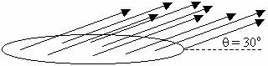

3) (from Ruth Chabay and Bruce Sherwood, Electric and Magnetic Interactions, John, Wiley, and Sons Inc., NY, 1995)
Here is a box on whose surfaces the electric field is measured to be horizontal and to the right. On the left face (3cm by 2cm) the magnitude of the electric field is 400 N/C, and on the right face the magnitude of the electric field is 1200 N/C.

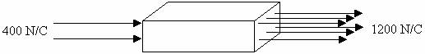

a) Calculate the electric flux through every face of the box.

b) Calculate the total flux through the box.

c) Calculate the total amount of charge that is inside the box.

SUMMARY
You should understand that the area of a flat surface can be represented by a vector. You should understand the concept of electric flux qualitatively and quantitatively and understand Gauss’ Law qualitatively. (We will do more with Gauss’ in class exercises.)

