Spring 2011
STUDIO Unit 02
PHY 2054 STUDIO College Physics II

This unit begins our study of Coulomb’s Law and the Electric Field. Be sure to check for any WebAssignment that has been posted for this chapter. You are certainly free to read ahead in the chapter.

[Coulomb’s law]

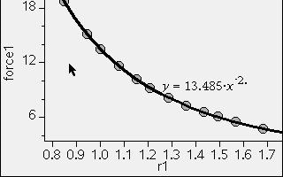

Coulomb’s Law
Record all of your answers and observations either in the space below a question or on an inserted blank sheet. These papers (always) should become a part of your notebook. Always feel free to add pages as necessary.
We begin this session with a game that includes in it, a simulation of Coulomb’s Law. A copy of the game is shown here and can be found (electric-hockey_en.jar) on the class website:

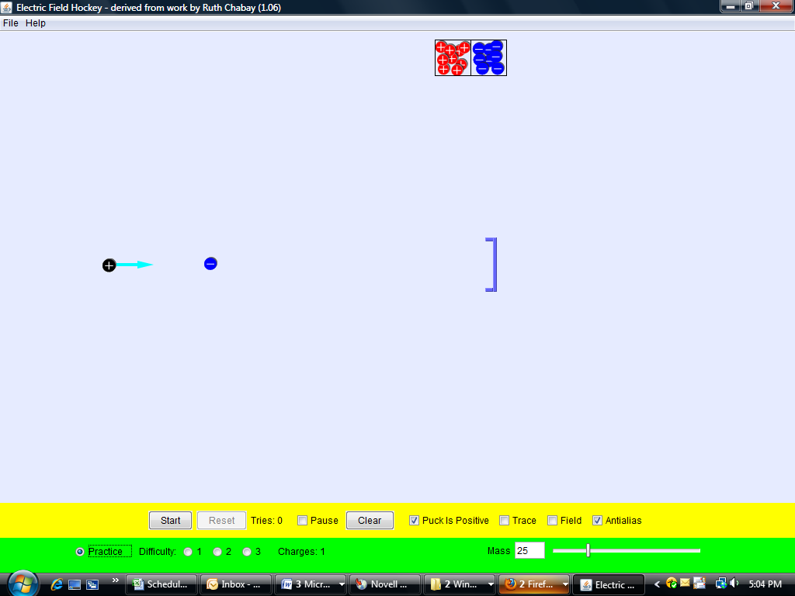
At the left is a puck that can be a positive or a negative charge. At the right is a goal that you want the puck to strike. The puck will move based on a distribution of charges that you can place on the screen by dragging them from the boxes of charge at the top of the screen. The goal and any other barriers that are placed into the game (by level of difficulty) cannot be penetrated by the puck but the force created by the charges can penetrate. Your job is to place charges around such that the “orbit” of the puck will strike the goal. The easy solution to this practice screen is to place a (-) charge behind the goal and let it attract the puck. Try it. Note what happens when you turn on “trace” or any of the other choices from the bottom of the screen.
Notice that the FORCE on the puck (as shown by the arrow) will vary as the distance(s) from the charge(s) are varied. More on this shortly.
Learning from “simulations” is the latest thrust in modern education. A simulation mathematically models a situation in a very real way by including all of the appropriate laws of physics in the computer programs code. One has to take this on faith but one can discard the program if it ever shows a result that does not sync with reality.
A. The Attractive/Repulsive Race
- We start with a race. When you get the signal (after you have a few minutes to get used to the game), set the game for level “1” with a (+) puck and start. When you are able to hit the goal, feel free to yell out! You will be asked to share your solution with the class.
- Repeat for level 2, again waiting for the signal from your instructor to start.
- List two things that you have learned from this game (assuming that you have!). Do you know why these things occur? If you do, write this in your notebook as well.


- In the last session we looked at bringing charged rods close to charged tapes, etc. Qualitatively, how did the interaction depend upon the spacing between the charges? Was this consistent with what you see in the hockey game?

B. “Measuring” It, sort of.
Next, we will look at the “arrow” that represents the force on the puck. You will make some “measurements” of the force on the puck and the distance of the puck from the deposited charge (within limits). You will need a ruler. If one is not available, fold the one shown here and use it even though it probably isn’t very accurate. Don’t worry about the units of the measurement.
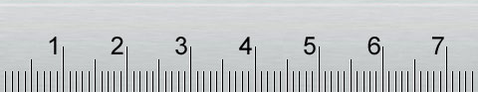
We will start by placing a negative charge a small distance from the puck so that the “force” vector remains on the page and its length can be measured with our “ruler”. The distance between the “charges” can also be measured. A result such as the following will appear:
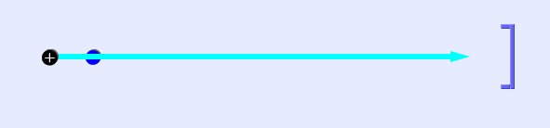
Move the charge a short distance away from the original one and the diagram will change to:
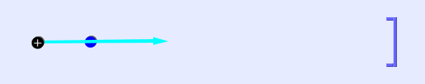
For each position of the charge, you can measure a pseudo-force and a table can be prepared that looks like the following (use Excel if you wish). Ignore units for this chart.
Point # | Distance | Force
1
2
3
4
5
6
7
8
9
10

Here are the next few steps.
- Fill in as much of the table shown above as you can. Make the measurements as carefully as you can.
- Plot a graph of your data. What kind of graph did you plot? Some graph paper is provided below for your use. Your instructor may have additional paper if you need it.
- You probably knew that the force is an inverse square (1/r²), but perhaps it is just an inverse distance effect (1/r). Use your knowledge of graphs, or statistics or magic to DEMONSTRATE that your data strongly suggests an inverse square law. You can use the following graph papers for your data. Use either one or both. You can use EXCEL on the computer terminal (or your own laptop if you wish) and
email your graph to yourself or have one of your group members save it on a Flash Drive and have it emailed to you so you can print it for reference.
- Did you “prove” or at least demonstrate that the force is an inverse square law? Or have you proven something else?? We will discuss your observations. Outline your results for reference.
.
Graph Paper for your use: (log-log if you know how to use it and linear paper if you don’t).

Notes:

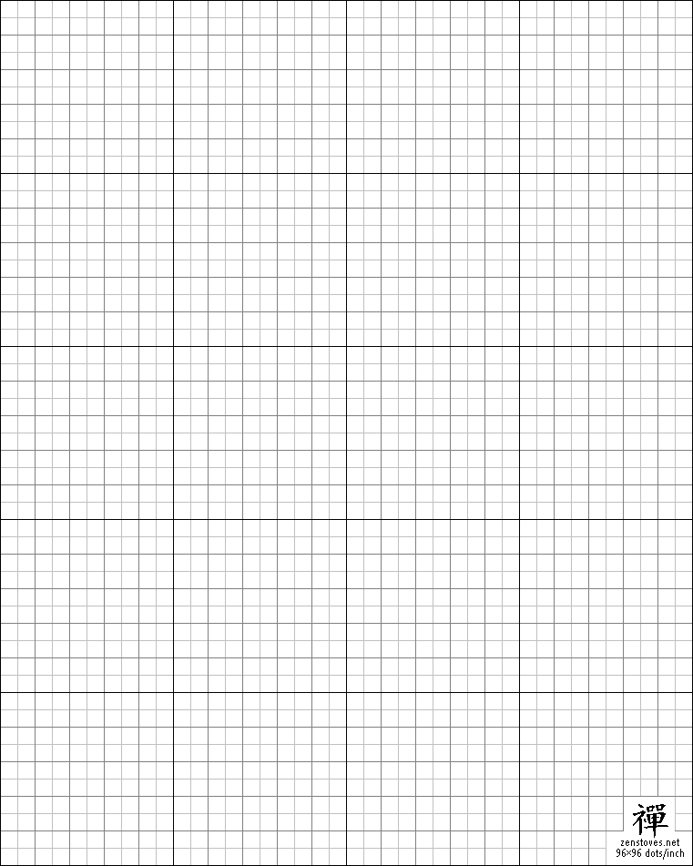
Notes
C. Charge Movement
Charge can move around in some materials and is relatively fixed in others. We now know that charge comes in two flavors: (+) positive and (-) negative. Positive charges are difficult to move (bonding) but the electrons present in the outermost shell of the atoms of which the metal is made of, are fairly mobile and easily move from one place to another. These materials are called conductors. Materials for which these electrons are difficult to move, the charge is relatively immobile and the materials are called insulators.
Here is a simple example of what is called a charge diagram:
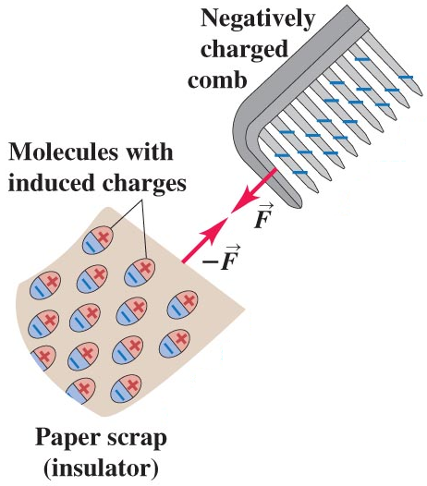
The negative charges on the comb repel the electrons in each molecule in the paper thus creating induced charges, an effect called polarization. Due to this, the side of the paper facing the comb has a slight net positive charge.

Consider a metal (conductor) sphere that is neutral.
Is there ANY charge in or on the sphere?
Now, mentally “sprinkle” the sphere with a bunch of electrons. Keeping in mind that it is common only to draw the additional or added charges, draw a diagram of where the charges are in or on the sphere. Use + and – signs to suggest where the charge resides. In other words, just show where the excess charge winds up.
Answer the question directly on this diagram.
SOLID Metal Sphere

AT THIS POINT THE CLASS WILL BRIEFLY DISCUSS THE RESULTS OF THIS EXERCISE.
Now, consider two identical conducting spheres. One conductor is touched with a rubber rod that has been rubbed with fur. (The rubber rod is found to be negative.) The sphere that has been touched with the rod is now charged. Let’s say that it has a negative charge q. (q is always a positive number so the charge on the sphere is –q.)
Draw a picture of how the excess charge q is distributed on the sphere. As above, use (+) and (-) symbols to do this. Remember that a sphere with charge -q has both positive and negative charges (why?), but more negative than positive charges. The symbol q represents the additional negative charges, the excess negative charge. It is common only to draw the additional charges, with the understanding that the object contains positive and negative charges, but more negative charges. Explain how the charges would be distributed on the sphere. Fill in the charge diagrams.

Initial Sphere Touched by negative rod Rod Removed
Consider two identical spheres (the one we charged and another one) that is uncharged. The spheres are now touched together and then separated, how would the charge be distributed? How much charge would be on each sphere? Draw the charge diagram. Explain your reasoning below.
Charged sphere brought into contact with uncharged sphere and then they are separated.

The charged sphere The uncharged
sphere that is
brought in contact
with it.
Consider the following image:

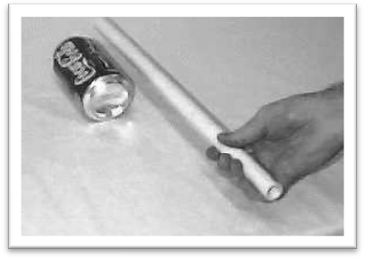
A charged rod is brought near to an empty and uncharged soda can. The rod is charged positively. Draw a “charge diagram” showing how the charge is distributed in the can and use the diagram to explain what happens to the can.
+

Repeat for a negatively charged rod:
-
Explain the can experiment:
Ask your instructor to demonstrate the “can experiment”.
Consider a pair of conductors hanging from non-conducting strings, as in the diagram below. Each of the conductors has a charge that may not be the same.

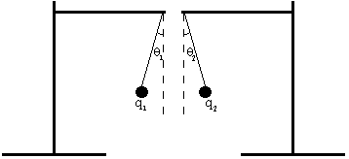

Initially the conductors are placed a certain distance apart. Make predictions for the following situations and draw a FORCE (free-body) DIAGRAM.

a. Initially, how does the angle with respect to the vertical for charge q₁ compare with the angle with respect to the vertical for charge q₂? Explain your reasoning.

b. If the conductors are moved closer together, would the angle with respect to the vertical for each conductor increase, decrease or remain the same? How does the angle with respect to the vertical for charge q₁ compare with the angle with respect to the vertical for charge q₂? Explain your reasoning.
c. If the conductors are moved farther apart, would the angle with respect to the vertical for each conductor increase, decrease or remain the same? How does the angle with respect to the vertical for charge q₁ compare with the angle with respect to the vertical for charge q₂? Explain your reasoning.

d. If the conductors were moved back to their initial position and the amount of charge of each conductor was decreased to q/2, would the angle with respect to the vertical for each conductor increase, decrease or remain the same? How does the angle with respect to the vertical for charge q₁ compare with the angle with respect to the vertical for charge q₂? Explain your reasoning.
e. If the conductors were moved back to their initial position and the amount of charge on conductor q₁ was decreased to q/2 (the other conductor, q₂, still has charge q), would the angle with respect to the vertical for each conductor increase, decrease or remain the same? How does the angle with respect to the vertical for charge q₁ compare with the angle with respect to the vertical for charge q₂? Explain your reasoning.

D. Coulomb’s Law At Last!
Coulomb’s Law states that the force of charged object One on charged object Two, F₁₂, equal to the force of charged object Two on charged object One, F₂₁, (this is Newton’s Third Law), the magnitude of the force is given by

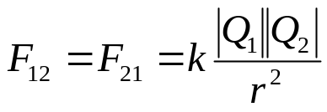,

and the direction of the force is along a line between the two objects. In the equation, Q₁ is the charge of object 1, and Q₂ is the charge of object 2, and r is the distance between the objects. Charge is measured in Coulomb’s represented by the symbol C.
The k in the equation is a constant and has the value 9.0 × 10⁹ Nm² /C².
Coulomb’s Law applies to the force between two small charged objects, so small that all the charge can be considered to be at one point. These are often called point charges.
a. If the sign of both charges is positive,
- which direction is the force of object Two on object One?
- which direction is the force of object One on object Two?
- is the force positive or negative?
b. If the sign of both charges is negative,
- which direction is the force of object Two on object One?
- which direction is the force of object One on object Two?
- Is the force positive or negative?
c. If the sign of one charge is positive and the sign of the other charge is negative,
- which direction is the force of object Two on object One?
- which direction is the force of object One on object Two?
- is the force positive or negative?
d. What does the sign of the magnitude of the force tell you?
UNIT 2 EXERCISES

1) Consider two charged objects lying along the x-axis. A 2.0 × 10⁻⁹ C point charge is located at x = 3.0 cm and a –3.0 × 10⁻⁹ C point charge is located at x = 5.0 cm.
a) What is the magnitude of the force on the negatively charged object due to the positively charged object? What is its direction? Show your work and explain your reasoning.

b) Suppose the –3.0 × 10⁻⁹ C charge is moved to x = 5.0 cm and y = 6.0 cm. What is the magnitude of the force exerted by the negative point charge on the positive point charge? What is its direction? Show your work and explain your reasoning.

2) (from Arnold B. Arons, Homework and Test Question for Introductory Physics Teaching, John Wiley and Sons, Inc., NY, 1994.)
The charged particles A, B, and C, occupy fixed positions at the vertices of a right triangle, as shown. The charges on the particles are all equal in magnitude. Consider only the electrostatic forces between the particles.

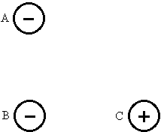

(a) Draw a force diagram for each particle showing all of the forces acting on it. Also draw the net force on each particle. For each force indicate the object exerting the force. Identify all Newton’s Third Law pairs.

(b) If the magnitude of the charges is 2.6 × 10⁻⁶C, and the distance between the charges A and B and B and C is 2 × 10⁻²m, what is the magnitude of the net force on particle A? Show your work.

3) (from Arnold B. Arons, Homework and Test Question for Introductory Physics Teaching, John Wiley and Sons, Inc., NY, 1994.)
Two charged particles are located along the x-axis as shown, a charge of +2C at x = 0 and a charge of -1C is at x = 4cm. We define a region A as that for which x < 0, region B as that for which 0≤ x ≤ 4cm, and region C as that for which x > 4cm.

+2C -1C

x = 0 x = 4cm

- Could the net force on a +1C charge be zero, anywhere in region A? In region B? In region C? Explain your reasoning.

- If you could place any amount of charge at x = 0 cm and x = 4 cm, could you arrange it so that there is no point on the x-axis, other than at x = +∞ and x = -∞, that the net force on a +1C would be zero? Describe them.

SUMMARY
You should understand Coulomb’s Law qualitatively and quantitatively and be able to work problems using Coulomb’s Law and you should understand the principle of superposition. But we really haven’t noted what happens if multiple forces have to be added together.

Of course you already know how to do this, but just in case, solve the following two problems and be prepared to discuss them. If there is insufficient time, please solve these problems in addition to the current WebAssignment
(1) Two equally charged particles, held 3.2 10⁻³ m apart, are released from rest. The initial acceleration of the first particle is observed to be 8.0 m/s² and that of the second to be 11.0 m/s². The mass of the first particle is 6.3 10⁻⁷ kg. What is the mass of the second particle?

(2) For the square in the following figure, what are the (a) horizontal and (b) vertical components of the net electrostatic force on the charged particle in the lower left corner of the square if q = 1.3 10⁻⁷ C and a = 6.6 cm? (Assume the positive directions are upward and to the right.) Be careful to use consistent units.


