STUDIO Unit 07
PHY 2054 – College Physics II

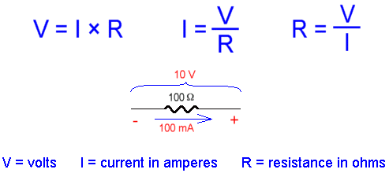

[UNIT 07 DIRECT CURRENT CIRCUITS -II: Ohm]

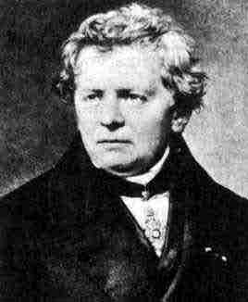

UNIT 7 - DIRECT CURRENT CIRCUITS: CURRENT
(from Lillian C. McDermott and the Physics Education Group, Physics by Inquiry Volume II, John Wiley and Sons, NY, 1996)

Objectives

- to understand qualitatively current flow through circuit elements connected in series and parallel
- to understand qualitatively the total resistance of networks of bulbs in series and parallel
- to understand qualitatively the inverse relationship of current and resistance for networks of bulbs in series and parallel for constant potential difference
- to understand independent and dependent networks of bulbs connected in series or in parallel
- to understand the concept of open circuits
- to understand the concept of short circuits

Equipment:
1 short piece of nichrome wire
1 battery

1.1 Connect a short piece of nichrome wire (looks silvery and is relatively stiff) across the terminals of the battery. Feel the wire. Does the wire seem to be the same temperature across the entire length or are some sections warmer than others? Do a blind test—have someone hold the battery while a second person with their eyes closed touches the wire at different places. What does this observation suggest about the amount of current (charge per unit time flowing) in the wire at one point compared to another point.

NOTE: DO NOT KEEP THE WIRE IN CONTACT WITH THE BATTERY FOR TOO LONG BECAUSE IT WILL LOSE POWER FAIRLY QUICKLY.

Be prepared to discuss your observation with an instructor.

Equipment:
6 wires with alligator clips
3 bulbs
3 sockets
2 batteries
2 battery holders

REMINDER: In these experiments you will be asked to make predictions before deciding on a result or measuring it. It is important that you do this because the thinking that goes into your decision will allow you to grasp the concepts. Predict THEN verify – PLEASE!!

2.1

a. Predict the brightness of the bulbs in the two-bulb circuit shown below compared to the brightness of a bulb in a single-bulb circuit. Will the bulbs in the two-bulb circuit have the same brightness? Will the bulbs in the two-bulb circuit be brighter, dimmer or equally bright compared to a bulb in a single bulb circuit?

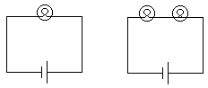


b. Set up a two-bulb circuit and test your predictions. Based on your observations, what can you conclude about the amount of current through each bulb in the two-bulb circuit?

c. How does the amount of current through a two-bulb circuit compare to the amount of current through a single-bulb circuit?

d. Do you think it is appropriate to think about charge flowing (current) through the battery? Explain your reasoning.

Be prepared to discuss your answers with an instructor or with the class if there is a group discussion.

e. How does the current through the battery in the two-bulb circuit in part a compare to the current through the battery in a single-bulb circuit? Explain your reasoning.

Discuss your reasoning with an instructor.

Two bulbs connected as shown in part a are said to be connected in series.

The two bulbs in the diagram on the right are said to be in SERIES.
_______________

Equipment:
6 wires with alligator clips
3 bulbs
3 sockets
2 batteries
2 battery holders

3.1

a. Predict the brightness of the bulbs in the two-bulb circuit shown below compared to the brightness of a bulb in a single-bulb circuit. Will the bulbs in the two-bulb circuit have the same brightness? Will the bulbs in the two-bulb circuit be brighter, dimmer or equally bright compared to a bulb in a single bulb circuit?

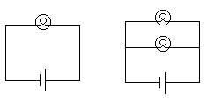
b. Set up a two-bulb circuit and test your predictions. Based on your observations, what can you conclude about the amount of current through each bulb in the two-bulb circuit?

c. IMPORTANT: How does the current through the battery in the two-bulb circuit compare to the current through the battery in a single-bulb circuit? Explain your reasoning.

Be prepared to discuss your answers.

Two bulbs connected as shown in part a are said to be connected in parallel.
The Two bulbs in the circuit to the right in this diagram are said to be in PARALLEL.

Equipment:
9 wires with alligator clips
4 bulbs
4 sockets
2 batteries
2 battery holders

4.1

a. Predict the brightness of the bulbs in a circuit with three bulbs in series compared to a single bulb circuit and compared to the bulbs in a circuit with two bulbs connected in series.

b. Set up the circuits in part a and test your predictions. What did you observe?

c. Suppose you have a closed box in a circuit as shown below. You observe a brightness in bulb A. Imagine someone then makes a change in the electrical elements inside the box. You do not see what has been done. However, you observe that the indicator bulb becomes brighter. What can you conclude about the current through the battery?

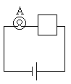
d. Suppose you observe that the indicator bulb becomes dimmer. What can you conclude about the current through the battery? Explain how bulb A is serving as an indicator bulb in this circuit.

We can think of a bulb as presenting an obstacle or resistance to the current in the circuit.

e. When bulbs are added to a circuit in series, as in part a, does the total resistance of the circuit increase, decrease, or remain the same? Does the current through the circuit, increase, decrease, or remain the same? How are the current and resistance related for electrical elements in series? Explain.

4.2

a. Set up a circuit with two bulbs in series, as shown in the diagram below.

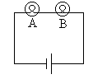

Consider bulb A to be an indicator bulb. Consider another bulb added to the circuit in parallel to bulb B, as shown in the diagram below. Predict whether the current through bulb A, the indicator bulb, will increase, decrease or remain the same.
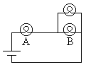
b. Test your prediction. How does the brightness of bulb A change when a bulb is added in parallel to bulb B? How does the current through bulb A change when a bulb is added in parallel to bulb B? How does the current through the battery change when a bulb is added in parallel to bulb B? Explain.
c. How does the total “resistance” of the circuit change when a bulb is added in parallel to bulb B? How does this change in the resistance of the circuit affect the total current through the battery?

d. Summarize how the total resistance of a circuit changes

(i) when bulbs are added in series

(ii) when bulbs are added in parallel

Class discussion may follow this experiment. This is actually very important conceptual exercises so be sure that you give them proper thought.

Equipment:
12 wires with alligator clips
5 bulbs
5 sockets
2 batteries
2 battery holders

5.1

a. Set up a single bulb circuit. Then add two bulbs in parallel, as in the diagram below, one at a time. Is there a significant change in the brightness of bulb A when each of the other two bulbs are added?

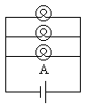

b. Add two more bulbs to the circuit, as in the diagram below. Is there a significant change in the brightness of bulb A when the other three bulbs are added?

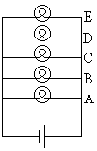

c. In the circuit in part b, predict what would happen to the brightness of bulb E, if bulb A were unscrewed?

d. Carry out the experiment in part c and check your prediction.

In the circuit in part b, we say that we have added four branches in parallel to bulb A. We say that parallel branches are independent of one another when changes in one branch do not significantly affect the other branch.

e. Compare the current through the battery in part b to the current through the battery in a single bulb circuit. Determine whether the current through the battery in part b is greater than, less than or equal to the current through the battery in a single bulb circuit. Explain your reasoning.

Discuss your answers with your team and possibly with the class.

5.2 -THINK THESE THROUGH!!!

a. Consider the circuit shown below.

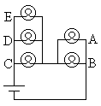

Predict what would happen to the brightness of bulbs A and B, if one of the bulbs C or D were unscrewed. Predict what would happen to the current through the battery, if one of the bulbs C or D were unscrewed.
b. Perform the experiments in part a and check your predictions.

c. Does the total resistance of the circuit increase, decrease, or remain the same, if bulbs C, D, or E are removed? Explain.

d. Does removing bulb D affect the brightness of bulbs C and E? Bulbs C, D, and E are parallel branches. Parallel branches are independent of one another when changes in one branch do not significantly affect the other branch. Are the parallel branches C, D, and E independent or dependent of one another? Explain your reasoning.

e. Under what conditions are parallel branches independent of one another, under what conditions are parallel branches dependent on one another? Explain.

Equipment:
12 wires with alligator clips
4 bulbs
4 sockets
4 batteries
4 battery holders

6.1

a. Setup the following circuit.

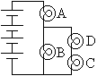

Bulb B is in parallel with the branch containing bulbs C and D. Compare the current through bulb B to the current through the branch containing bulbs C and D.

b. Does the same amount of current flow through parallel branches? Explain. If different amounts of current flow through parallel branches, what determines which branch has more current flowing through it? Explain. Are there circuits in which the same amount of current flows through parallel branches? If so, give an example of a circuit in which the same amount of current flows through parallel branches.
Equipment:
10 wires with alligator clips
3 bulbs
3 sockets
2 batteries
2 battery holders
1 switch

7.1

a. Set up the following circuit.

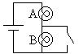

What happens the brightness of bulb A when the switch is closed? Explain.

b. What happens the brightness of bulb B when the switch is closed? Is it possible that there is current through bulb B when the switch is closed? Explain.

When a bulb is in parallel to a wire, the bulb is said to be shorted out.

Discuss your answers with an instructor.

c. Consider the circuit shown below.

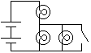

Predict what will happen to the brightness of the bulbs when the switch is closed. Will the current through the battery change when the switch is closed? Explain.

d. Set up the circuit in part c and check your predictions. Summarize your findings.

When bulbs are in parallel with a wire, much more current flows through the wire than through the bulbs and the bulbs are considered to be shorted out.

SUMMARY

You should understand current flow through circuit elements connected in series and parallel. You should understand qualitatively the total resistance of networks of bulbs in series and parallel. You should understand qualitatively the inverse relationship of current and resistance for networks of bulbs in series and parallel. You should understand independent and dependent networks of bulbs connected in series or in parallel. You should understand the concept of open circuits and the concept of short circuits.

