NOTES
Evil Clickers: I have scores but no idea who you folks are. You probably got your clicker from a guy in a raincoat and never changed its registration! Result CLICKER SCORE = 0! Very BAD!
#1EB019B7
#1EC80ADC
#8AAB517
#8B32D96
#8DCB662
#1F589ADD

Monday 12/7 | Review Exam #4  Semester overview
Saturday 12/12 | Final Examination PSY-108 @ 9:00 AM  NOTE: 2 Index Cards Will be Allowed  Pick Up Exam #4 if not distributed previously


STUDY
FINAL
OPTIONS!

PHY-2054 College Physics II (Section 0003)
Dr. J. B. Bindell
Wednesday, December 2, 2009
EXAMINATION #4

INSTRUCTIONS: Be sure to answer all questions clearly. If what you indicate cannot be understood or read it will be considered incorrect. Draw diagrams to illustrate your work and use words to state your approach. Try to avoid numbers until the conclusion of a problem. This makes it easier for you to check your work. WRITE YOUR NAME ON THE TOP OF EVERY PAGE. Good Luck!
PROBLEM #1 (4 points each) Circle the correct answers. If there is more than one correct answer, circle BOTH of them. Leaving out an alternate correct answer will result in half credit for the question. Circling an incorrect answer will have a similar effect.
1.1 If a single lens forms a real image, we can conclude that
A. It is a converging lens.
B. It is a diverging lens.
C. It could be either type of lens.

1.2 An object lies outside the focal point of a converging lens. Which of the following statements about the image formed by this lens must be true? (There may be more than one correct choice.)
A. The image is always real and inverted.
B. The image could be real or virtual, depending on how far the object is past the focal point.
C. The image could be erect or inverted, depending on how far the object is past the focal point.
D. The image is always on the opposite side of the lens from the object.
1.3 Which of the following statements are true about the lenses used in eyeglasses to correct nearsightedness and farsightedness? (There may be more than one correct choice.)
A. They produce a real image.
B. They produce a virtual image.
C. Both nearsightedness and farsightedness are corrected with a converging lens.
D. Both nearsightedness and farsightedness are corrected with a diverging lens.

1.4 An object is 2m in front of a plane mirror. Its image is:

A. virtual, inverted, and 2m behind the mirror

B. virtual, inverted, and 2m in front of the mirror

C. virtual, erect, and 2m in front of the mirror

D. real, erect, and 2m behind the mirror

E. none of the above

1.5 In a Young’s double-slit experiment, the slit separation is doubled. To maintain the same fringe spacing on the screen, the screen-to-slit distance D must be changed to:

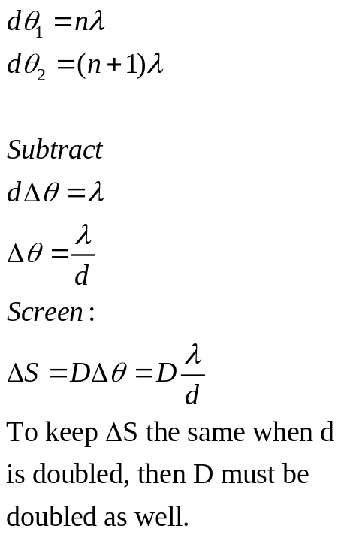 A. D/2

B. D/√2

C. D√2

D. 2D

E. 4D

PROBLEM #2 (25 points)
A concave mirror has a radius of curvature of 34.0 cm.
(a) What is its focal length? (5) 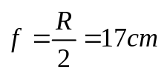
(b) A ladybug 7.50 mm tall is located 22.0 cm from this mirror along the principal axis. Find the location , height and type of image of the insect that is produced. (type =r eal, inverted, etc.) (10)
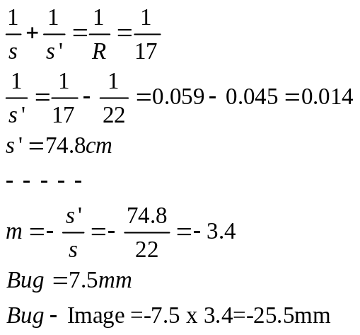
real, inverted

(c) Draw a ray diagram for this mirror example. (5)
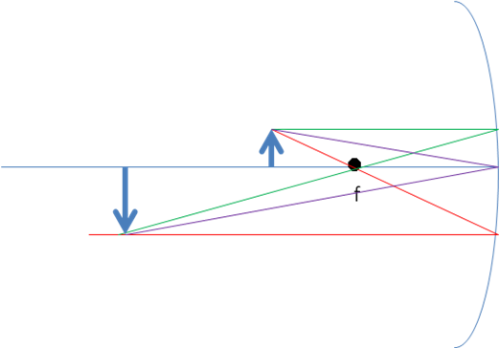
(d) If the mirror is immersed in water (of refractive index 1.33), what is its focal length? (5)
No Change. Not a refraction effect.
PROBLEM #3
A double-convex thin lens has surfaces with equal radii of curvature of magnitude 2.50 cm.
Looking through this lens, you observe that it forms an image of a very distant tree, at a distance
of 1.87 cm from the lens.
(a) What is the index of refraction of the lens? (10)
(b) A second object, an apple, is now placed 4 cm. in front of the lens. Where is the image located? Describe it (real, virtual, sideways, purple … ). What kind of apple is it? (5)
(c) What is the magnification of the object in (b)? (5)
(d) Draw a ray diagram, roughly to scale, showing how the image of the object in part (b) could be located and described graphically. (5)

(a) The object very far away will focus at the focal distance from the lens. So f=1.87cm.
The lensmakers equation will tell us that:
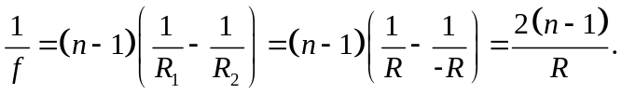
The only unknown in this equation the refractive index.
Solving: n=1.668
(b)Apple: s=4 cm.
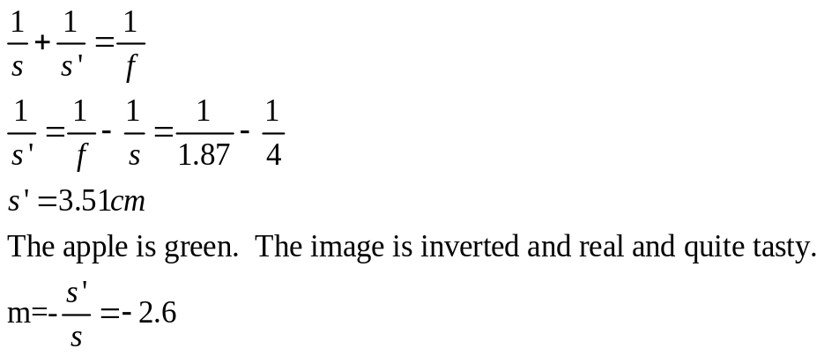

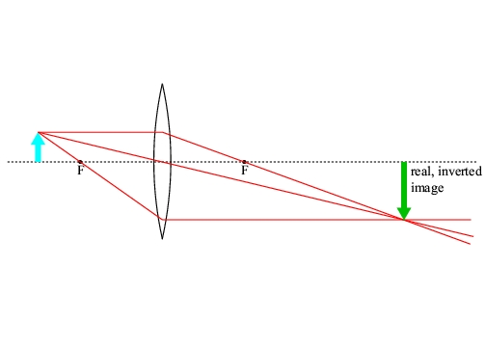
This diagram was stolen from the internet so it is not quite to scale. The object is at “almost” 2f from the lens. That changes the scale a bit but a diagram such as this is quite ok.

PROBLEM #4
Two thin parallel slits that are 0.0116 mm apart are illuminated by a laser beam of wavelength 585 nm.
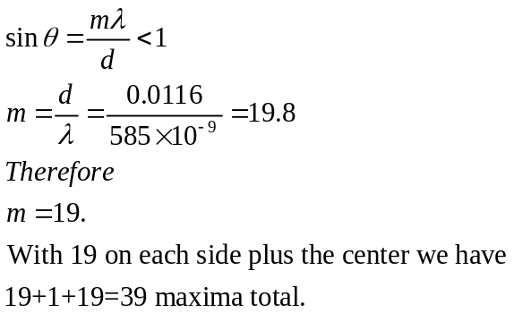(a) On a very large distant screen, what is the total number of bright fringes (those indicating complete constructive interference), including the central fringe and those on both sides of it? [15 points]

We use the double slit equation so that

(b) At what angle, relative to the original direction of the beam, will the fringe that is most distant from the central bright fringe occur? [5 points]
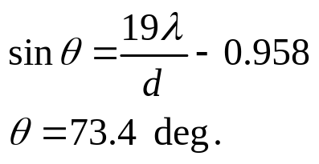

Problem #5 (10 points)
Around harbors, where oil from boat engines is on the water, you often see patterns of closed
colored fringes, like the ones in the diagram. Why do the patterns make closed fringes. Why are
the fringes different colors?
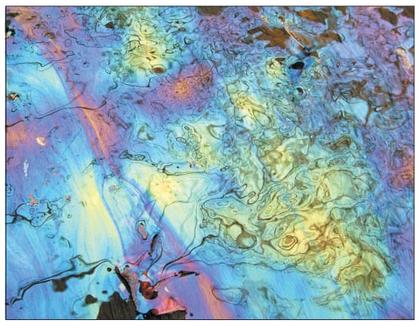

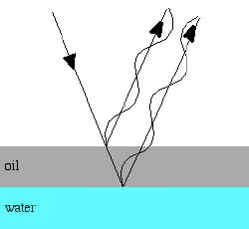
Concepts to mention:
- Each color will have its own interference pattern with maxima and minima.
- The film is continuous so there must be a path around the film of constant thickness. This will result in a closed pattern … again, for each wavelength.
That’s about it. For more information, call the captain of the Exxon-Valdez. 

