Physics for Engineers and Scientists

A Quick Overview of the Vector Cross-Product

In class we discussed the vector cross product **a x b** = **c** and defined it as a vector that in magnitude is equal to  and whose direction is in the direction that a right handed screw would progress if **a** and **b** were on the head of the screw and **a** was turned into (towards) **b**. A diagram of this is:

❑ is the angle between **a** and **b**. It is worth while to spend a bit of time seeing how this fits into our mathematics tools.

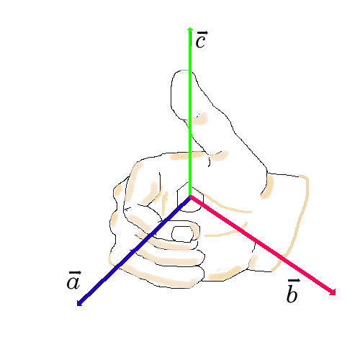

We can apply these rules to the unit vectors **i**, **j**, and **k**.

**i x j = k**

**j x k = i**

**k x i =k**

**i x i = j x j = k x k=0**

**i x j = - j x i** etc.

Actually, it is convenient to use these unit vector operations as the *definition* of the cross section! We then must show that it is the equivalent of the initial geometrical definition. We proceed as follows by considering two vectors **a** and **b** which, for convenience, we place in the x-y plane. That way we can write:

**a**= ax **i** + ay **j**

**b**= bx **i** + by **j**

We now can write:

**a** x **b** = (ax **i** + ay **j) x (**bx **i** + by **j)**

We can now co the algebraic multiplication in this equation as long as we do not change the ORDER of the vector cross product terms. That would be a no no.

Moving along with this threat:

**a** x **b =** axbx **i** x **i +** axby **i** x **j +** aybx **j** x **i +** ayby **j** x **j**

The first and last terms here are zero from the unit vector behavior stated above. Consequently,

**a** x **b =** axby **i** x **j +** aybx **j** x **i**



With

**i** x **j** = -**j** x **i = k** (note minus sign!)

we can simplify this as:

**a** x **b =(** axby - **-** aybx)**k**

This says that the cross product of the two vectors in the x-y plane is in the z direction as we expect from our initial definition.

Notice that we can express this as a determinant as well. (Remember those?)





In this, remember that az=bz=0 in this example.

So the question is how do we get from these last two expressions to the ab sin() concept. Keep in mind that everything here is being done in the x-y plane just for simplicity. If you REALLY want to understand this most important process, follow the rest and then reproduce the calculations in all three glorious dimensions. So, consider the following diagram.

x

y

**a**

b

1

2

r

Now we need to look at the diagram where two angles are indicated. We want to calculate 1 so let’s do some trigonometry. We use the parameters in the diagram as well as the components of a and b which are not specifically shown but we all know what they are. (Right??)

Now it gets a bit sneaky. Notice from the geometry and from the law of cosines, that

r2 = a2 + b2 – 2ab cos()

where   1 - 2.

In a similar fashion, r is the hypotenuse of the small right triangle, so that

r2 = (by-ay)2 + (ax – bx)2

Equate these two expressions for r2 and then square the resulting equation, replacing cos2() with 1-sin2(). After a little algebra, lots of terms drop out resulting in the relationship:

a2b2 sin2() = (axby –bxay)2

Comparing this with **a** x **b =(** axby - **-** aybx)**k,** we see that the theorem has been proven with a remaining issue as to the sign of the square root which only mathematicians worry about!.

Bindell/2049