PHY-2049 Physics for Engineers and Scientists II
PHY 2049C Sections 0003(Lecture) & 0004 (Lab)
SCALE-UP PHYSICS – A NEW WAY TO LEARN

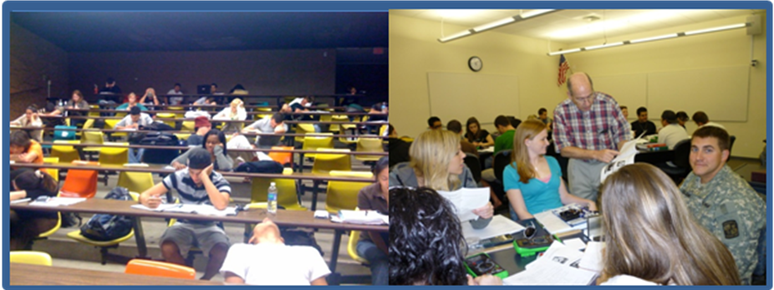
LECTURE or LEARN??

There is a new way to learn Physics for Scientists and Engineers (II) that is spreading around the country. There is documented evidence that shows that very little learning happens in a lecture hall. Attention spans are very limited (~10 minutes) and most learning takes place when a student does homework or studies for a test. This is not an optimum way to learn any subject.

SCALE-UP Physics is specifically designed for engineers and scientists and creates a very different learning environment. Using various approaches, you will be challenged in ways that are exciting and that yield greater understanding. A special textbook is used in this class – “Matter and Interactions” –Volume II- by Chabay and Sherwood (Wiley), third edition.

SCALE-UP Physics (similar to an approach sometimes called “Physics by Inquiry”) does away with 50 minute lectures and labs that are uncoordinated with the lecture section as well as recitations that may or not be covering the questions that you are concerned with. It does this in a number of ways:

1. Labs and Learning are combined into three 2-hour sessions which are a mixture of exploratory experiments and short mini-lectures delivered just when you need them.

2. Recitation and problem solving sessions are coordinated with current work.

3. Students learn by working in teams of three to do experiments, solve challenging problems/exercises and yes, possibly take quizzes together as well.

4. There is a low student to faculty ratio.

5. Each group of three students will have a classroom computer available to them during the sessions.

6. A different textbook, specifically designed to make sure that your learning will be enhanced based on the latest research into how students learn.

7. Not only is talking during class permitted, it is encouraged (as long as it stays focused on the class material).

This method of teaching is becoming the norm at many other universities and you have an opportunity to be a part of this new approach. The first delivery of SCALE-UP is scheduled for the Fall 2011 semester. The lecture and lab sections are linked together so be sure that you register for both sections.
JOIN US IN THE SCALE-UP CLASSROOM!!
Classroom Building I – Room 218

