PHY 1121 Physical Science
“Physics through Music”
Examination #3
November 22, 2004

NAME _____________________ Signature _________________PID ___________

Instructions: Answer all questions directly on the test paper.. Be sure to put your NAME and PID number in the appropriate place on the top of this page and be sure to SIGN your name as well. Put your name on each of the other pages. Show your work in the space provided. You may use the reverse side of the page if you need to. If I can’t read it, it’s wrong!

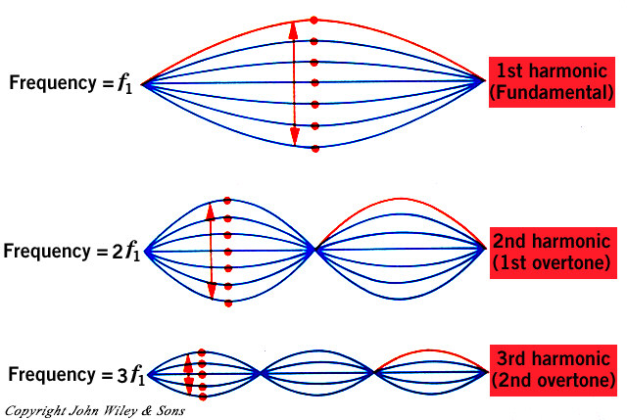
(1) The diagram on the right shows a string of length L vibrating on one of its possible “modes”. The ratio of the wavelength of the mode at the bottom to the wavelength of the mode at the top is
L
(a) 1:2
(b) 2:3
(c) 3:1
(d) 3:2
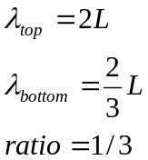

[4] ANSWER _accept anything

(2) A person speaking normally produces 10⁻⁴ watts. (0.0004) How many people should speak at one time if all of the energy was to be collected to light a 60 watt light bulb?
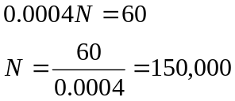

[4] ANSWER __150,000_

(3) Consider the following diagram of the pressure in a flute:

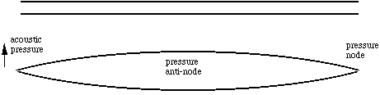

If the length of the flute is L, what is the wavelength of the wave shown?

[4] ANSWER ____2L_____
The following is a graph of the sound from a guitar:
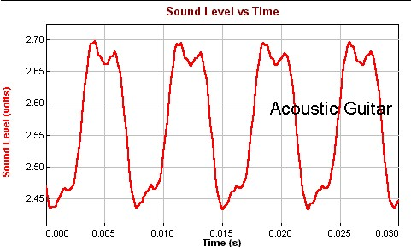

Peal to Peak is approximately 0.004 to 0.012 sec. Period = 0.008 sec
(4) The approximate period associated with this sound (include units) is
[4] ANSWER _0.008 Sec_

(5) The basic frequency of this sound is
[4] ANSWER _125_______
NOTE THERE IS SOME LEEWAY SINCE THE NUMBERS ARE HARD TO RED OFF THE GRAPH. ANYTHING REASONABLE WILL BE OK.

(6) The “frequency spectrum” of this sound is shown in the following diagram.
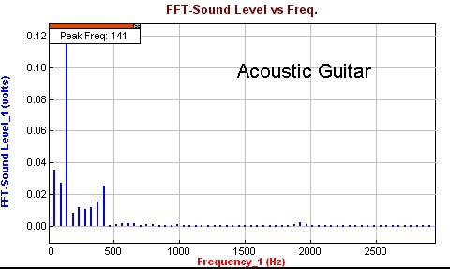

(a) The instrument has an unexplainable timbre.
(b) More than just the strings are vibrating.
(c) The frequencies don’t match what is expected so this is probably NOT a guitar.

[4] ANSWER _____B____

(7) Explain what is depicted in the photograph on the right. [4]
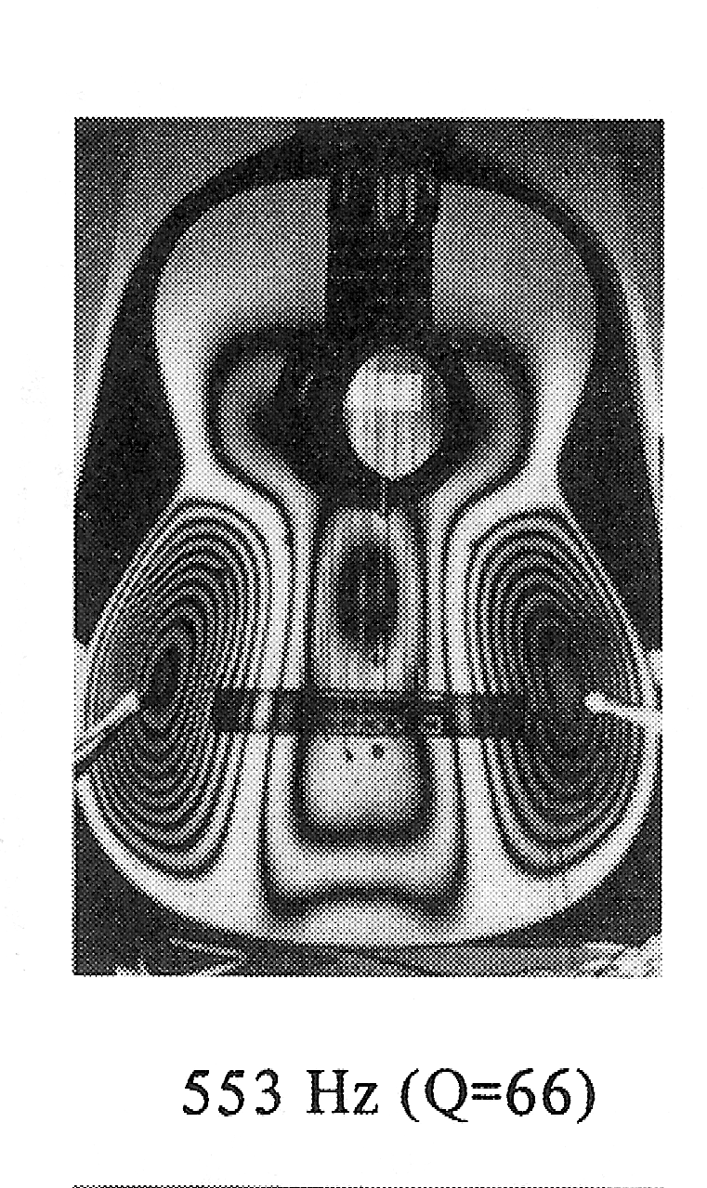
Here I am only looking for a statement suggesting that we are looking at ONE of the many modes of vibration possible fro the face of the instrument.

(8) Two sounds are heard at the same time. The first has a frequency of 440 Hz. and the second has a frequency of 450 Hz. What is the beat frequency?
These are beat frequencies equal to the difference between the two frequencies.
[4] ANSWER __10 Hz.___

(8) What is Fourier’s Theorem? [4]

The basics that I am looking for is that ANY PERIODIC function can be approximated by the sum of sine waves. Overtones would be nice (multiples of the frequency) but the above will suffice/

For the following questions, you may use the fact that the volume of a sphere is (4/3) πR³ and the surface area is 4πR².

(9) A 30 watt speaker is situated 10 meters from a listener. How much energy is produced by this speaker in a minute?
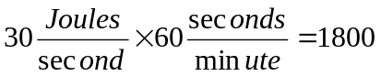
[4] ANSWER _1800___

(10) How much energy strikes a 1 square meter surface at the listener’s position in one second?
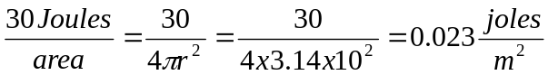
[4] ANSWER __0.023__J_

(11) How much energy strikes a 1 square meter surface at the listener’s position in one second if she moves another 10 meters away from the speaker?
The distance is doubled so the inverse square law would divide the answer by 4. So we want 0.023/4=.00575

[4] ANSWER __.0058 J__
(12) What is the value of log(1,000,000,000)?
(a) 10
(b) 9
(c) 8
(d) 4
[3] ANSWER ____B______

(13) An order of magnitude represents a quantity being multiplied by 10. So, 1000 is one order of magnitude greater than 100. Over how many orders of magnitude is the human ear capable of hearing without damage?
(1) 3
(2) 6
(3) 9
(4) 12
[3] ANSWER ___4_______

(14) A Bass Drum can produce 25 watts of power. If your left ear is located 1 meter from the drum and it has an area of 0.0001 square meters, can the sound cause pain if your threshold of pain is 1 watt/sq. meter?
The power per square meter arriving at the ear is, as above, 25/4πr²=25/4x3.14=2 j/m².
So we are getting 0.0004 w/sq.m at the ear. Much less than pain.

Answer yes or no.
[3] ANSWER _____NO____

(15) Why is there a need for a decibel scale?? [4]

Because the range of hearing varies over such a wide range of values, a compressed range is needed. The decibel scale fulfills this purpose. Reference to wide range of sound intensity levels is sufficient.

(16) In the space below, explain how the human cochlea isolates the frequency of a tone that arrives at the ear. Use whatever diagrams you feel that you need. The following diagram is simply offered as reference. Concentrate on the physics. [8]

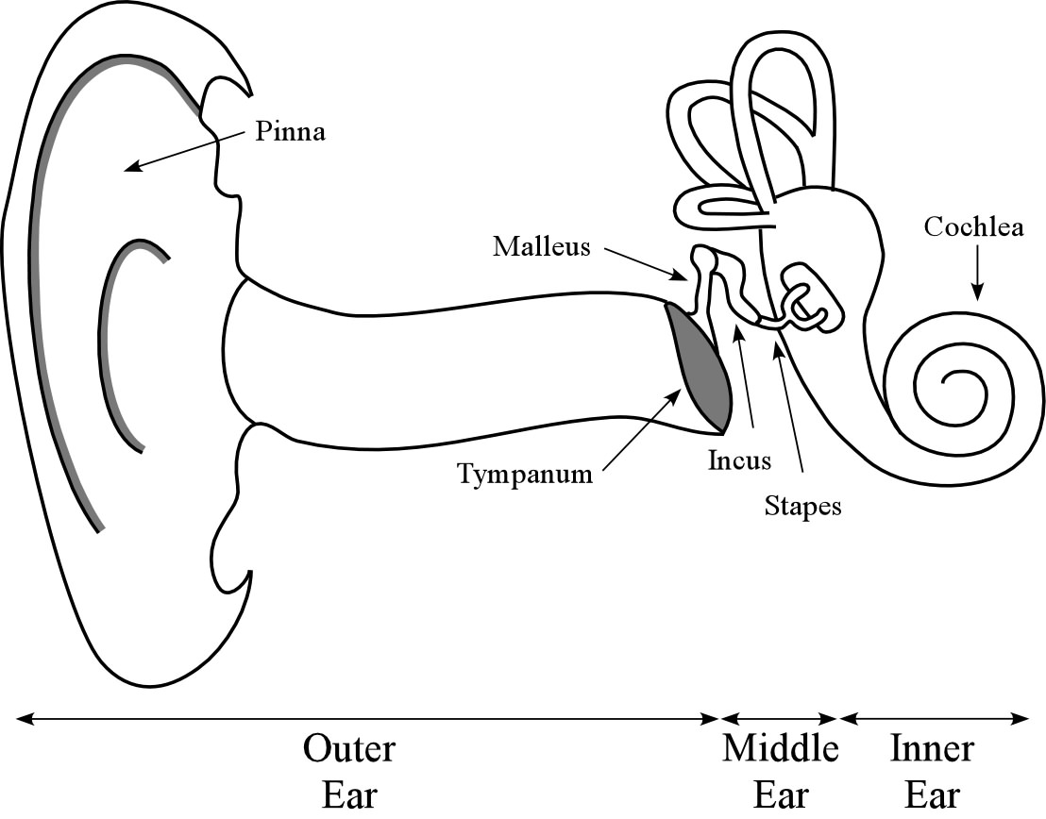

Here I am looking for a reference to the cochlea as containing whose resonant frequency is a function of position along the membrane. The hair cells along the membrane are also forced to vibrate and they send the signal to the brain. The reference to the positional dependence on frequency is basically what I want.

(17) You can lose your hearing after exposure to high levels of sound such as that from a rock band because:

(a) The basilar membrane ruptures
(b) The ear drum ruptures
(c) The hair cells rupture
(d) It fractures the connections from the cochlea to the neurons in the brain
(e) The music is so bad.
[3] ANSWER __B and C are both correct.

(18) Define reverberation time: [3]

The time for a sound in the room to drop to 1/1,000.,000th of it’s initial value.

(20) You can hear someone playing music in another room. The most likely reason is because
(a) The sound can bounce around and get to your ear after multiple reflections.
(b) You can be at a spot where all of the sounds interfere constructively.
(d) The sound can usually penetrate the wall.
(e) You have really good hearing.
(f) The sound is diffracted to your ear.
[3] ANSWER ____A_______
(21) Explain why this Greek Amphitheater was constructed in the way that it was. Use diagrams if necessary. [6]
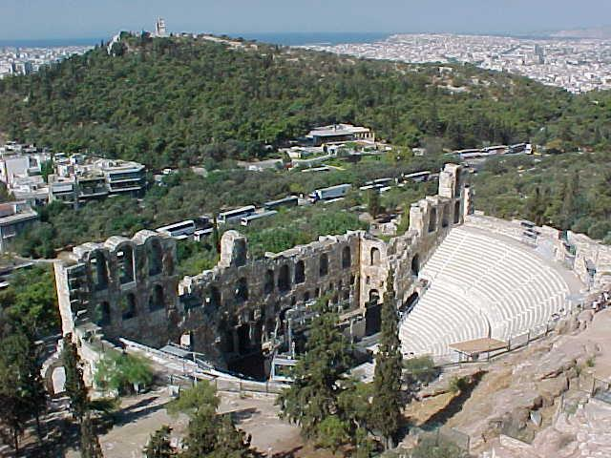
The direct sound from a singer or speaker is too weak to be heard throughout the theater unless a wall is built behind the singer that will reflect the sound and greatly enhance the volume of the sound heard by the listeners. Pretty simple concept!

(22) A room that is optimized for speech is needed for an opera. What can be done to improve the acoustics?
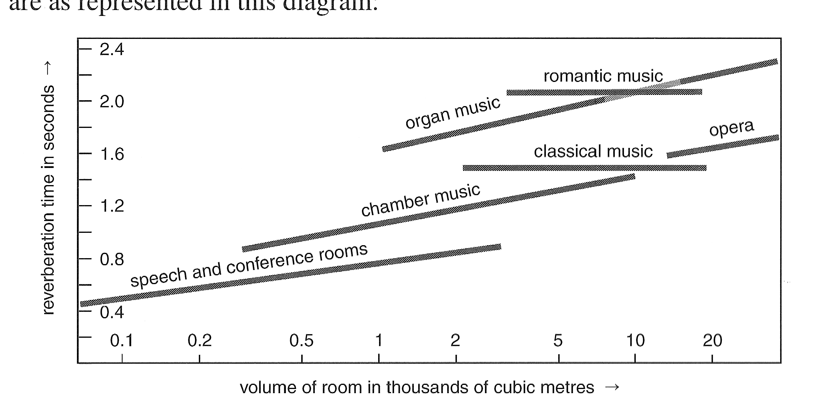
(a) Burn it.
(b) Place rubber padding all over.
(c) Replace all of the walls and ceilings with wooden panels.
(d) Remove the partition between the room and the adjoining room.
(e) Two of the above
(f) Three of the above.
(g) None of the above

[4] ANSWER __C&D are correct. E gets full credit. C or D gets half._________

(23) When the hall is filled with people, the reverberation time will
(a) increase
(b) decrease (less reflection)
(c) remain the same
[4] ANSWER ___B________

(24) The following shows the vocal folds of a singer as viewed from the throat looking down. Which of the three figures (a), (b), (c) represents the lowest tone?
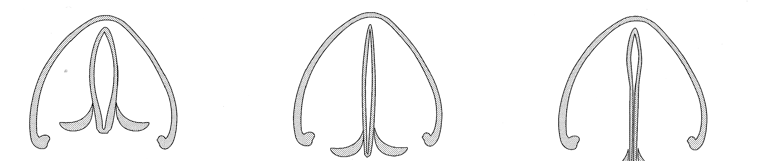

a b c
[4] ANSWER _____A remember the balloon!______

(24) The frequency that one hears from a singer is determined by

(a) The vibrational frequency of the vocal fold,
(b) The effective length of the “resonant tube” produced along the vocal tract.
(c) The power with which the lung pushes.
(d) (a) and (b)
(e) (a) and (c)
(f) (b) and (c)
[4] ANSWER __A&B You need the frequency and the resonance. D is correct. A or B gets ½ credit._________

