Some Introductory Concepts for the Science of Music

Jeffrey B. Bindell
Keith Koons
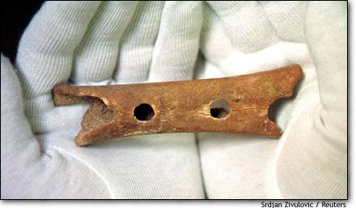
A man (or woman) picks up a flute that has been crafted from the femur bone of a cave bear and begins to play. The sound of the music seems distant yet familiar. The tones are those of the pentatonic scale, a scale that seems to pervade the music of many cultures worldwide. The cave in which the music is being performed is located in Slovenia. The flute, recently discovered, has been scientifically dated to be at least 40,000 years old. The musician (craftsman) has been identified as most likely Neanderthal. His name, if he had one, is lost.

What we can glean from this scenario is that music is very old; older than “civilization” itself. But how did we date the flute? How do we know that this flute was actually crafted rather than being formed by the teeth of another cave bear chomping down on it to puncture holes in order to suck the nourishing marrow from the recently deceased femur owner? How do we know that this flute was played using the pentatonic scale? How do we know what it sounded like? The answer is simple: the application of various aspects of modern science.

Because the science of music includes a great deal of physics and because physics speaks in the language of mathematics (numbers) and graphics, these introductory notes are meant to be a brief discussion of those aspects of these topics that will be important as we navigate through this fascinating topic. It is assumed that the reader is familiar with college level algebra and will not develop hives when some simple concepts of trigonometry are mentioned. With this simple caveat, we begin a discussion of simple graphs.

In order to begin a study of the Science of Music we first must review some important issues, in some of which you may already be proficient. We include the following: the nature of graphs, large and small numbers and a simple introduction to logarithms.

It is a well known fact that investing in stocks is a good way to grow your financial assets over a long period of time. There are two ways to do this. The first is to pick a stock because you like its name (Enron is a neat name) or you can study a stock’s past performance and look into other aspects of the company’s business. The more you know about a stock the better your investment decision can be. Sometimes it is a good idea to look at the value of a particular group of stocks to get an idea if it is a good time to invest your savings. The “Dow Jones Industrial Average” is a good index of the overall performance of the stock market. It is often referred to as “The Dow”. A market (as viewed by the value of the index) that is trending down suggests waiting for a while unless you know something that the rest of the world doesn’t. (Make sure this is not privileged information or you may wind up reading this in jail!) The Dow trend data is available from the internet and the index of the New York Stock Exchange (NYSE) is a good place to start. A small amount of the data that is available about the historical values of the Dow index is shown in the table below:
Date | Value at Close
17-Jun-05 | 10,623.07
16-Jun-05 | 10,578.65
15-Jun-05 | 10,566.37
14-Jun-05 | 10,547.57
13-Jun-05 | 10,522.56
10-Jun-05 | 10,512.63
9-Jun-05 | 10,503.02
8-Jun-05 | 10,476.86
7-Jun-05 | 10,483.07
6-Jun-05 | 10,467.03
3-Jun-05 | 10,460.97
2-Jun-05 | 10,553.49
1-Jun-05 | 10,549.87
31-May-05 | 10,467.48
27-May-05 | 10,542.55
26-May-05 | 10,537.60
25-May-05 | 10,457.80
24-May-05 | 10,503.68
23-May-05 | 10,523.56
20-May-05 | 10,471.91
19-May-05 | 10,493.19
18-May-05 | 10,464.45

Table 1. Values of the Dow Jones Industrial Average closing values over a short period of time.

The table shows about a months worth of closing values from May 18 to June 17, 2005. As you can see, the market improved over this period of time but it also jumped around a bit. In order to see if the drop was consistent over the period it is useful to plot a graph. Graphs are tools that allow us to look at something over a period of time (or some other variable) in a pictorial way. We can look at a graph and get information that we simply can’t easily absorb by looking at a large table of values. A graph of the data in Table1 is shown in Figure 2.

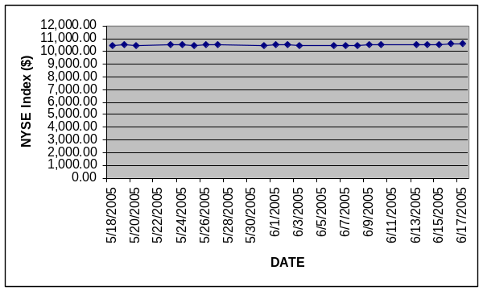
Here we see the elements of all graphs. A graph describes how two variables are related to each other (a variable is something that can take on different values under different circumstances). For example, the closing Dow index takes on a different value every day. In this case, the values are DATE (or time) measured in days and the closing Dow vales are measured in dollars. Let’s look at the vertical axis. Numbers run from $0.00 to 12,000.00. The titles on the axis tell us that we are looking at the value of the Dow index and that the “units” are in dollars. These could have also been in Yen which is why the unit must be explicitly stated.

The horizontal axis is DATE and the dates are listed in a vertical format. This makes it somewhat difficult to read. Because of the size of the writing (for legibility), not every date is listed.

Another strange thing about this graph is that the dates are displayed in groups of five. This is obviously the work week. There is no trading on the weekend so two days per week have no values associated with them.

Figure 3. The graph in a better format.

Another odd thing about the graph is that you can draw a straight line through all of the points and conclude that the index never changed from day to day over the period. But we know that this is not correct by looking at the table of values. The answer is that our choice of scale wasn’t very good. We should have started somewhere near $10,000.00 rather than at $0.00. Doing it this way produces Figure 3.
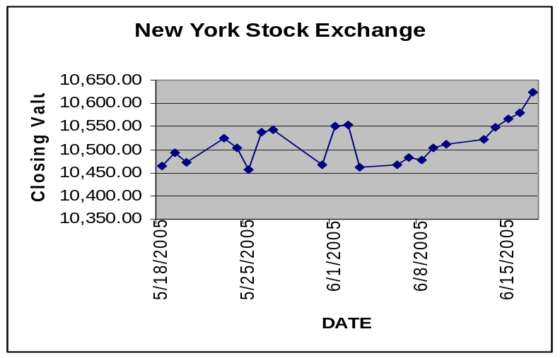

Suddenly the graph becomes clearer. We see that the index generally increased over the period that we have elected to view and we also see that there were some fluctuations over the period. On some days the market went “down” and on others it went “up”. Note that overall, it improved. Also notice how much easier it is to understand the data in graphical form than in tabular form.

What is most important about the graphical display is how quickly we can understand it. We understand pictures so much better than lists of data that a graph is the best route to understanding many types of data. For music, we shall that graphs are all pervasive. Associated with each axis of the graph is a “unit” which the person looking at the graph is usually assumed to know. The vertical axis of our example has the unit of “dollars” and everyone usually seems to “know” what that means. But this may not really be the case. Just exactly what is a dollar? We know the symbol is “$” but do we know what it stands for?

One way to think about what a dollar is, is to consider what a dollar can actually purchase. For many years the dollar was based on something called the “gold standard”. Let’s assume that for our purpose that it still is. Then the value of a dollar could be defined by how much gold a dollar could purchase. But how do we define this “amount”? Perhaps by how many pounds of gold a dollar would purchase. But this raises another question; what is a pound?

What we are alluding to is the fact that in science all terms must be precisely defined. In physics, a pound has a very well defined meaning but it does not describe the actual amount of gold, merely its weight. On Mars, the bar would have a different “weight”, whatever weight is. (We will define “weight” later.)

The “amount” of material present in an object is usually described by its mass. We operationally define mass by comparing it to a “standard”. These standards are usually internationally agreed upon but their actual “value” is determined by some physical characteristics that we will also discuss later. The international unit of mass is the kilogram.
“At the end of the 18th century, a kilogram was the mass of a cubic decimeter of water. In 1889, the 1st CGPM (General Conference on Weights and Measures) sanctioned the international prototype of the kilogram, made of platinum-iridium, and declared: This prototype shall henceforth be considered to be the unit of mass. (The photo below) shows the platinum-iridium international prototype, as kept at the International Bureau of Weights and Measures under conditions specified by the 1st CGPM in 1889.
“The 3d CGPM (1901), in a declaration intended to end the ambiguity in popular usage concerning the word "weight," confirmed that:
“The kilogram is the unit of mass; it is equal to the mass of the international prototype of the kilogram. “
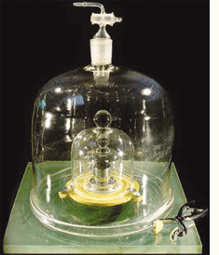
With an unknown mass in hand, one could travel to France and compare your object with the international standard. Of course, they won’t let you near the thing because of the need to keep it as pristine as possible. A system of secondary standards was therefore created by comparing each of them with the Paris model. The United States has a secondary standard that is resident at the National Institute of Standards and Technology located in Gaithersburg Maryland. From this standard, tertiary standards have been created which can be purchased for use in academic or industrial laboratories that need to tie their mass measurements directly to the international standard. We again avoid discussing exactly how to do this for future discussion. But the concept of comparison should be readily grasped for our current needs. Any object that we have can be compared to the international kilogram. If our object contains twice as much mass as the standard contains, we have an object whose mass is 2.0 Kilograms. We abbreviate this as Kg. (To make matter more complicated, the value of gold varies from day to day as well!)
Getting back to our example, at any particular time, people are willing to pay a certain amount of money for a gram (1/1000th of a Kilogram) of gold (if they are actually permitted by law to own gold). This “going rate” commits our graph to some kind of standard and adds definite meaning to the vertical axis.
The horizontal axis has a similar story. This axis reflects time and we measure time in years, months, weeks, days, hours, minutes or seconds. All of these “units” are connected. We know that there are 60 minutes to an hour and 60 seconds to a minute. We can actually treat units as if they were algebraic symbols. Thus,
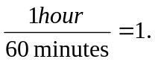
Since we can always multiply something by 1 and not change its value, we can do something like the following:
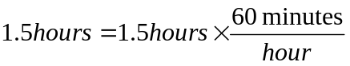.
The “hours” cancel algebraically and we find that 1.5 hours = 1.5 x 60 minutes = 90 minutes. This, of course, is something we already know. But what the heck is this thing that we call an hour? Or a second? Again, it is necessary to define a fundamental unit of time. The definition requires a standard that can be duplicated all over the world. But where can you purchase a bottle of time?
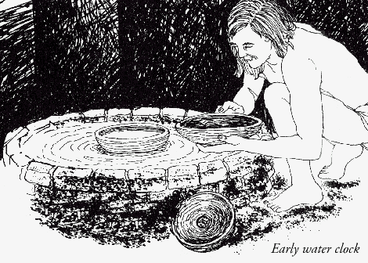
Historically time was loosely measured in days. The meaning of “day” should be clear; it stretches from one sunrise to the next. It was pretty obvious that all “days” had the same length. (Of course, there was no way to verify this.) A journey could be of two days duration. You stewed some meat for about half a day. A short time was a “moment”. In fact, in those days, more exact time measurement wasn’t really necessary. A second was a unit of time that nobody could even conceive of, let alone use for anything.

An early form of time keeping device was the water clock.

“Water clocks were among the earliest timekeepers that didn't depend on the observation of celestial bodies. One of the oldest was found in the tomb of the Egyptian pharaoh Amenhotep I, buried around 1500 BCE. Later named clepsydras ("water thieves") by the Greeks, who began using them about 325 BCE, these were stone vessels with sloping sides that allowed water to drip at a nearly constant rate from a small hole near the bottom. Other clepsydras were cylindrical or bowl-shaped containers designed to slowly fill with water coming in at a constant rate. Markings on the inside surfaces measured the passage of "hours" as the water level reached them. These clocks were used to determine hours at night, but may have been used in daylight as well. Another version consisted of a metal bowl with a hole in the bottom; when placed in a container of water the bowl would fill and sink in a certain time. These were still in use in North Africa in the 20th century.”
The need for a good timepiece from our (science) perspective was not the need that drove the development of clocks. The real driver of clock development was the need to determine a ships longitude and this required an exact knowledge of the rotation of the earth and hence, the exact time which, for example, is not the same in London and Paris. For an interesting discussion of why accurate time measurements were needed for the determination of longitude and why new clock developments were considered military secrets you might want to read “The Discoverers”.
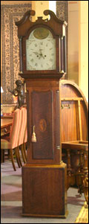
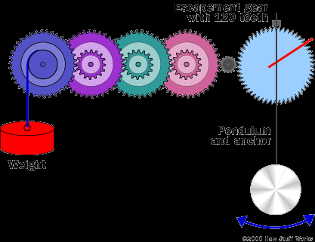
A useful device for recording the passage of time, but not particularly portable, is the pendulum. A pendulum is formed by a mass suspended by a spring from a fixed point above it. If the mass is displaced slightly, it will go from side to side with each complete oscillation taking the same time. But friction slows it down a bit and time or period of the oscillation is not exactly constant. For music, a reasonable use for a pendulum (somewhat modified) would be to beat time. This would be a metronome. But a pendulum doesn’t make a sound at each beat and loses energy (another later thing) so it wasn’t practical. A mass on a spring behaves in a similar way and a reasonable timepiece could be made using a pendulum as a basic time measurement device. One example of this is the well known grandfather’s clock shown above. A mechanical device called an escapement is the secret to its success. The top of the pendulum is attached to the escapement gear which will rotate one tooth position for each time the pendulum swings. The gear is also connected to a suspended weight which is wrapped around the axel of the gear. This provides a “back pressure” and provides a slight bit of energy to the swinging mass. This little “kick” provides the energy to keep the clock ticking. Each tick of the clock allows the suspended weight to drop a small distance so every once in a while the weight has to be raised by the owner to keep it operating. The escapement gear itself is attached to the hands of the clock which actually points to the time scale on the back plate.

We now have a way to measure time, but what about a time standard? A real clock can replace the pendulum by a mass at the end of a spring and the suspended weight by a coiled spring to provide the energy. (Recently, batteries and electronics have made this entire discussion obsolete, but what the heck.) So now the clock becomes portable and can be “matched” to a standard clock. The standard clock is locked behind huge doors and exists in a carefully controlled environment. But even this isn’t sufficient for today’s time standards.
Today we use “atomic clocks” as our international standards. This makes use of some fundamental properties of Cesium and is well beyond the discussion we need to have here. Hopefully, this diversion has provided the simple concept that it is possible to have a standard for time and that clocks can be synchronized so that they all will indicate the same time no matter where the clock may be located. Einstein’s concept of time later screwed up this concept a bit but, since relativity doesn’t do much for music, we will ignore that subject entirely.
We have succeeded in grounding our graph of the stock market index with standards of measurement for each axis. We needed the concept of mass to solidify the dollar and we needed a time standard to completely specify what we meant by the time axis.
Returning to the example of the bone flute, let’s just assume that the man or woman who crafted the flute had some idea about how to construct it. A flute generally has a number of holes in it and it is sounded by blowing either into it or across it. A close look at the picture suggests that the flute artifact is not complete but has been damaged in some way. There are indications that there was originally at least one more hole in the side of the instrument; There is also one additional hole on the other side. By carefully measuring the artifact and be “reconstructing it” based on other, more modern bone flute discoveries, workers came up with the following completed flute (again, assuming that it was a flute).
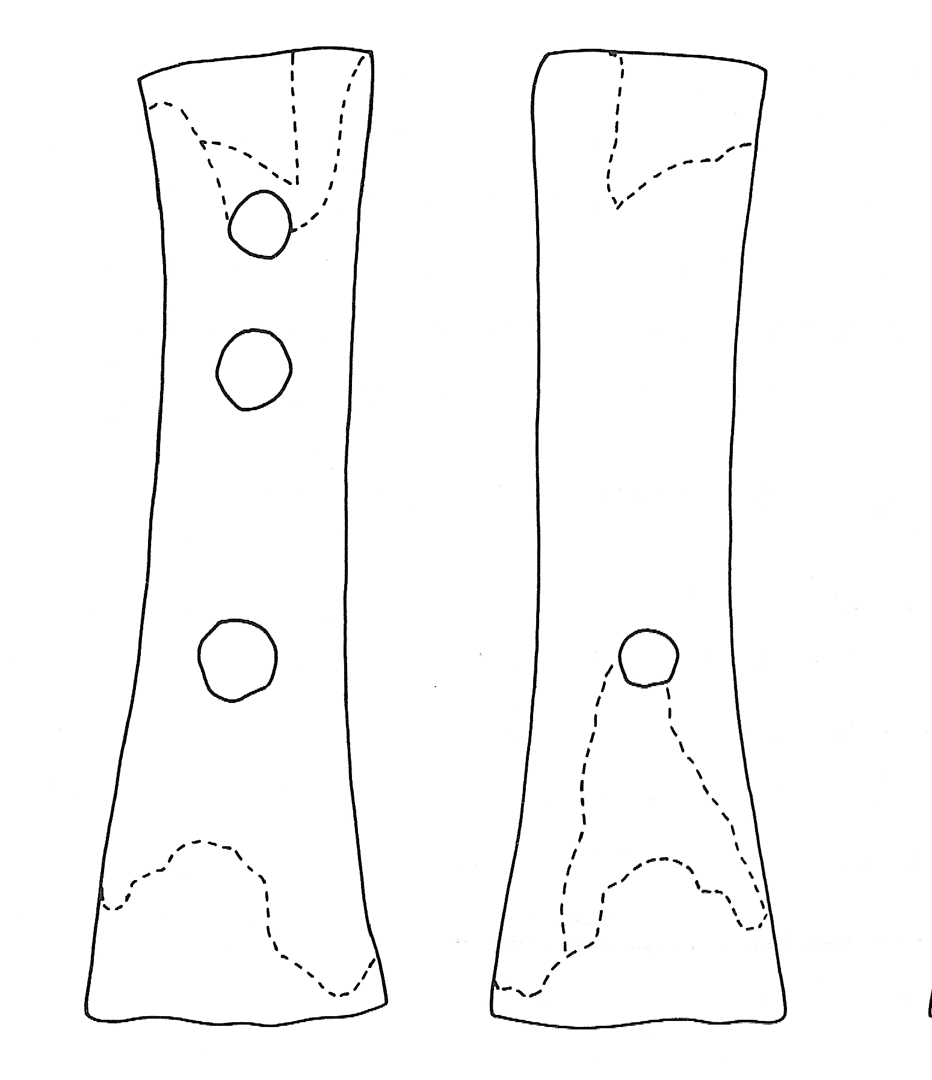
Here we see both sides of the flute which also shows the hole on the bottom of the instrument. The “missing hole” has also been reconstructed and a best guess as to the ends of the instrument has also been supplied. It should be mentioned that other possible reconstructions were also prepared. When the completed instruments were fabricated in plaster and in other materials (including modern animal bone), it was found that a musical scale could be produced (pentatonic). The scale was not perfect, but it was close to a scale. We will eventually discuss this scale in more detail..
So, was this the only such flute made? Although this is the only one found at this (or any other) site, it must be remembered that archeologists only explore very small fractions of what is out there in the field. So, let’s assume that there are others that have yet to be discovered. Clearly the artisan must have had a model of a successful flute to work with and to replicate. So he or she must have measured the positions of the holes somehow before beginning to “drill:” them. A trip to Home Depot was not yet possible so perhaps sticks were cut to indicate each of the critical dimensions and then used to locate the centers of the holes.
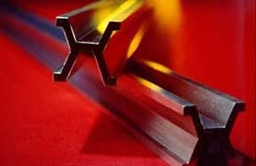
What our instrument maker was doing was creating very primitive measurement standards for length. More recently, a physical standard was established for this purpose. It defined a length of one meter to be the length between two marks on a standard bar stored in Paris under conditions similar to how the other standards are stored. Today “the meter (m) is the SI unit of length and is defined as the length of the path traveled by light in vacuum during the time interval of 1/299 792 458 of a second” which is far more precise. We don’t quite need this level of precision for musical applications!
Over the past few pages we have defined the three major units that are used in physics for measurements and comparisons, although we have not been particularly robust in what we have said. But you should have a fair idea of what is meant by these units. There are other common units in use. Here is a simple table that allows conversion from one type of unit to another. Remember that lengths can only be converted to lengths. A length is never converted to a mass or to a second. They are fundamentally different quantities!
In looking at this table we can see that one foot is the same as 0.3048 meters. We will discuss some of the other entries in this later, including the strange looking numbers in the some of the columns such as 10⁻⁴, whatever that is. Note that one meter is 3.281 feet which is very close to a yard. The original yard was the length of a cloth that wrapped around somebody but we don’t know who. We must assume that the fellow did not like being a standard because of the heavy travel requirements.
Conversion Factors of Length
Unit | m | cm | km | in. | ft | mi
1 meter | 1 | 10² | 10⁻³ | 39,37 | 3,281 | 6,214 x 10⁻⁴
1 centimeter | 10⁻² | 1 | 10⁻⁵ | 0.3937 | .,281 x 10⁻² | 6.214 x 10⁻⁶
1 kilometer | 10³ | 10⁵ | 1 | 3,937 x 10⁴ | 3,281 x 10³ | 0,6214
1 inch (in.) | 2.540 x 10⁻² | 2.540 | 2.540 x 10⁻⁵ | 1 | 8.333 x 10⁻² | 1.578 x 10⁻⁵
1 feet (ft) | 0.3048 | 30.48 | 3.048 x 10⁻⁴ | 12 | 1 | 1.894 x 10⁻⁴
1 mile (mi) | 1.609 | 1.609 x 10⁵ | 1.609 | 6.336 x 10⁴ | 5.280 | 1
Conversion Factors of Mass
Unit | kg | g | slug
1 kilogram | 1 | 10³ | 6,852 x 10⁻²
1 gram | 10⁻³ | 1 | 6,852 x 10⁻⁵
1 slug (lb/g) | 14,59 | 1,459 x 10⁴ | 1
Conversion Factors of Time
Unit | s | min | h | day | year
1 second | 1 | 1,667 x 10⁻² | 2,778 x 10⁻⁴ | 1,157 x 10⁻⁵ | 3,169 x 10⁻⁸
1 minute | 60 | 1 | 1,667 x 10⁻² | 6,994 x 10⁻⁴ | 1,901 x 10⁻⁶
1 hour | 3.600 | 60 | 1 | 4,167 x 10⁻² | 1,141 x 10⁻⁴
1 day | 8,640 x 10⁴ | 1.140 | 24 | 1 | 2,738 x 10⁻³
1 year | 3,156 x 10⁷ | 5,259 x 10⁵ | 8,766 x 10³ | 365,2 | 1
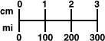
(Note that in some countries, the decimal point is often replaced by a comma.)
Let’s return to our discussion of graphs. Consider the following experiment as shown in the diagram. A mass hangs on a string from a support someplace above. In “equilibrium”, meaning in this case, that it is stationary and not moving, the mass hangs directly above a scale over the number zero. If the mass was moved to the right (as shown) and held there, it looks like it is displaced about 1.3 units to the right. Let us call the distance to the right, the distance “x”. Let us also assume that the unit of measure for x is centimeters (cm=1/100 meter.)

The structure is actually a pendulum and we already know a lot about these because we often come across them in the form of swings, swaying lights, etc. If we move the pendulum to x=1.3 cm and release it, it will gradually swing back to x=0 cm. But when it gets to x=0, it will continue to move resulting in values of x that are less than zero. x is then said to be negative. The mass will continue to travel until it gets to x= - 1.3 cm and will stop there for a very small (infinitesimal) time and it will then swing back toward the origin (where x=0). Without any friction, this motion will continue indefinitely and is referred to as periodic motion. It will just continue to sway back and forth. And back and forth. Kind of boring, actually. But this is a very important type of motion for music.

It is said that Galileo was in church one day and not particularly paying attention to the service itself. He preferred to watch the motion of the suspended lighting candles which were swaying back and forth. He determined (while in church) that each full swing of the lamp took about the same length of time as the next swing. He also might have noticed that the time of swing was related to the length of the suspending rope and not the mass of the lamp itself (later!). It is not clear whether Galileo’s observations of swinging lamps was considered a sin or not, but he later got into much more hot water with the church when he dared to state that the Earth rotated about the sun rather than the converse. This was a BIG TIME sin! Anyway, we can attribute the first thoughtful investigation of swinging pendulums to Galileo.

Let’s consider what a graph of the position of the mass would look like if we plotted its position as a function of time in seconds. It would look something like the following:

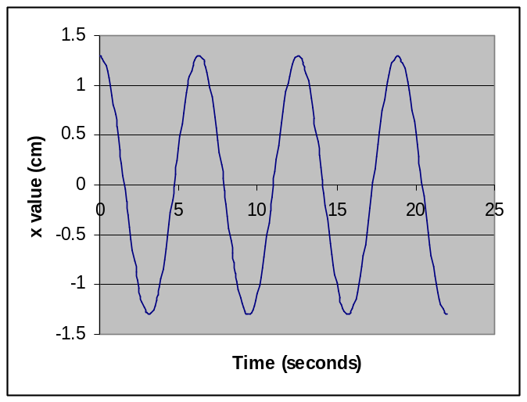

The motion of a pendulum.

The time axis is horizontal and the graph shows time values from 0 to 25 seconds. But there is data only to about 22 seconds. This isn’t a problem since the motion will continue to reproduce itself for a long time (without friction). The vertical axis is the “x” value. The graph starts at t=0 where we release the mass at x=1.3 cm. Looking closely at the graph, we see that the values of the curve span x values from 1.3 cm. to – 1.3 cm., just as we would expect.

The shape of the graph is often called a sinusoid and the oscillating motion is also commonly referred to sinusoidal motion. The shape of the curve is called a sine wave and it is a very important type of graph for music.

Notice that the graph seems to repeat itself approximately every 6 seconds. When t=0, the value of x is 1.3 cm. and when t= ~6 seconds the value returns to x= 1.3 cm. again. Notice that when t is about 1.5 seconds, x=0 and x returns to zero about 6 seconds later at t=7.5 seconds. This repetition time is referred to as the period of the oscillation. It is usually designated by the capital letter T. Its units are seconds. Whatever the value of x is at any time “t”, it will return to that value t+T seconds later and it will be moving in the same direction. (Try putting some numbers into this.) The period of this graph is therefore said to be about 7.5 seconds. We often write this as T~7.5 seconds. The “~” sign means approximately and we write it this way because we estimated the value from the graph.

From the same graph we see that at t~2 seconds and at t a little less than 5 seconds the value of x is zero. But as we move forward in time, the motion is downward and then reverses itself. At t~5 seconds, the motion is up but the value of x is again zero. These two zero values can therefore NOT be used for calculating the period because they are not “equivalent” points.

Here is a puzzle. If something has a period of T seconds, how many full oscillations will it make in one second? If T=1 second, then it clearly will oscillate one time in one second. Suppose T=0.5 seconds. It will oscillate once in one half of a second and twice in a full second. If T=2 seconds, it will only go through half of an oscillation in one second.

We call the number of complete oscillations per second, the frequency of the oscillation and designate it by the symbol f. Note that in each example in the last paragraph, f=1/T (do the arithmetic) and has units of (1/seconds). This is usually designated as sec⁻¹, but this is another “later”. So, we specify the following for oscillations:

The PERIOD, T is the time it takes to go from one condition to the next time that exact condition is repeated.

The frequency, the number of oscillations per second, is given by:

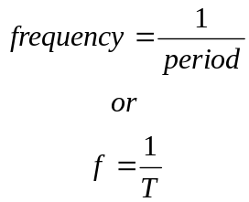

These equations (or formulas, if you must use that term) are very important in music and it is important that you understand them.

Before we can really talk about music we need to talk about sound. Everything that we see and hear is the outcome of some external stimulus arriving at one or our “receivers” such as the ear, the eye or the skin on our bodies (heat, vibration, etc.). The receiver transmits the “signal” to the brain where it is eventually interpreted in the cortex.

With this concept in place, the question of the tree falling in a forest making a noise if nobody is around to “hear” it is easily answered. If there is no receiver or brain present, there is no sound. But whatever it is that travels from the tree to your ear is still present in the air but it never hits your ear because you’re not there. We will discuss more of this later but it is only the brain that can translate the disturbance in the air into what we call a sound.

There are many different kinds of sound. Some sounds are easy to listen to and some are not. We enjoy the sound of the ocean and of the waves crashing on the beach. We enjoy it because it is a sound that our brain presumably likes to hear. Perhaps it is because we once lived in the ocean (when we were fish) or perhaps we once lived near the ocean (as apes) and these sounds meant something such as a food supply or an opportunity to take an enjoyable swim.

Some sounds are not pleasant. A piece of chalk squeaking across a blackboard is definitely NOT a pleasant sound which is why we now use “whiteboards” and markers in the classroom. Breaking glass also produces an unpleasant sound. But when somebody whistles, the sound produced is relatively pleasant. Steel bars when struck with something also can sometimes make a pleasant sound as well. A sound that we enjoy hearing is often referred to as a musical sound or, sometimes, a tone. We need to be careful with this concept but it isn’t too far from the truth.

Our society is constantly barraged with music of all kinds. Most of it can be broken down into a series of tones or notes which are sequentially processed in our brains as something we often refer to as a tune. “Happy Birthday to You” is a common tune that we all know. It is a very simple tune with very little depth to it. But we all sing it or have it sung to us on our birthdays even though it is probably the most boring piece of music ever written (or perhaps, evolved).

Tunes consist of a sequence of what we will call tones. We all know what a tone is. We hear them all the time. There are “high” tones and “low” tones and tones in between. In a song or a tune, there is a certain separation between the tones and we recognize that there are only certain tones that fit into a tune. Some tones don’t seem to fit. They are wrong, whatever that means. But what exactly is a tone or a note. There is a huge history of exploration of tones and what they are but it appears that Hermann von Helmholtz (1821-1824) was the first to attempt to understand them.

Helmholtz noticed what we all have noticed at one time or another. If you blow across the opening of a bottle of soda, you hear a relatively clear tone. The tone seems independent of how hard we blow but it changes with the volume of the bottle. Adding a little liquid to the bottle seems to raise the tone to a higher one. Larger bottles provide a sound that is “lower”. With an appropriate series of bottles, we can probably play a melody and some performers have done exactly that. With time, though, the bottles go out of tune because of evaporation of the liquid which shifts all of the tones a bit lower, but not uniformly so.

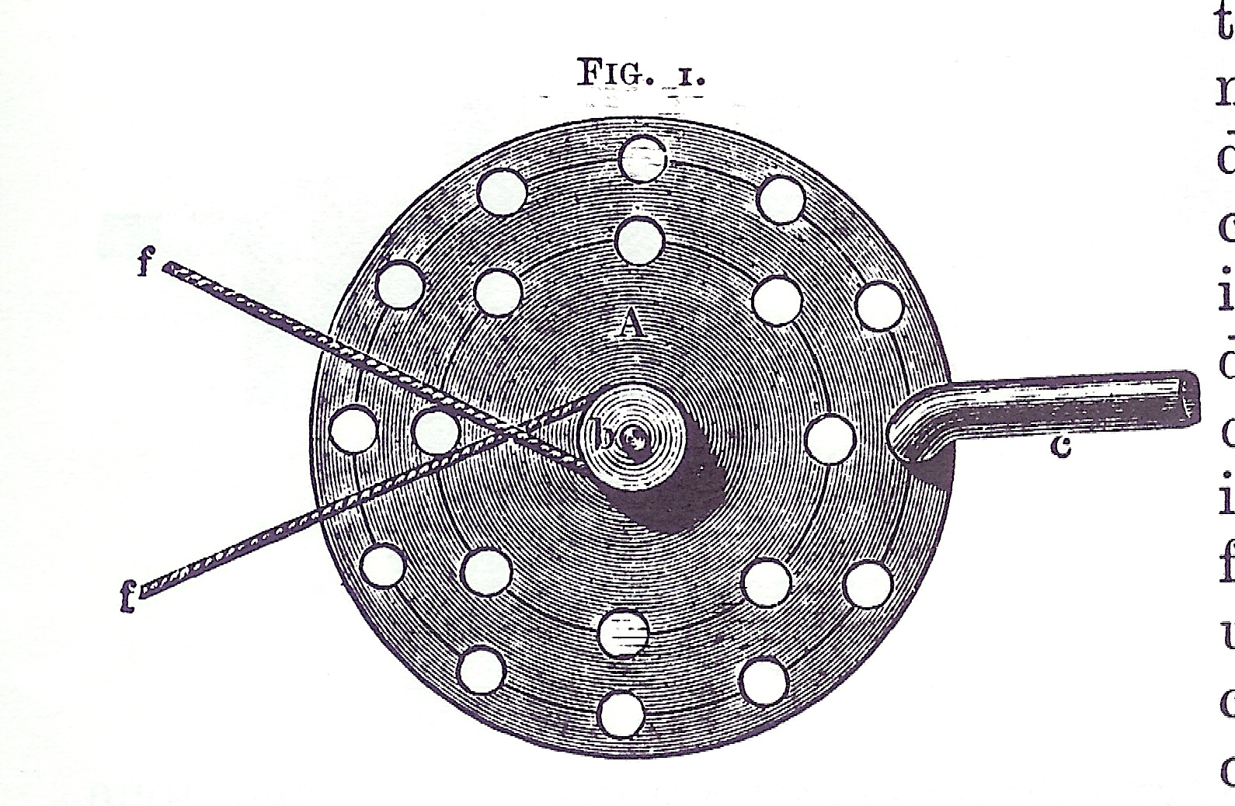
Helmholtz made good use of this effect and the bottles are a form of what is now termed “Helmholtz resonators”. “Resonator” is another term we will discuss later. In conjunction with this observation, Helmholtz also worked with a siren. A siren is an interesting device which is shown in simplified form in the figure to the left which is taken from Helmholtz’s book. The tube on the right of the diagram allows a stream of air to be directed onto the round plate which has a series of holes drilled through it. Consider the outer circle of holes which contains 12 holes. If the plate is rotated at four rotations per second, 48 puffs of air will pass through the holes each second as each hole passes below the tube.

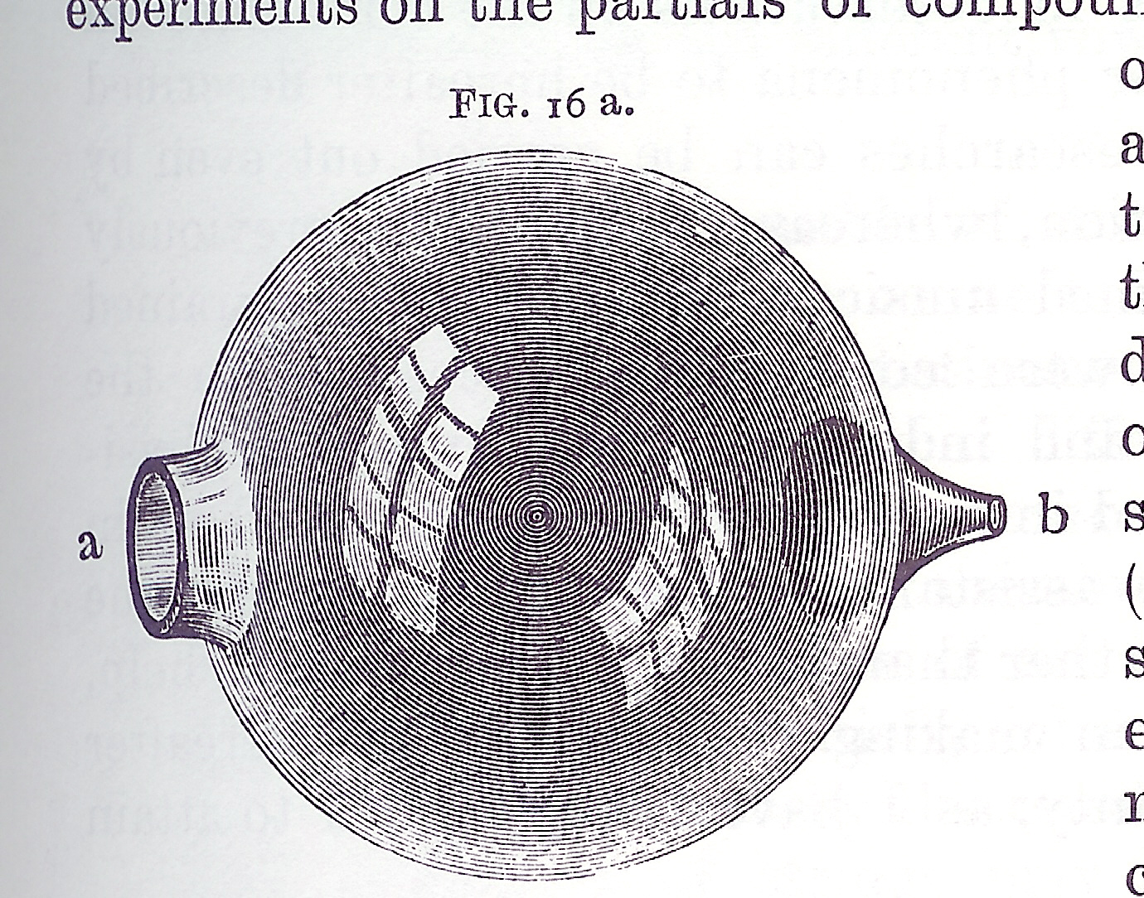
Imagine yourself to be on the other side of the plate. What Helmholtz noticed was that he placed his ear near the plate, he actually heard a sound. The sound had a distinct “tone” and was relatively pure. When he turned the crank faster, the tone was raised to a higher one. Helmholtz then decided to use one of his bottles that he had specifically designed for his tonal investigations. A diagram of this bottle (resonator), also stolen from his book, is shown here. The resonator is spherical in shape and has a large opening on the left and a smaller, open, protrusion on the right that was just shaped properly with wax to fit into his ear.

The experiment that Helmholtz then performed was interesting. With the siren spinning, he placed the smaller end in his ear and the larger next to the source of the sound. What he heard was very little. This was a bit surprising because the siren was not particularly quiet. He then began to increase the speed of rotation by cranking faster. As he did so,
the detected tone began to “rise” until at one rotational speed, he heard it quite clearly while as he continued to increase the rotational speed, he once again couldn’t hear it.
Rotational Speed
(Turns/second)
Loudness
There are two very important results derived from this experiment and both can be described by a graph of something verses something. A guess as to what his experimental data might have looked like is shown in the diagram above. On the horizontal axis is plotted the rotational speed (rotations per second) and the vertical axis is the subjective loudness of the tone produced by the siren as Helmholtz heard it. The result was quite surprising and we shall discuss it in detail shortly, but the diagram has a very surprising feature. For most of the rotational speeds, Helmholtz heard very little, but at a very specific rotational speed, he heard a loud tone coming through his bottle. At higher rotational speeds, the sound died down again. The tone he heard was the same tone that he heard when he blew across the opening of the bottle!

Before we explore this graph further, let’s consider another graph, this time of the puffs that emerge from the siren as a function of time. We have to decide exactly what we wish to plot on this graph. The time axis is simple but what do we plot as the other axis? The speed of the air passing through the hole is a reasonable choice and we shall choose it with the caveat that we shall later plot something called pressure. If you already know what pressure is, use that in your mind as you interpret the graph. If not, the velocity idea is OK for now.

We can easily figure out what the shape of this particular graph is. When the air stream does not overlap a hole in the plate of the siren, nothing comes through. The exiting airspeed (just plain speed for now) would be zero. As the hole passes through the air stream, the speed would begin to increase and would be a maximum when the hole and the air tube line up. It would then decrease but would repeat as the next hole passes by. So the graph probably looks like the next diagram.
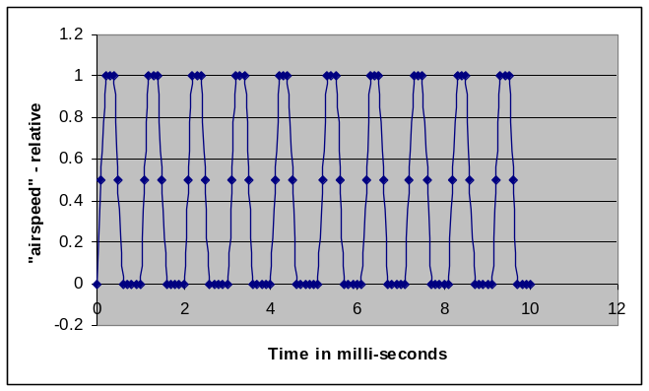

The time axis is plotted in milliseconds which are each 1/1000th of a second. At the beginning of the graph we do not detect any level of airspeed coming through the plate but it then begins to increase slowly to some value as the hole passes through the air stream. Assuming that the hole is bigger than the orifice of the air tube, the airspeed will remain constant for a while and then decrease again to zero. It will remain zero until the next hole comes around and the process will repeat again. And again, and again, until we stop the disk from spinning or we stop the air stream. When you listen to the sound of the siren, a tone is sounded that can be matched by a tone on a violin if the violinist puts his finger at exactly the right place.

If we take a careful look at the diagram we can note that the signal is periodic. This is a VERY important result. From it we can (almost) conclude that a steady musical tone is periodic disturbance in the air.

If we examine the graph for corresponding points of each cycle, we see, for example, that the curve is at zero and rising at t=0 and at t=1 millisecond. This means that the period of the tone is 1 millisecond or one thousandth of a second. Since the frequency, f, is 1/T the frequency of the tone is:

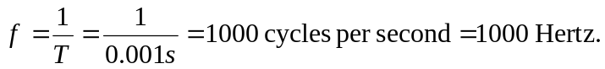

So the frequency of our sound is 1000 Hz. This is a fairly “high” tone on our musical scale.

Helmholtz recognized that his resonators could be constructed for any tone he could produce and, in particular, for each tone of our musical scale. A modern set is shown in the photograph.
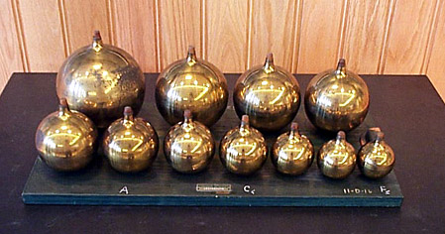

One could ask how the musical scale mentioned above is actually known without this “frequency concept”. The answer to this is that the scale was basically created “by ear” using stringed instruments and by varying the length or “tension” in the string to change the tone. For example, if the length of a guitar string is divided in half, the new tone produced will sound very much “in sync” with the original tone and will, in fact, be an “octave” above it. So, by the time Professor Helmholtz began his work, the musical scales were all well established.

The larger the size of the resonator, the lower is the tone. At one side (visible) is the opening that you would place next to the tone source and the other end (that you cannot see) is the piece that you put into your ear. As a result of careful work, Helmholtz was able to determine the frequencies for all of the tones that we currently listen to in our (Western) music. Some of his results are as follows:

Note from Middle C | Frequency
C | 264
D | 297
E | 330
F | 352
G | 396
A | 440
B | 496

We currently define the frequency of the “A” in the table to be 440 from which all of the other frequencies can be determined. The important point here is that musical “notes” are periodic disturbances but are not necessarily sinusoidal. An example of this is the “loudness” vs. time plot of the sound from a guitar string being plucked that us shown below.
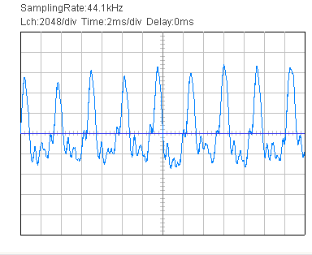
This graph looks a bit different. Neither of the axes seem to have labels but there is some information written on top of the diagram that helps. The horizontal axis is the time axis and the text states that there are 2 ms/div. “ms” is the abbreviation for milliseconds which are thousandths of a second and “div” stands for “division” and is the horizontal distance between two successive vertical grid lines. The vertical axis is the output from the microphone that was used to generate the graph and we will just consider that to be loudness for now. Looking at the graph we see that it is periodic. Almost. The real world is rarely exactly as we would expect it to be. The graph is almost periodic with each pattern “almost” repeating itself. The distance between two consecutive peaks in the graph is the period T. We see that T is approximately 1.8 units and since each unit is 2 ms (milliseconds), the period is 3.6 ms or 0.0036 seconds. The frequency is

1/T = 1 / (0.0036 sec)

and is easily calculated to be 278 Hz. The guitar is clearly out of tune because the frequency doesn’t correspond to any of the notes of any open guitar string. If it were found to be 248 Hz. it would be the B string which was indeed what was plucked. The guitar was clearly “out of tune”.

The periodicity of the graph is easily recognized but the signal is clearly not sinusoidal. There are numerous “wiggles” in the curve which we will later analyze in detail. The important point is that we are looking at the time “record” of a musical tone as produced by an instrument. The tone is periodic and has an identifiable period and frequency. In an actual musical performance, there are many musical tones of many different frequencies playing at the same time for different durations. Our brains seem to be able to dissect these sounds and comprehend a pleasing (musical) sound!

It is of interest to know that the human ear can perceive tones as low as 20 Hz. and as high as 20,000 Hz. but not everybody can actually hear this range and individual hearing ranges tend to degrade with age.

An important relationship between two musical tones is the octave. The octave is a tone that is higher than the tone that we start with. We call the original tone the fundamental and the octave is a higher tone that sounds really good when played simultaneously with the fundamental. In fact, we can often be fooled into thinking that the octave sounds almost “the same” as the fundamental. They clearly just go together. But the octave is higher in tone (frequency) than the fundamental and is eight musical tones above it, hence its name.

Let’s take a look at another series of graphs.
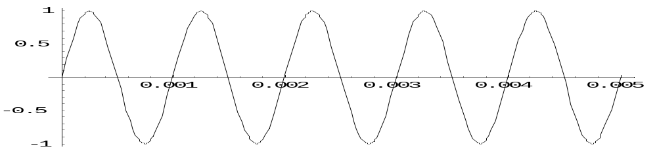
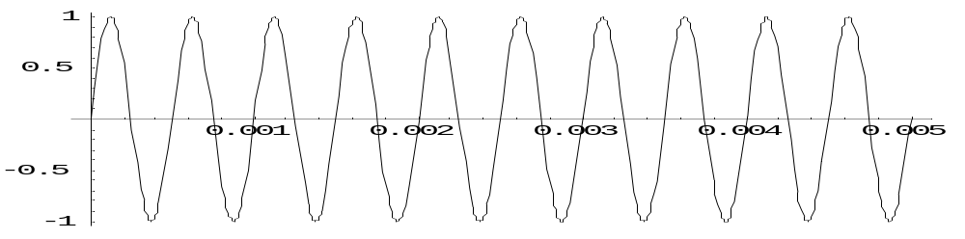
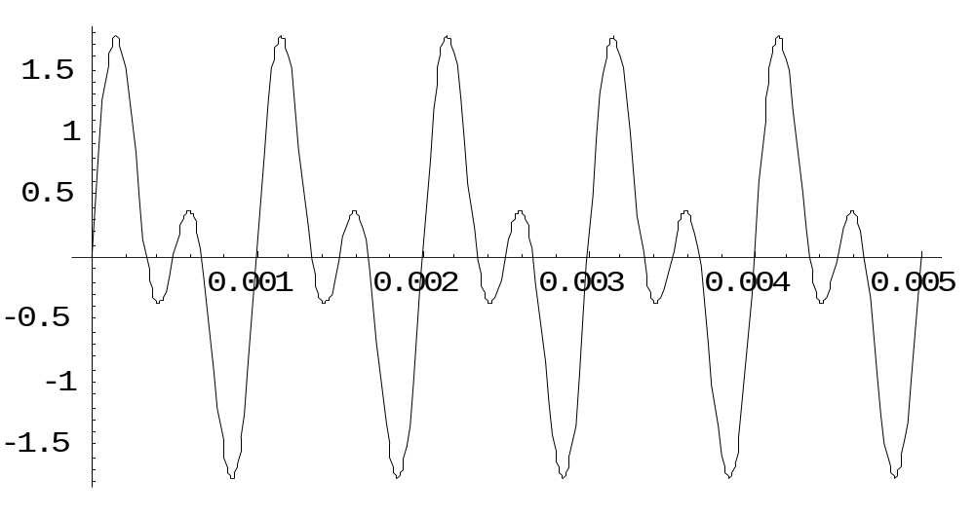

(a)

(b)

(c)

Graph “a” shows the fundamental sound level as a function of time. The units are seconds and we see that the graphs only cover a short period of time. Notice that the top graph of the fundamental sound (foe this example, anyway) contains five full cycles and that the graph extends over a time of 0.005 seconds. So the period is one fifth of this amount of time and is easily seen to be 0.001 seconds. The reciprocal of the period is the frequency (as before) and the frequency is therefore 1000 Hz. (cycles per second.)

Graph “b” is a similar representation of the octave which therefore has a frequency of 2000 Hz. This is twice that of the fundamental. There are therefore 10 full cycles shown on the graph which spans the same 0.005 seconds.

Each of these two graphs can represent the sound that reach the ear from each of these two frequencies. But when the two are heard at the same time we must add the two graphs to see what the sum looks like in a graph. This sum is shown in “c”. This new graph doesn’t have the same shape as either of the first two “sinusoids”. But the graph clearly is still periodic because it repeats itself over and over again. Notice that there are five fully cycles of the sum shown on the last graph and that the period of the “sum sound” is 0.001 seconds which is exactly the same as the period of the lower of the two frequencies. The lower frequency is usually referred to as the fundamental frequency. So it shouldn’t be a surprise that the octave sounds similar to the fundamental, at least to our ear. The “character” of the sound is somewhat different and we refer to this character of a tone as its timbre, a term we shall use continuously in our future discussions.

There are other tones that sound well when played simultaneously with the fundamental and these tones are those that are used to build up the musical scales that we are familiar with. But it must be kept in mind that no musical instrument actually plays a single sinusoidal tone. All instruments actually emit a series of different frequencies simultaneously and it is the combination of all these frequencies (tones) that we use to define terms such as the octave. Fortunately, for reasons that will become evident later, we arrive at the same relationship for the octave.

Now that we know what the two most “consonant” tones sound like together, it is interesting to look at two tones that to not go well together when they reach the ear. We are back to single tones for the moment rather than sounds from real instruments. Consider the next set of graphs shown below:

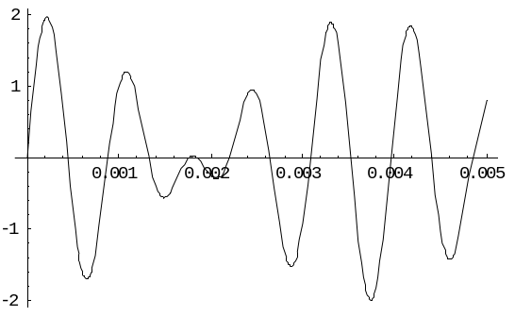
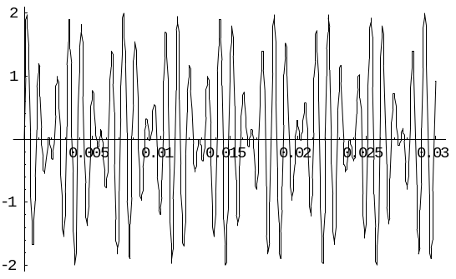
(a)

(b)

These graphs were produced by adding two tones that are not some nice multiple of the fundamental, but rather are the sum of f=1000 Hz. and f=1273 Hz. These two tones do not sound well together and are termed dissonant. Graph “a” shows the sum over the same 0.005 seconds bur when a longer time is plotted one can see no semblance of periodicity at all. Music is pretty much formed by relatively consonant sounds but not entirely (e.g. the drum).

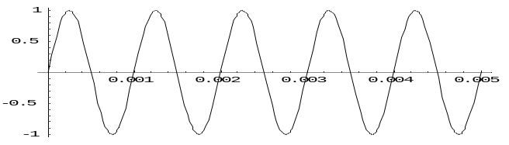
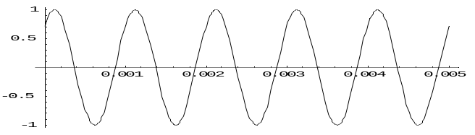
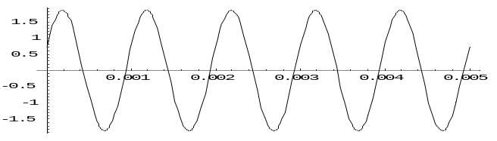
There is another important concept that can be shown via graphs. Consider the next set of graphs:

These graphs look very similar to each other but there are some subtle differences. All three graphs are plotted over the same 0.005 second time interval. The top two go from sound levels of +1 to -1 without any units specified. The negative numbers on these axes that we have been showing for a while shouldn’t cause any problems because all of these numbers are relative. Before the sound arrives at the ear there is always some level of ambient sound present and we simply define this level as zero because a constant level of sound isn’t very interesting. So (+1) is the highest level of sound and (-1) is the lowest level of sound produced by our tones relative to any background sounds that might be present.

The top two graphs look very similar but notice that although they both appear to be (and are) sinusoidal, they don’t start together. The top one starts at zero but the center graph actually looks like it got a head start because at t=0 it already has a value of about 0.75. These two graphs are said to be “out of phase” with each other and one of these curves is actually shifted by some amount of time with respect to the other one. The third graph is the addition of the first two and it should be noted that the sum of two sine waves, with one out of phase with the other, is still a sine wave. Notice the scale on the third graph goes higher than +1 but that even though both sine waves have an amplitude (maximum height of the signal) of +1, the sum never quite gets to two because the two curves are never at maximum of +1 at the same time.

An interesting and important example of the combination of two sounds (here we still are only discussing pure sine waves) is the addition of two sounds of nearly the same frequency. Consider again a sound whose frequency is 1000 Hz. and a second sound whose frequency is 1010 Hz., 10 Hz. different from the first.

The sum of these is as follows:

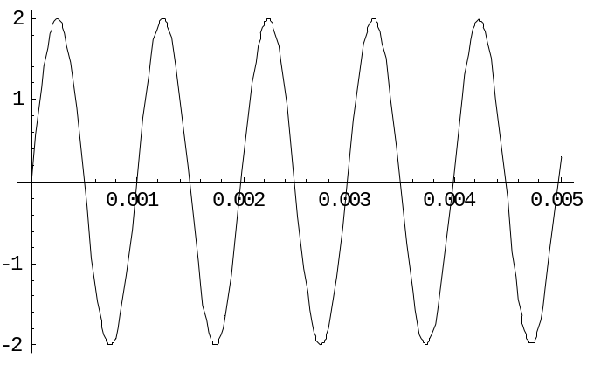
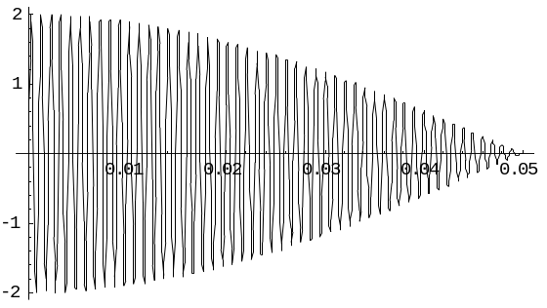
This graph looks almost the same as the original graph except that the amplitude is now 2 units rather than 1.0 because we add the two equal (=1) amplitudes. Since the frequency difference between the two sounds is not very great, they both start off together (in phase) but as time goes on they will begin to separate from each other. We can examine this graph on a different time scale, in this case, up to t=0.05 seconds, 10 times longer than the graph we just examined. Here is the graph:

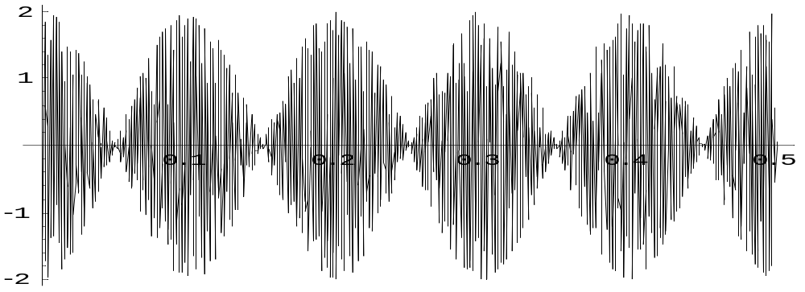

Notice that the amplitude is “almost” 2.0 units and that as time goes on the two sounds gradually get out of “sync” with each other. Eventually they get almost perfectly out of phase and cancel each other out! On a longer time scale, we see a periodic repeat of this “interference” effect between the two sounds:

The fundamental frequency is almost buried in this plot that extends out to 0.5 seconds. The combination of these two shows a second effect of the addition. The components changing their relationship to be both in and out of phase causes the amplitude of the total signal to increase and decrease periodically. The ear can hear this modulation. The frequency of what the ear hears is shown from the graph to be 10 Hz., exactly the difference between the two simultaneous sounds that are being combined. This phenomenon is referred to as “beats”. In the current example, 10 Hz. is below the hearing ability of most people but we shall see that this important phenomenon will emerge as being very important when we look at musical consonance and dissonance and the psychophysical reasons for both.

Some of the figures that we have been looking at are the sum of sounds of different amplitudes and frequencies. A very interesting and important example of this is shown in the next illustration.

This is a graph that looks very similar to the graph that displayed the output from the siren. There are two differences. The first is that this graph is centered about a sound amplitude of zero but we can always shift this by putting the axis at the bottom of the graph. The second difference is the presence of all the “wiggles” in the graph. But it is very similar and if we ignore the “wiggles”, we can replace the graph with the following approximation (on the right).

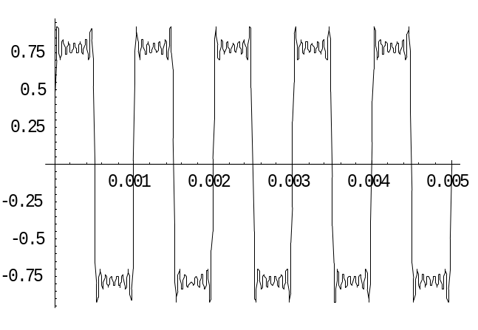

The thick dotted lines represent the repetitive pattern that, with a greater slope to the top and bottom, would be a very close representation to the siren. What is interesting is that this diagram was created by adding “tones” of different frequencies together. For this case, we used frequencies of 3000 Hz, 5000 Hz., 7000 Hs, 9000 Hz.,1100 Hz. and 1300 Hz. Each had different amplitude with the higher frequencies having smaller amplitudes. If we had added more frequencies in this sequence of odd thousands of Hz., we would have considerable smoothed out the wiggles. If we added a hundred terms, the result would be a perfect “square wave” shape which would switch back and forth from the high level to the low one similar to the dotted curve shown above.

The result can be shown to be even more significant than this. A great French mathematician, Fourier, came to the strange conclusion that any periodic curve could be created by adding together a bunch of appropriate pure sinusoidal curves of the frequencies and amplitudes that he showed how to compute. ANY periodic curve! At the time, most folks believed Fourier to be a nut case but he was later proven to be correct and Fourier’s theorem has a central position in both the study of music and mathematical/theoretical physics. In the world of music, we can state Fourier’s theorem as:

Any musical sound can be created by adding the right combination of pure tones (frequencies) together.

Thus the sound of the guitar shown above can be shown to be formed out of various frequencies that are natural to the instrument. Understanding this statement will require a lot of discussion.

We not move from the world of sinusoids to the mundane subject of arithmetic. Well, maybe not so mundane because arithmetic is not quite the simple subject that we all think it is. Our focus will be on a small portion of arithmetic; the way that we can express very large and very small numbers in a concise and simple manner. What we are about to do is fairly simple so, if it is new to you, give it a chance. If you are familiar with scientific notation and with simple logarithms (base 10), feel free to skip the rest of this section.

One of the arithmetical problems that we have to deal with is the issue of frequencies and other quantities scanning many decades in scale. The frequencies that we cab actually hear span the range of a bit greater than 20 Hz. to 20,000 Hz. This is a span of three decades. Plotting quantities over such an extended range can sometimes be problematical. Let’s look at a simple example. We have discussed the concept of an octave before. The octave of any frequency is double that frequency. A piano contains many octaves of each tone in the musical scale.

We already mentioned that an “A” near the middle of the piano sounds at 440 Hz. The lowest “C” on the piano is 32.5 Hz. This is often referred to as C_{1.} The next C, called C₂ would be twice this frequency or 65Hz. C₃ would be double this again or 130 Hz. next would be 260 Hz. Neglecting the problems with exact numbers for the present, the next tones in the C octave progression would be: 520, 1040, 2080 and 4160 Hz. respectively. The next octave is not useful for music because the frequency is too high. We can tabulate this approximately as follows:

Octave | Frequency (Hz.)
1 | 32.5
2 | 65
3 | 130
4 | 260
5 | 520
6 | 1040
7 | 2080
8 | 4160

When we plot these two numbers, Octave Number vs. Frequency, we obtain:

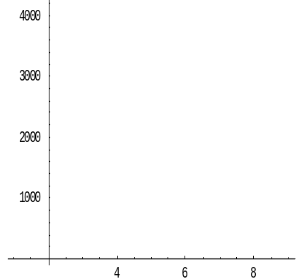

The problem with this graph is that too much information is crammed into the lower portion of the graph and too little in the upper portion. The situation would be even worse if we were plotting more octaves. The problem is that one of the items that we are plotting increases linearly while the other is increasing much faster. This so called exponential (or geometrical) increase is an important type of increase and we will encounter it in frequency issues as well as with musical intensity which varies over even more decades. Further, exponential variation is behind the concept of the measurement of musical (or sound) loudness using the decibel (dB) scale. It is therefore worth while discussing how we deal with this type of arithmetic.

Let’s recall from our distant past that if a is some number, then we could write

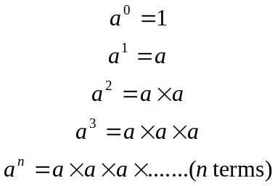

The sense of this becomes apparent when we choose the special case of a=10. The same table becomes:

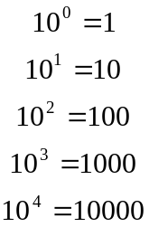

Notice that in this specific case, the number of zeros after the “one” is the same as the exponent. If we have a number, let’s call it N, that can be expressed in the form of

N=10^{n},

then the number n is called the Logarithm (or “log”) of the number N. Looking at the table above, we see that the log (100)=2 and the log(10000)=4. Another simple way of looking at this is that the log of a number (that is a simple power of 10) is the number of zeros that the number contains (as long as the number has a 1 as the first digit and all zeros after that). So, if we look at the number 13000000, we can change the 3 to a zero and count the number of zeros to get a guess about its logarithms. So the log(13000000) is about 7. (Stay with me on this obvious lack of detail.). Let’s look at the table we had above:

Octave | Frequency (f) (Hz.) | Reducing to  Simple Form | log(f)
1 | 32.5 | 10 | 1
2 | 65 | 10 | 1
3 | 130 | 100 | 2
4 | 260 | 100 | 2
5 | 520 | 100 | 2
6 | 1040 | 1000 | 3
7 | 2080 | 1000 | 3
8 | 4160 | 1000 | 3
9 | 8320 | 1000 | 3
10 | 16640 | 10000 | 4

Notice the simplification of each number in the third column. These numbers are of course not too accurate because we have changed the first number to a “1” and then used the approximate rule from above but we added the next two octaves. Again, neither of these frequencies often appear in music. Let’s look at the new graph that we get.

The approximate graph spreads the data out much better but the lack of horizontal resolution leaves much to be desired. The graph certainly shows the advantage of a “Log

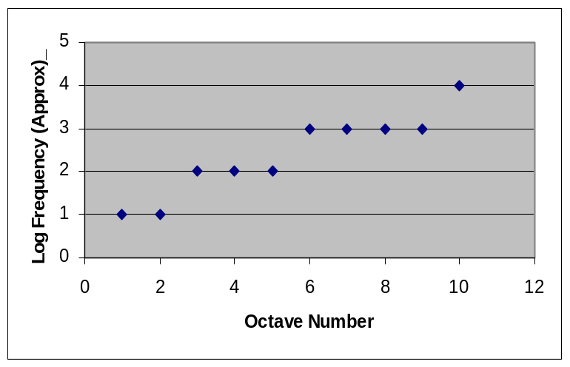
Plot” but it doesn’t go far enough to be really useful. So we need to examine the algebraic/arithmetic concept in a bit more depth. Sorry about that!

Let’s look again at those big numbers. We know that 1000 x 10000 = 10,000,000. In the exponential notation that we used above, we did something like:

1000 x 10000 = 10³ x 10⁴
and
10000000=10⁷ (count the zeros)
so

10³ x 10⁴ = 10⁷

You can now easily verify for yourself that

10^{n} x 10^{m} = 10^{(n+m)}

also

10^{n} /10^{m} = 10^{(n-m)}

so that multiplication of two numbers results in the exponents of 10 being added.

Let’s go back to the definition of the logarithm, N=10^{n} from which n is the log(N). From this we can use two numbers N₁ and N₂. If N₁=10^{n} and N₂=10^{m}. Then

n=Log(N₁) and m=Log(N₂)

so, putting this into the equation above this one,

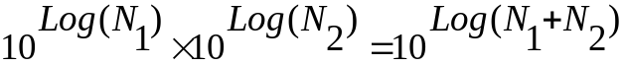

All that we did here was use the n and m equations in the product above. No magic! Another way to say this is:

Log (AB) = Log (A) + Log (B),

which is a very important relationship. To see how useful this is, let’s look at a number like 1,250,000. What is the log of THIS number? From what we did before, we can wrote this as

Log(1,250,000) = Log(1.25 x 1,000,000) = Log(1.25) + Log(1000000) = Log(1.25) +6

where the 6 is because 1,000,000 has 6 zeros. Better yet, let’s write this in an even more convenient form:

Log(1,250,000) = Log(0.125 x 10,000,000) = Log(0.125) + Log(10,000,000)
= Log(0.125) +7

We can thus always write the Log of a number as an integer added to the Log of a positive number less than one.

But what does this mean? Let’s again consider a number N (any number, we never said that N was an integer). So:

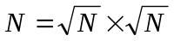
This is consistent with the notation

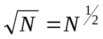

Multiplying each side of the equation by itself gives N on both sides since ½ + ½ =1. So a fractional exponent makes sense. So let’s take a look at one example which will make our point so we can get away from this issue and back to music. Consider the Log(0.5). From what we have just done, we can write”

Log(0.5) = Log(1/2) = Log(1) - Log(2)

The Log(1)=0 from before, so

Log(0.5)= - Log(2).

(Pay attention to that minus sign!) We have no problem thinking about a number such that 10 to some power=2. We already accepted fractional exponents so that some fractional power (less than one) would work. A surprise is that the Log(0.5), that is, the log of a number less than one, is negative, but such is life! Now we can go back to our table of octaves and add another column; the actual log. We can look up the Logs of numbers less than one in any math handbook. Here is the new table.

Octave | Frequency (f) (Hz.) | Approximate  log(f) | log(f)
1 | 32.5 | 1 | 1.51
2 | 65 | 1 | 1.81
3 | 130 | 2 | 2.11
4 | 260 | 2 | 2.41
5 | 520 | 2 | 2.72
6 | 1040 | 3 | 3.02
7 | 2080 | 3 | 3.32
8 | 4160 | 3 | 3.62
9 | 8320 | 3 | 3.92
10 | 16640 | 4 | 4.22

Notice that our earlier estimates were good to the first figure; not bad for such a crude calculation. Now let’s look at the actual graph of octave number vs. the log of the frequency.

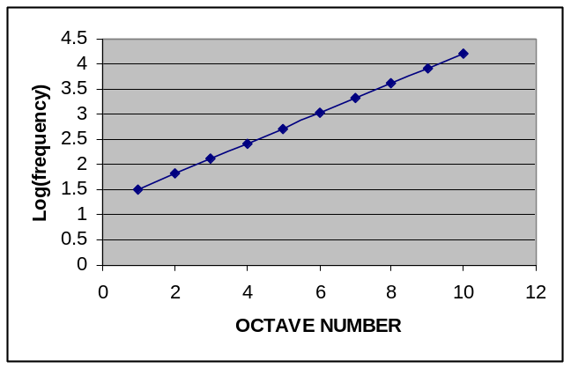
Suddenly, the graph is a straight line! That’s nice because it is easier to read and understand. So when something varies exponentially with something else, we will always plot the variable as a log.

As we shall see, all of this is very important to music. In fact, the musical staff is actually a logarithmic plot of the frequencies that the music asks the performer to play. Thus, in a strange sort of way, a musical score is a (series) of log(frequency) vs. time graphs!

We only have one brief topic to complete these introductory notes. We already discussed writing numbers such as 1.5 x 10⁵ = 1.5 x 100,000 =150,000. But what about numbers that are less than one? How do we express them? We can look at a few numbers to see how our concept can easily be extended to cover small numbers. The number 1.0 is easy, it is 10⁰. The number 0.1 can be written as 10⁻¹ using the same rules as before. Instead of looking at the number of 0’s after the first 1, we look at how many decimal places exist to the right of the decimal point. We therefore simply extend our table in the way shown in the next table. For numbers greater than 1, the exponent is the number of zeros after the leading zero. If a number is like 1250, we split it into 1.25 x 1000 and write it as 1.25 x 10³. For numbers less than 1, for example 0.025, we write the number as 2.5 x .01 and come up with 2.5 x 10⁻².

We will be using numbers such as this for a great deal of our numerical discussions of music so it pays to spend some time reviewing this material carefully.

Number | Exponential  Notation
1000 | 10³
100 | 10²
10 | 10¹
1 | 10⁰
0.1 | 10⁻¹
0.01 | 10⁻²
0.001 | 10⁻³

We are now prepared to proceed into the discussion of the Science of Music with the algebraic skills that we need to be able to make sense of many of the topics.

This scale is created when only the black notes of a piano are struck in order.
It should be noted that the bone flute has not been universally accepted as a musical instrument. Science generally works like that and it takes a great deal of agreement and substantiation before a scientific theory is fully accepted. As of this writing most people agree as to its identity. Others don’t. See http://cogweb.ucla.edu/ep/FluteDebate.html for some of the arguments that are (or were) circulating.
We are doing a lot of “we shall be discussing” because our goal right now is to get some necessary background and motivation for our subject.
From http://physics.nist.gov/cuu/Units/acronyms.html.
See http://physics.nist.gov/GenInt/Time/ancient.html from which some of this discussion is stolen.
But not necessarily the first kind of clock.
From http://physics.nist.gov/GenInt/Time/early.html
See “The Discoverers” by Daniel Boorstin. Vintage; 1st Vintage Book ed edition (February 12, 1985), ISBN 0394726251
See: http://home.howstuffworks.com/clock1.htm
Please recognize that this is really creative fiction but it could have happened in this way.
SI units, or System International units, were adopted internationally more than 50 years ago and is used widely in all modern sciences.
http://www.mel.nist.gov/div821/museum/length.htm
Raymond A. Serway, http://www.str.com.br/English/Scientia/physics2.htm
“x” is a very popular notation for distance and we will use it very often in what follows.
This is not something to panic about. Yes, if you have any previous experience with graphs, the horizontal axis was probably always the x-axis and the vertical axis the y-axis. But not here! We are not plotting x vs. y but rather x vs. t so the graphical axes must match what we are trying to actually graph.
To be exact, this is a graph of a “cosine”, but let’s not get picky.
For some reason that I do not understand, the cortex is often referred to as “cortex” without the “the”. So we say that a signal is processed by cortex. I don’t care for this and will use “the” in most cases. If you don’t like this, you can always sue.
OK, the real reason is to reduce the dust produced by the chalk but I like the other explanation much better!
Helmholtz was one of the true geniuses of physics. His original study of music was published as “On the Sensations of Tone. The book is still an essential reference today and has been republished under the same title by Dover Publications, New York (1954). ISBN 0-486-60753-4. It is a difficult book to read, especially if one attempts to follow the included mathematics.
Beer bottles also work well!
Believe it or not, we will discuss this concept shortly!
We don’t yet know what the appropriate unit for loudness is but “subjective loudness” should suffice for now.
The violin has the ability to play almost any tone while many stringed instruments (such as the piano or the guitar) are restricted to the specific “notes” of our musical scale.
The “scale” eventually will be discussed as a major topic.
Equally Tempered Scale.
http://images.google.com/imgres?imgurl=http://www.oberlin.edu/physics/catalog/demonstrations/waves/helmholtz.jpg&imgrefurl=http://www.oberlin.edu/physics/catalog/demonstrations/waves/helmholtz.html&h=236&w=449&sz=65&tbnid=JjChzJDrtsUJ:&tbnh=65&tbnw=124&hl=en&start=18&prev=/images%3Fq%3DHelmholtz%2Bresonators%26svnum%3D10%26hl%3Den%26lr%3D
All of these new terms will be discussed shortly.
One might assume that Professor Helmholtz had an assistant who must at one time have asked him how the resonator was used. His reply, “stick it in your ear” is probably not the origin of this particular epithet but is makes for a good story anyway!
This particular guitar is probably the cheapest one available and not suitable for performance. It is being used just to make a point!
Joseph Fourier (1768-1830). An amazing mathematician who almost, but not quite, made the vows for the priesthood.
A decade is a factor of ten. Thus 1000 and 10,000 are separated by a decade.
It is interesting to note that A was a variable quantity in music until a standard was possible. When one traveled across Baroque Europe, A varied from city to city, but few actually noticed the change.
These numbers are not exact. C₄ is actually 261.6 Hz.
This is not a particularly useful plot and is here only to demonstrate the plotting problem itself. The issue pervades music and its resolution is important for future discussions.
We use the term intensity in a rather caviler manner, leaving a critical discussion of its actual definition for later.
There are two different kinds of logarithms. The one we are using is to the “base 10”. The other system is the “natural logarithm” which is abbreviated ln(number) and uses a different “base”. If you don’t know what this means, don’t worry about it. It will never be mentioned again!
Don’t freak at the subscript in N₁. The subscript is just a label. So N₁ and N₂ are just two different numbers. But N¹ = 1 and N² is the square of the number N.
If this really scares you, check into any high school algebra textbook for a more in depth description.
The log of a negative number is not a “real” number. Don’t ask any more questions about this.
We will leave the actual computation of logarithms to some math course.
This is often called a semi-log plot. Special graph paper is available that will automatically produce a straight line for exponential data because the divisions are proportional to the logarithm of the horizontal axis. We probably won’t be doing this.

