STUDIO – Unit 10
PHY-2054 College Physics II

[MAGNETS ]

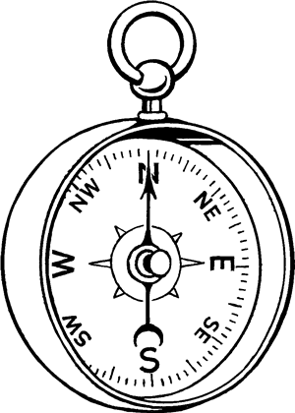
Just as charge was a new concept for us at the beginning of the semester, magnetism will follow a similar path as we enter into the second third of the material in this course.

The Magnetic Field will be found to have many similarities with the Electric Field but there will be some surprising large differences as well.

THE MANAGEMENT

MAGNETS
(from Lillian C. McDermott, Peter S. Shaffer and the Physics Education Group, Tutorials in Introductory Physics (Homework), Prentice Hall, NJ, 1998 – modified by JBB)

Objectives

- to be able to class materials or objects as magnetic, ferromagnetic or non-magnetic and understand how different classes of materials interact

- to understand how magnets interact with charged objects and how magnetic poles are different from positive and negative charges

- to be able to develop a method to measure the strength of a magnet

- to understand how a compass works

- to understand the Earth as a magnet

History (http://science.howstuffworks.com/compass-info3.htm)
Before the compass was invented, a captain's only guide to his position was his knowledge of winds, tides, landmarks, and the sun and stars. In open, unfamiliar waters he could only guess which way he was going. The Chinese are thought to have invented the compass as far back as the first century A.D. The original device consisted of a floating piece of magnetized iron in a bowl of water. The Arabs used the compass as early as the eighth century. It reached Europe in the 12th century.
The “arrow” in the compass (see title page) is actually what we now refer to as actually being a “magnet”. We will now investigate the properties of magnets and the significance if the associated “magnetic Field”, designated by B. We will see that B is a vector quantity and we will be studying its properties during the next few chapters in the textbook.
Initial Question: Base your answers on how you currently understand the workings of magnets.
A paper clips hung from a string in the middle of a Styrofoam cup covered with aluminum foil does not move when a negatively charged rod is brought near the outside the cup.

1) If the north pole of the magnet was brought near the outside of the cup would the paper clip move? Explain.

2) If the south pole of the magnet was brought near the outside of the cup would the paper clip move? Explain.

IMPORTANT: Experiments with magnets can often be a bit tricky and sometimes they don’t work properly. The reason for this is that there are many sources of magnetic fields (later) that can interfere with your work. The biggest problem in our present classroom is that the tables are made with magnetic materials and as we will see, this can cause problems with magnets and compasses. To get around some of these issues you may have to resort to some form of trickery. The first attempt might be to perform your experiment on top of your textbook. If this doesn’t work, you might try doing the experiment on the floor. If neither of these approaches work, consult your instructor.

Equipment:
1 set of materials for observing interactions between different type of objects

1.1 Obtain the set of materials that have been assembled and placed in a small envelopes. Be sure to replace these items when you are finished with this activity. Observe the interactions between the different objects that you have been given and separate the objects into three classes based on their interactions with each other. Examples of classes of materials include insulators, various kinds of conductors, magnets,

a. Briefly describe the three classes of materials that your group thinks is appropriate and list the objects in each of your classes.

class 1:__________________________________________
class 2:__________________________________________
class 2:__________________________________________

Comments, if any:


b. Fill out the table below by briefly describing the interaction between members of the same and different classes. (Attract, repel, no interaction).

 | Class 1 | Class 2 | Class 3
Class 1
Class 2
Class 3

c. Are all of the metals in the same class? Explain.

Equipment:
1 permanent magnet
1 set of materials for observing interactions
between different type of objects
3 unlabeled magnets
D
E
MO

1 pith ball – This might be an interactive demo.
1 paper clip & some string
1 Styrofoam cup to be covered with aluminum foil (also may be an interactive demo)

2.1 Obtain a permanent magnet and an object that is attracted to the magnet but not repelled. Imagine that you do not know which object is the magnet. Using only these two objects, find a way to determine which object is the permanent magnet. Describe it below.

The parts of a permanent magnet that interact most strongly with other materials are called the poles of the magnets.

2.2

a. How many different types of poles do you have evidence for so far? Explain briefly..

b. Obtain three unlabeled magnets and find a consistent way to label the poles. Describe what you did (briefly).

2.3

a. Recall how an uncharged pith ball suspended from a string can be used to test whether an object is charged. Describe briefly.
b. Predict what will happen when an uncharged pith ball is brought near one of the poles of the magnet. (Clicker)

A - It will be attracted
B - It will be repelled
C - There will be no interaction

c. Predict what will happen when a charged pith ball is brought near one of the poles of the magnet. (Clicker)

A - It will be attracted
B - It will be repelled
C - There will be no interaction

Briefly describe the results of b. and c. and indicate what was learned from these observations. (Followed by a class discussion.)

d. INTERACTIVE DEMO - A paper clip will be suspended from a string inside a Styrofoam cup surrounded by aluminum foil. Predict what will happen to the paperclip when a charged rod is brought near the cup.

A - It will be attracted
B - It will be repelled
C - There will be no interaction

e. INTERACTIVE DEMO Predict what will happen when one of the poles of the magnet is brought near the cup? (clicker)

A - It will be attracted
B - It will be repelled
C - There will be no interaction

f. Describe your observations in parts d and e. Were your predictions correct? Do you know why. (Hint – look up “Faraday cage” either in the textbook or on the internet.)

g. Based on your observations in part c, d, and e, are the poles of a magnet the same as net positive and net negative charge? Explain.

Be prepared to contribute to a class discussion on this topic..

DEFINITIONS: Materials that appear to have two different kinds of pole and exhibit attraction and repulsion in interactions with other materials are called magnets. Materials that only exhibit attraction with other materials are called ferro-magnets. Materials that do not interact with other materials are non-magnetic.

3.1

a. Can you devise a method to determine the strength of a magnet?
Discuss your method with an instructor or with the class if there is time.

3.2 Imagine hanging a bunch of bar magnets (horizontally) labeled with your labeling system in part 2.2.b from different parts of the ceiling (spread them out), free to rotate.

a. After the magnets have stopped rotating, what do you think the directions of the magnets are pointing in.

IMPORTANT FOR THE FOLLOWING:
Take note of the fact that the table top interacts strongly with a magnet. Why do you think this is the case?
This interaction with the tabletop should be taken into account for all of the following. You may, in fact, want to try some of the experiments on the floor where this won’t be a problem.

Start with one of the strong (stacked) magnets and place them either on the floor or on the table/textbook. Obtain a “bunch” of small compasses and array them around the magnet and see in what direction they point. Use the diagram below to sketch the pattern and connect the patterns in a way similar to the way that you did with the electric field.

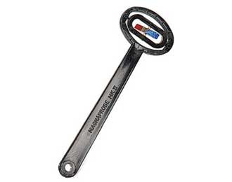
The device shown to the right is called a “magnaprobe”. It consists of a small bar magnet suspended so that it can rotate freely in three directions. Obtain one from your instructor if it is not on your workbench. Use this device to do the imaginary experiment described above in section (3.2).

Describe your results. Repeat near the tabletop and see if the results are the same or different. Describe both observations below:

b. Place magnaprobe near a bar magnet. Observe the direction of the compasses in different positions. Draw a 3D diagram if you can. Figure out a way to do this – the magnet obviously can’t be on the table or even on the floor.

To which category in Section 1.1 do compasses belong? Explain.

Extend your observations into the third dimension with the magnaprobe. Describe your observations. Any difference if you locate your magnet on the floor?
c. Place compasses far away from any known magnets (including other compasses).Observe the direction that the compasses point. How do your observations compare to how the magnaprobe behaves. Be sure to note that the magnaprobe has two different colors. Do the two ends of the magnaprobe behave the same or differently?

It is common to label the end of a magnet which points towards the Earth’s geographic north pole as the north pole of the magnet. (This is a convention.) Label your magnets this way.

If you were to hang magnets all over the Earth, you would find that the Earth acts like a magnet with north and south poles. How does this statement relate to the earlier magnaprobe results?

d. Based on your observations in parts a above, is the north pole of the Earth’s magnet in the northern or southern hemisphere? Explain.

SUMMARY

You should to be able to class materials or objects as magnetic, ferromagnetic or non-magnetic and understand how different classes of materials interact with each other. You should understand how magnets interact with charged objects and how magnetic poles are different from positive and negative charges. You should be able to develop a method to measure the strength of a magnet. You should understand how a compass works. You should understand the Earth as a magnet.

It is said that bird’s migration patterns are related in some way to the earth’s built in magnet. Check it out.
EXERCISES TO THINK ABOUT – This means be sure that you can answer these questions. You never know where they might pop up.

EXERCISES

1) (from Lillian C. McDermontt, Peter S. Shaffer and the Physics Education Group, Tutorials in Introductory Physics, Prentice Hall, NJ, 1998.)

A student is studying the behavior of three objects. She labels the objects 1,2, and 3 and places red (R) and blue (B) stickers on either end of each object as shown below.

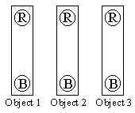

She finds that:

(i) the end 1R attracts the end 2R

(ii) the end 2R attracts the end 3B

(iii) object 1 and object 3 do not interact

Classify the three objects as magnets, ferromagnets, or non-magnetic objects. Explain your reasoning. If you cannot classify some of the objects on the basis of the information given above, explain why not and describe experiments you could perform to help you classify the objects.

2) (from Lillian C. McDermontt, Peter S. Shaffer and the Physics Education Group, Tutorials in Introductory Physics, Prentice Hall, NJ, 1998.)

Consider four metal bars as in the diagram below. The bars are numbered 1 through 4. The ends of each bar are labeled A and B, and the middle of each bar is labeled m.

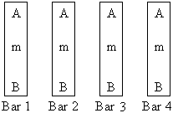

Assume that any objects that are magnets have their poles on the ends A and B.

A student makes the following observations:

(i) 1A attracts 2A

(ii) 1A does not interact with 3m

(iii) 1A repels 4B

a) Classify the three objects as magnets, ferromagnets, or non-magnetic objects. Explain your reasoning. If you cannot classify some of the objects on the basis of the information given above, explain why not and describe experiments you could perform to help you classify the objects.

b) How would 1A interact if it were brought near 4m? If it is possible to tell, what are the possibilities? Explain.

3) A small compass is placed near a very large piece of ferromagnetic material.

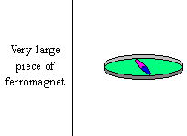

Before the compass is placed near the material, it is pointing toward the Earth’s geographic north.

Would the compass needle move? Explain your reasoning. If so, what direction would it point? Explain your reasoning.

4) Why does a magnet stick to a refrigerator? What is the door made out of? Explain your reasoning.

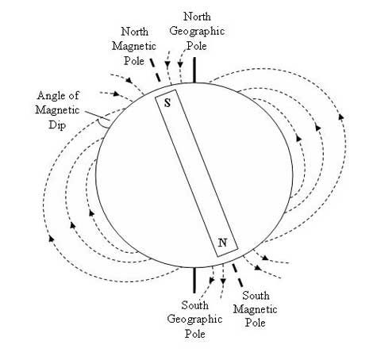

You may find the following material interesting.

Birds Follow Their Noses During Bird Migration
ScienceDaily (Jan. 28, 2010) — Birds largely rely on their sense of smell to navigate on their long migration routes. Indeed, the “third sense” has been shown to be a more important for them than orientation based on the sun and the earth’s magnetic field. Exactly how birds navigate on their migration routes has not yet been fully clarified. How does a bird develop an “internal map”? How does it find its way back to last year’s nest?
Adult migratory birds are clearly able to remember migration routes. Even if they end up flying over unknown terrain, they still manage to find their way to the right place. Researchers at the Max Planck Institute for Ornithology in Radolfzell and their colleagues at the universities of Princeton, Pisa and Copenhagen have established in a field study that odors considerably facilitate bird migration and act as a more important navigational cue than the sun and the earth’s magnetic field.
Researchers already know from the fledglings of many bird species that they use an inherited species-specific compass point to reach their wintering grounds on their first migratory journey. If they are moved a significant distance away from their starting point, they fail to reach their destination.
As opposed to this, adult migratory birds are able to remember routes that they have flown just once, and to correct their flight direction following a change of location and find their way back to their wintering locations. This is proof of real navigation performance and, based on this, scientists are trying to identify the factors and mechanisms that enable the animals to find their locations.
Researchers working with Richard Holland and Martin Wikelski from the Max Planck Institute for Ornithology in Radolfzell and the University of Konstanz began by studying small songbirds in their natural environment. To this end, they captured 24 adult and 24 juvenile catbirds (Dumatella carolinensis) in the field station of Princeton University (New Jersey). The researchers then manipulated the olfactory sense in eight birds from each group by applying a saline solution to the birds' nasal mucous membranes. As a result, the birds were no longer able to smell properly; however, their olfactory cells were not permanently damaged. The researchers also manipulated the magnetoreception capacity in another eight birds from each group by means of strong magnetic impulses. The sensory perception of the birds in the control group remained unimpaired.
Simultaneous to this, 19 adult catbirds were captured in Illinois -- in the middle of the American continent -- transported overnight to New Jersey and divided there into the same three groups. The scientists then fitted all of the birds with a radio transmitter weighing 0.9 grams and released them. This enabled the ornithologists to observe the flight of the birds from the both the ground and the air.
In the course of their autumn migration, catbirds usually fly through New Jersey in a south-west direction along Delaware Bay. If -- like their fellow species members in Illinois -- they flew a strict southern course, they would arrive in Cape May. This would mean that they would cross Delaware Bay at its widest point or would have to fly northwards up the coast again until they reach a narrow point in the bay. For this reason, adult birds usually avoid the direct southern route.
The non-smelling adult birds selected a different flight route than the experienced control group and the animals whose magnetoreception had been manipulated. The birds, whose olfactory capacity had been impaired, were unable to find their bearings and flew south. Like the juvenile birds, they had to fall back on their endogenous direction-finding skills because they could no longer rely on their sense of smell. The animals from Illinois with impaired olfactory perception also flew in a southerly direction while the control group tried to compensate for the change in location by flying in a south-westerly or westerly direction.
In contrast to the olfactory manipulation, the magnetoreception manipulation did not affect the orientation in either the adult or juvenile birds. "Other field studies have also failed to produce clear proof of any effect of the distortion of magnetoreception," says Richard Holland. Therefore, the question arises for the researchers as to how important the magnetic field actually is for avian navigation over large distances. "Nevertheless, we do not assume that the failure of the magnetic pulse treatment to trigger any effect indicates that magnetoreception does not play any role in the migration of adult birds." The results of the study enabled the scientists to reach the initial conclusion that the olfactory sense is a significant component of the birds' navigational chart. In addition, the experiment also provides a reliable method for future field studies aiming to examine the role of environmental factors in bird migration.

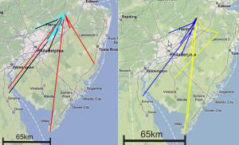

Fig.1: Tracks of adult birds, captured in New Jersey. Black: control, green: magnetic treatment, red: anosmic treatment and Fig. 2: Tracks of orientation of adult and juvenile catbirds, captured in New Jersey. Blue: adults, yellow: juveniles. (Credit: Image courtesy of Max Planck Institute for Ornithology) For the colors, go to

http://www.sciencedaily.com/releases/2010/01/100127110423.htm

